

ONLINE VEHICLE PARKING RESERVATION SYSTEM
ParkSure: advance parking reservation with a hold-back buffer, nearest-alternate re-allocation and a driver Trust Score
A project report submitted in partial fulfilment of the requirements for the award of the degree of
BACHELOR OF TECHNOLOGY
in
COMPUTER SCIENCE AND ENGINEERING
Submitted by
PALLE YASHASWINI | 23K91A05H9
MOHAMMED MUNEEB AHMED | 24K95A0518
KAMASANI MANISHA | 24K95A0513
POTHAGANI NITHYYA BHARGAVA | 23K91A05J6
Batch C3 (CSE-C)
Under the esteemed guidance of
V PALLAVI
[DESIGNATION]
DEPARTMENT OF COMPUTER SCIENCE AND ENGINEERING
TKR COLLEGE OF ENGINEERING & TECHNOLOGY (AN AUTONOMOUS INSTITUTION)
Medbowli, Meerpet, Balapur, Hyderabad, Telangana - 500 097
Academic year [ACADEMIC YEAR]

CERTIFICATE
This is to certify that the project report entitled "Online Vehicle Parking Reservation System" is a bonafide record of the work carried out by PALLE YASHASWINI (23K91A05H9), MOHAMMED MUNEEB AHMED (24K95A0518), KAMASANI MANISHA (24K95A0513), POTHAGANI NITHYYA BHARGAVA (23K91A05J6), in partial fulfilment of the requirements for the award of the degree of Bachelor of Technology in Computer Science and Engineering, during the academic year [ACADEMIC YEAR], under my supervision.

Project Guide | Head of the Department | Principal
V Pallavi | [HOD NAME] | [PRINCIPAL NAME]
[DESIGNATION] | Department of Computer Science and Engineering | TKR College of Engineering & Technology

External Examiner: [NAME AND SIGNATURE]
Place: [PLACE]
Date: [DATE]

DECLARATION
We hereby declare that the project report entitled "Online Vehicle Parking Reservation System", submitted to the Department of Computer Science and Engineering, TKR College of Engineering & Technology, in partial fulfilment of the requirements for the award of the degree of Bachelor of Technology in Computer Science and Engineering, is a record of original work carried out by us under the guidance of V Pallavi, [DESIGNATION]. The results embodied in this report have not been submitted to any other university or institution for the award of any degree or diploma.

PALLE YASHASWINI 23K91A05H9
MOHAMMED MUNEEB AHMED 24K95A0518
KAMASANI MANISHA 24K95A0513
POTHAGANI NITHYYA BHARGAVA 23K91A05J6

Place: [PLACE]
Date: [DATE]

ACKNOWLEDGEMENT
We express our sincere gratitude to our project guide, V Pallavi, [DESIGNATION], for valuable guidance, encouragement and constructive suggestions throughout this project.
We thank [HOD NAME], Head of the Department of Computer Science and Engineering, for providing the facilities and support needed to complete this work, and [PRINCIPAL NAME], Principal, TKR College of Engineering & Technology, for the encouragement given to us.
We thank the project coordinators and all faculty and staff members of the department for their help, and our families and friends for their constant support.
We also acknowledge the authors of the two papers on which this project rests: M. Jemmali, L. K. B. Melhim, A. Ammar, T. R. Gadekallu and W. Boulila, whose work on smart parking allocation is the registered base paper, and G. Cabri, M. Montangero, F. Muzzini and R. Wang, whose reservation buffer and reward system are implemented in the engine. We are grateful to the maintainers of the open-source software used here: FastAPI, SQLAlchemy, SQLite, APScheduler, React, Vite, Recharts, pytest, matplotlib and Playwright.

PALLE YASHASWINI
MOHAMMED MUNEEB AHMED
KAMASANI MANISHA
POTHAGANI NITHYYA BHARGAVA
Drivers in dense urban areas lose time and add congestion searching for a free bay, and operators who run parking from manual registers and cash have no view of demand. This project builds ParkSure, a web-based Online Vehicle Parking Reservation System in which drivers register, search live availability for a time window, reserve a bay in advance, pay online, and check in and out, while administrators manage locations, users, bookings and payments. A Smart Availability Engine admits a request only if overlapping bookings plus a hold-back buffer stay below capacity, moves a driver who finds the lot full to the one nearest alternate by haversine distance (or credits the fee if none exists), and keeps a Trust Score from 0 to 5 that changes the fee and can suspend booking. The buffer and reputation ideas follow Cabri et al.; the registered base paper is the work of Jemmali et al. on passenger-aware allocation. The system has 22 REST routes, five database tables and a React console.
We measured it with its own tools. All 70 automated tests pass, and a simulator of the base paper's 80-bay scenario agrees with the engine on 10,300 decisions. Search takes 5.7 ms and a reservation 19.6 ms on average. In the simulator the buffer rule shipped in the code, which grows on on-time checkouts, refuses far more reservations than the base paper's rule, so the paper's claim for the dynamic buffer is not reproduced for it. The probes also found an over-booking race (1 of 10 trials), an unauthenticated payment-confirmation route, and no vehicle profile or receipt. The data are the product's synthetic seed history, and no study with real drivers was done.
Keywords: online vehicle parking, parking reservation system, web application, slot booking, vehicle parking management, online payment, user authentication, admin dashboard, database management, smart parking.

TABLE OF CONTENTS
CERTIFICATE i
DECLARATION ii
ACKNOWLEDGEMENT iii
TABLE OF CONTENTS v
LIST OF FIGURES viii
LIST OF TABLES x
LIST OF ABBREVIATIONS xi
CHAPTER 1: INTRODUCTION 1
1.1 Introduction to the Project Domain 1
1.2 Background and Motivation 1
1.3 Problem Statement 2
1.4 Need for the Proposed System 3
1.5 Project Objectives 4
1.6 Scope of the Project 4
1.7 Project Contributions 5
1.8 Limitations and Assumptions 5
1.9 Organization of the Report 6
CHAPTER 2: LITERATURE SURVEY 7
2.1 Overview 7
2.2 Base Paper Analysis 7
2.3 Reservation Systems and the Reliability of a Reservation 10
2.4 Allocation, Optimisation and Pricing 10
2.5 Auction and Agent-Based Parking 11
2.6 Surveys, Sensing and Recent Reservation Services 11
2.7 Datasets and Algorithms Used in Related Work and in This Project 11
2.8 Strengths and Limitations of Existing Research 12
2.9 Research Gap 14
CHAPTER 3: FEASIBILITY STUDY 15
3.1 Technical Feasibility 15
3.2 Economic Feasibility 16
3.3 Operational Feasibility 16
3.4 Schedule Feasibility 17
3.5 Advantages and Constraints 17
CHAPTER 4: SYSTEM REQUIREMENTS AND ANALYSIS 18
4.1 Existing System 18
4.2 Limitations of the Existing System 18
4.3 Proposed System 18
4.4 Advantages of the Proposed System 19
4.5 Functional Requirements 20
4.6 Non-Functional Requirements 20
4.7 Hardware Requirements 21
4.8 Software Requirements 21
4.9 User Roles and System Constraints 22
CHAPTER 5: SYSTEM DESIGN 23
5.1 Design goals and architecture 23
5.2 High-level workflow 24
5.3 Data flow diagrams 25
5.4 UML design 28
5.5 Database design 30
5.6 Core algorithm design 31
5.7 Module design 32
5.8 API design 33
5.9 User interface design 34
5.10 Design decisions and trade-offs 35
CHAPTER 6: METHODOLOGY AND SOFTWARE IMPLEMENTATION 36
6.1 Overall methodology 36
6.2 Dataset 37
6.3 Input handling and preprocessing 37
6.4 Algorithm choice and justification 38
6.5 Mathematical formulation 39
6.6 Engine parameters, simulator and parity check 40
6.7 Application architecture 41
6.8 API design 42
6.9 Security and error handling 43
6.10 Installation and execution 44
CHAPTER 7: SYSTEM TESTING 45
7.1 Testing strategy 45
7.2 Unit testing 45
7.3 Integration and API testing 46
7.4 Functional testing with the smoke script 47
7.5 Security testing 47
7.6 Validation and edge cases 48
7.7 Performance testing 49
7.8 User acceptance and the browser walk-through 50
7.9 Limits of the testing done 51
CHAPTER 8: RESULTS AND OUTPUT SCREENS 53
8.1 Experimental set-up 53
8.2 Output screens 54
8.3 Buffer policies against the number of vehicles 56
8.4 Buffer policies against the share of overstaying vehicles 57
8.5 Effect of the Trust Score system 58
8.6 Strategy Insights on the seeded history 60
8.7 Response time and allocation efficiency 60
8.8 Comparison with the base papers 61
8.9 Sample inputs and outputs 62
8.10 Success and failure analysis 63
8.11 Limitations of the evaluation 64
8.12 Objectives versus outcomes 65
8.13 Summary of findings 65
CHAPTER 9: CONCLUSION 67
9.1 Summary 67
9.2 Objectives achieved 67
9.3 Key findings 67
9.4 Practical applications 68
9.5 Closing remark 68
9.6 Known limitations 68
CHAPTER 10: FUTURE SCOPE 69
10.1 Improvements to the existing system 69
10.2 Additional features 69
10.3 Scalability and deployment 69
10.4 Order of work 70
10.5 Risks and dependencies 70
10.6 Further research 70
REFERENCES 71
APPENDIX A: IMPORTANT CODE 73
A.1 Admission and fee (app/engine.py) 73
A.2 Nearest alternate (app/engine.py) 73
A.3 Trust Score and suspension (app/engine.py) 73
A.4 The check-in route (app/main.py) 74
A.5 The check-out route (app/main.py) 74
APPENDIX B: INSTALLATION AND USER GUIDE 76
B.1 Requirements 76
B.2 Installation and start with run.bat 76
B.3 Manual start 76
B.4 Demo accounts and settings 76
B.5 Using the console 77
B.7 Tests and experiments 77
B.8 Troubleshooting 78
APPENDIX C: ADDITIONAL SCREENS 79

LIST OF FIGURES
Figure 1: Layered architecture of ParkSure: React console, Vite proxy, FastAPI application with 22 routes, the engine and auth modules, SQLite database, and the Stripe and scheduler side services. 23
Figure 2: End-to-end workflow: search, reserve, pay, arrive, check in (alternate or fail if full), park, check out, trust update and buffer update. 24
Figure 3: State diagram of a reservation: reserved, active, completed, cancelled, failed and declined, with the events that cause each transition. 25
Figure 4: Context diagram (DFD level 0): ParkSure as one process with the driver, the administrator and the payment provider as external entities. 25
Figure 5: DFD level 1: six processes (authentication, availability search, reservation and payment, check-in and arrival handling, check-out and trust, administration and insights) and the data stores. 26
Figure 6: DFD level 2: the reservation and payment process 3.0 expanded into suspension check, forecast admission, fee quote, credit application, payment creation and checkout link. 27
Figure 7: UML class diagram of the five persisted entities (User, ParkingLocation, Reservation, Payment, TrustEvent) and the engine and API modules that operate on them. 28
Figure 8: Sequence diagram: reserve, pay, check in, check out and the trust and buffer updates between the driver, the React console, the API, the engine, the database and the payment provider. 29
Figure 9: Use-case diagram for the driver, the administrator and the payment provider. 29
Figure 10: Entity-relationship diagram of the SQLite database: users, parking_locations, reservations, payments and trust_events with keys and cardinalities. 30
Figure 11: Flowchart of the Smart Availability Engine: suspension check, admission rule, fee quote, arrival check, nearest-alternate search, departure check, buffer growth and trust update. 31
Figure 12: Trust Score state machine (benefit streak, warning count, score 0-5, fee multiplier, suspension rule) and the per-location buffer policy (initial value, growth, cap and daily reset). 32
Figure 13: Mean and 95th-percentile response time of each endpoint of the live API. 49
Figure 14: Number of reservations accepted in each of the ten trials; one bookable bay, twenty simultaneous requests. 50
Figure 15: Find parking for the default window (26 October, 3:00 to 5:00 PM): six locations with their bays, how many are held or reserved, the hourly price and the buffer (1 at five locations, 0 at the one-bay Kiosk Bay), and the bays that can still be reserved (Airport Express Park 24 free of 25, Central Station Garage 18 free of 20). Kiosk Bay is already Full for this window. 54
Figure 16: Search for a window that overlaps the booking of the one-bay Kiosk Bay: its card shows Full and a disabled No space for this window button, while the other five locations show free bays. 54
Figure 17: Reserve dialog for Airport Express Park, 27 October 3:47 PM to 6:47 PM: 3 hours at $5.00 per hour with the driver's trust multiplier x0.95 gives an estimated fee of $14.25. The server computes the final fee with the same formula. 55
Figure 18: Reservation confirmed: booking #352 with a fee of $14.25 (x0.95 trust multiplier) and the amount due. Because no Stripe key is set, the demo checkout button is offered. 55
Figure 19: My bookings for the demo driver: booking numbers, locations, windows, status badges, fees with the multiplier, and payment state. Reserved bookings offer Check in and Cancel; unpaid ones offer Confirm demo payment. 55
Figure 20: After the driver checked in and out of booking #348 through the buttons: the row is Completed, and the two confirmations read Checked in at Central Station Garage and Checked out on time. 55
Figure 21: Trust Score page: score 4 of 5, fee multiplier x0.95, on-time streak 1 (two more for the next point), no recent warnings, and the event history that begins with the on-time checkout just recorded above the seeded late checkouts. 55
Figure 22: Second driver arriving at Kiosk Bay, whose single bay was occupied: booking #353 shows Unable to park with the reason, the replacement booking #354 at Central Station Garage is Parked and marked Alternate for #353, and the toast reads that the driver was moved 0.1 km away. 55
Figure 23: Administrator overview of the fresh database after the capture session: 10 users, 6 locations, 354 reservations, paid revenue $1,604.00, 40 unable to park and 29 declined, with the Strategy Insights chart below. 56
Figure 24: Strategy Insights over the last 60 days: the same stored booking history replayed under no buffer, a fixed buffer of 1, a fixed buffer of 3 and the dynamic policy, shown as unable-to-park and declined counts, with the per-location table below. 56
Figure 25: Refused requests, arrivals with no bay and success rate against the number of vehicles for the five buffer policies (25 % bad vehicles, 30 runs per point). 57
Figure 26: Refused requests, arrivals with no bay and Trust Score lockouts against the share of overstaying vehicles (population 80 to 110, 30 runs per point). 58
Figure 27: What happens at the gate when half of the drivers overstay: no park, alternate physically full, and moved to the alternate, per run for each policy. 58
Figure 28: Share of requests that end in a parked car with the Trust Score on (as shipped) and off, at 25 % and 50 % bad vehicles. 59
Figure 29: Final Trust Score, share of drivers ever suspended and mean fee multiplier against the probability of a late checkout. 60
Figure 30: Strategy Insights totals on the seeded 60-day history under four buffer policies (synthetic data). 60
Figure 31: Additional screen: landing page, dark theme, with the live count of locations and bays and the search form. 79
Figure 32: Additional screen: landing page, light theme. 79
Figure 33: Additional screen: login page with the Log in and Create account tabs and the two demo-account chips. 79
Figure 34: Additional screen: My bookings after a check-in; booking #348 is Parked and shows the Check out action, with the 'Checked in' toast. 80
Figure 35: Additional screen: a second driver's bookings before arrival: one reserved booking at the one-bay Kiosk Bay. 80
Figure 36: Additional screen: after the arrival at the full lot: booking #353 is marked Unable to park and booking #354 at Central Station Garage is Parked as 'Alternate for #353'. 80
Figure 37: Additional screen: administrator's Locations page with bays, buffer, price, coordinates and the Edit, Delete and Reset all buffers actions. 81
Figure 38: Additional screen: administrator's All bookings page with search and status filter. 81
Figure 39: Additional screen: administrator's Users page with trust, on-time streak, warnings, credit and booking permission. 81
Figure 40: Additional screen: Strategy insights, per-location actual outcomes against the replayed dynamic policy, and the policy and totals panel. 81
Figure 41: Additional screen: Find parking at phone width (390 px): the sidebar becomes a menu and the form and cards stack. 82
Figure 42: Additional screen: the FastAPI OpenAPI page at /docs on the backend port, listing the 22 routes with the Authorize button for the bearer token. 82

LIST OF TABLES
Table 1: Abbreviations used in this report xi
Table 2: Objectives of the project and their outcome 4
Table 3: Relation of ParkSure to the two base papers 9
Table 4: Algorithms used in ParkSure and where each comes from 12
Table 5: Comparison of the surveyed work 12
Table 6: Batch survey titles that could not be verified 13
Table 7: Technical feasibility: components and the evidence for each 15
Table 8: Cost items 16
Table 9: Project phases 17
Table 10: Advantages and constraints of the project 17
Table 11: Modules of the proposed system 19
Table 12: Advantages and the evidence for each 19
Table 13: Functional requirements and how each is met 20
Table 14: Non-functional requirements, measured values and status 20
Table 15: Hardware used for development and measurement 21
Table 16: Software used 21
Table 17: User roles 22
Table 18: The five tables and their columns. 30
Table 19: Modules, sizes and responsibilities. 32
Table 20: The 22 routes of the ParkSure API. 33
Table 21: Pages, routes and the endpoints they use. 34
Table 22: Principal design decisions. 35
Table 23: The seeded demo database (fresh install, 2026-10-26). 37
Table 24: Alternatives considered and the reason for the choice. 38
Table 25: Policy parameters of the Smart Availability Engine. 40
Table 26: Simulator settings and the assumptions the base paper does not state. 40
Table 27: Test levels, tools and results. 45
Table 28: Unit tests of the engine, grouped by rule (tests/test_engine.py). 46
Table 29: API and integration tests by area (tests/test_api.py). 46
Table 30: Security probes and what they showed. 48
Table 31: Edge cases and how the product behaves. 48
Table 32: Response time of the API (milliseconds, 200 sequential requests per endpoint). 49
Table 33: What the simulator assumes where the paper is silent (fixed before the runs). 53
Table 34: Outcomes per run, 25 % bad vehicles, mean of 30 runs (requests = vehicles x 10). 56
Table 35: Outcomes per run against the share of bad vehicles (population 80 to 110, mean of 30 runs). 57
Table 36: Trust Score outcome after 100 daily sessions against the probability of a late checkout (200 drivers per setting). 59
Table 37: Comparison of the setting and the findings. 61
Table 38: The six project objectives against what was measured. 65
Table 39: Objectives against outcomes 67
Table 40: Seeded accounts 76
Table 41: Environment variables 77
Table 42: Driver steps 77
Table 43: Administrator steps 77
Table 44: Common problems 78

LIST OF ABBREVIATIONS
Table 1: Abbreviations used in this report
Abbreviation | Expansion | Abbreviation | Expansion
API | Application Programming Interface | MR | Baseline algorithm of the base paper
ASAP | Agent-assisted Smart Auction-based Parking | NFR | Non-Functional Requirement
CORS | Cross-Origin Resource Sharing | OJCS | IEEE Open Journal of the Computer Society
CRUD | Create, Read, Update, Delete | ORM | Object-Relational Mapping
DFD | Data Flow Diagram | QR | Quick Response (code)
ER | Entity-Relationship | REST | Representational State Transfer
FR | Functional Requirement | SQL | Structured Query Language
GVb | Grouping variant b of the base paper | SUMO | Simulation of Urban Mobility
HTTP | Hypertext Transfer Protocol | UI | User Interface
IoT | Internet of Things | UML | Unified Modeling Language
ITS | Intelligent Transportation Systems | USD | United States dollar
JSON | JavaScript Object Notation | UTC | Coordinated Universal Time
JWT | JSON Web Token

CHAPTER 1: INTRODUCTION

1.1 Introduction to the Project Domain
Parking is the last step of almost every car journey in a city, and it is the step with the least information. A driver who reaches a destination does not know which lot has a free bay, and a lot operator does not know how many cars are on their way. The batch introduction records the resulting observations: drivers in dense urban areas spend a significant share of a trip searching for parking, the search adds congestion, wasted fuel and avoidable emissions, and operators who keep occupancy in manual registers have no view of demand and cannot plan capacity. Surveys of smart parking treat this as a core problem of intelligent transportation systems [3], [4].
Advance reservation is the obvious remedy. If the driver books a bay for a time window before leaving home, the uncertain search becomes a guaranteed place. Reservation-based parking has been built in many forms: as interval scheduling in which the scheduler accepts or rejects each request [7], as web, SMS and smartphone services [10], [11], as optimisation of walking distance and congestion [12], and with flexible times and dynamic pricing [13]. All of them share one weakness that the technical base paper of this project puts at the centre: a reservation is a promise about the future, and the promise is broken when the previous occupant does not leave on time. Cabri et al. call the resulting event "No Park": a driver arrives with a valid reservation and finds the bay occupied [2].
Terms used throughout this report. A location is one parking facility with a capacity of bays. A reservation is a booking of one bay at one location for a time window. Admission is the decision to accept or decline a reservation request. The hold-back buffer is a number of bays at a location that new reservations may not use, kept free so that an arriving driver can still be placed if an earlier occupant overstays. An overstay is a checkout later than the end of the reserved window plus ten minutes of grace. The Trust Score is a driver's rating from 0 to 5 that changes the fee and can suspend booking. An alternate is the one nearest other location, by great-circle (haversine) distance, to which a driver is moved when the booked location is physically full on arrival.

1.2 Background and Motivation
The batch registers a 2026 IEEE Open Journal of the Computer Society paper as the base paper: "Smart parking for medical cities via passenger-aware allocation and fast grouping-permutation heuristics" [1]. Its authors observe that traditional parking systems allocate space by vehicle count and propose to allocate it by the total number of passengers, so that the number of people per parking space is balanced across the zones of a large medical campus. The framework combines booking interfaces, IoT sensing and a central allocation engine, and six grouping-permutation algorithms are evaluated on nine instance classes and 2,790 generated test cases. The best algorithm reaches the highest best-solution share among the six (68.2 %), and the variant called GVb matches or beats the baseline MR on 1,547 of the 2,790 instances (55.4 %) in sub-millisecond time.
That paper solves allocation inside one managed facility. The batch's own gap statement says what it leaves open: a general reservation platform that covers search, booking, payment and operator analytics for ordinary urban parking. The mechanisms that make such a platform reliable are described by a second paper, which is in the project folder as the base paper of the code and is treated here as the technical base paper: Cabri et al. [2]. It adds a buffer of non-reservable bays to the reservation module, with a dynamic size that adapts to observed overstays, and a reputation system in which a 0 to 5 star rating changes the fee and can suspend a driver. It is evaluated in the SUMO traffic simulator with 80 spots in 8 areas, and its conclusion, shown in figures rather than a table, is that any buffer beats none and that the dynamic buffer gives the best trade-off between failed parks and rejected reservations.
ParkSure is the product built on these ideas. It is a working web application, not a simulation: drivers register, search a time window, reserve, pay through Stripe Checkout in test mode or an offline demo checkout, check in and check out; administrators manage locations, users and bookings and read a Strategy Insights page that replays stored booking history under different buffer policies. The motivation is therefore twofold. For drivers and operators it is a concrete platform that covers the whole booking life cycle. For the project it is a chance to test, on running code, whether the published ideas behave as claimed, and to measure the platform's own response time and defects.

1.3 Problem Statement
The batch problem statement lists four difficulties. Drivers circle repeatedly because there is no way to know which slots are free. Parking operators manage occupancy through manual registers with no live view. Without reservation, arriving at a facility gives no guarantee of a space. Cash-based collection is slow at entry and leaves no usable records. The stated need is a reservation platform that shows live availability, guarantees a slot in advance and handles payment digitally.
We restate the problem as one that can be tested. Build a reservation platform in which a request is admitted only if a bay will be free for the requested window, a driver who finds the booked lot full on arrival is placed elsewhere or refunded, drivers who overstay pay more and can lose access, and the operator can see how different buffer policies would have performed on the recorded bookings; then measure how the platform behaves, including where it fails. Let a location have capacity c and buffer b, and let a request for the window (s, e) overlap k admitted bookings (reserved or active). The admission rule implemented in the engine is:
admit(request) = true if and only if k + b < c, where k = |{ booking : start < e and end > s }| (1)
A buffer of 0 admits up to c bookings at the same moment, and every unit of buffer removes one bookable bay from every window. The practical problem is that a larger buffer protects arriving drivers but refuses more requests, while a smaller one does the opposite. How large the buffer should be, and whether it should change with observed behaviour, is the central design question.

1.4 Need for the Proposed System
• A guarantee that holds in practice. A booking that is honoured only when the previous driver leaves on time is not a guarantee. The platform needs a buffer, an alternate and a refund rule for the case in which it fails.
• Incentives for punctuality. Overstays are the cause of failed arrivals. A fee multiplier and a suspension rule driven by the driver's own record give drivers a reason to book realistic windows.
• Digital payment and records. Cash at the gate is slow and leaves no data. Online payment creates a record for every booking, which is also what the operator analytics are computed from.
• Operator visibility. An operator who can see bookings, revenue, refused requests and failed arrivals, and can replay history under other policies, can tune capacity and buffers instead of guessing.
• Evidence, not assertion. Published buffer results come from a simulator and a preliminary study. A platform that carries its own tests, a parity-checked simulator and measured response times lets a reader check what actually works.

1.5 Project Objectives
The six objectives set for the batch, and the outcome of each, are listed below. The outcome column is the short version; Chapter 8 gives the measurements and Chapter 9 the verdict.
Table 2: Objectives of the project and their outcome
No. | Objective | Outcome (summary)
1 | Build user registration, authentication and vehicle profile management | Partly achieved: registration, login, JWT sessions and driver and admin roles work and are tested; there is no vehicle profile (plate, model) in the data model or the screens.
2 | Maintain real-time parking slot availability across registered parking facilities | Achieved as forecast availability: search returns the bookable bays per location for any window from stored bookings and the buffer; there is no sensor or gate feed, so physical occupancy is known only from check-ins.
3 | Implement slot search, advance reservation and booking cancellation | Achieved and tested; cancelling a paid booking returns the fee as account credit.
4 | Integrate secure online payment and generate digital receipts | Partly achieved: Stripe Checkout in test mode and an offline demo checkout store a payment record for every booking; there is no downloadable receipt, and the demo confirmation route is not authenticated (Chapter 7).
5 | Provide an administrator dashboard for slots, bookings, occupancy and revenue | Achieved: overview, locations, users, bookings and Strategy Insights screens; occupancy is shown as reserved and held bays, not live.
6 | Evaluate booking success rate, allocation efficiency and system response time | Achieved with the project's own tools: 70 passing tests, a parity-checked simulator for success rate and utilisation, and measured response times (for example search 5.7 ms mean).

1.6 Scope of the Project
In scope. Registration and login with hashed passwords and signed tokens; driver and administrator roles; parking locations with capacity, price and coordinates; availability search for a time window; reservation with admission control, fee quote and account credit; cancellation with refund to credit; payment through Stripe Checkout in test mode or an offline demo checkout; check-in, check-out and the on-time rule with ten minutes of grace; the per-location hold-back buffer with its daily reset; the haversine nearest-alternate move and the failed-and-credited outcome; the Trust Score with fee multipliers and suspension; the administrator screens and the Strategy Insights replay; a React console of eleven page components, 22 REST routes and five database tables; and the tests, simulator and measurement scripts that produce every number in this report.
Out of scope. Gate hardware, barriers, cameras and occupancy sensors; number-plate recognition; live traffic data; dynamic pricing by demand; multi-bay or multi-vehicle bookings; downloadable receipts and invoices; email or SMS notifications; vehicle profiles; native mobile apps (the console is responsive but is a web application); production hosting, backups and live-mode payments; and any study with real drivers.

1.7 Project Contributions
1. A complete reservation platform. One code base covers search, booking, payment, check-in and check-out, trust and operator analytics through 22 REST routes, five tables and an eleven-page React console, with 24 captured output screens.
2. The base papers' buffer and reputation ideas in running code, together with a haversine nearest-alternate re-allocation that creates a replacement booking, automatic fee credit when no alternate exists, and a fee multiplier that follows the Trust Score.
3. Strategy Insights. A deterministic replay of stored booking history under four buffer policies that gives an operator the counts of unable-to-park and declined requests without running a live experiment.
4. A parity-tested simulator. A discrete-event simulator that re-creates the base paper's 80-bay, 8-area scenario with ParkSure's rules and agrees with the real engine on 10,300 decisions with 0 mismatches, used to compare five buffer policies over 30 runs per setting.
5. An honest evaluation. 70 passing tests, measured response times, a concurrency probe and security probes. The evaluation reports what did not work: the shipped dynamic buffer refuses the most reservations, an over-booking race exists, and an unauthenticated route can mark a booking paid.
In one paragraph, what the measurements show. In the simulator at 100 vehicles and 25 % overstaying drivers, a request is refused by admission 30 times per 1,000 with no buffer, 158 with a static buffer of 3, 165 with the base paper's rule (grow the buffer when a vehicle leaves late) and 277 with the rule ParkSure ships (grow it on every on-time checkout). "No Park" stays rare under every policy because the nearest-alternate step absorbs the overflow, and the Trust Score lockout, not the buffer, is the largest source of refused requests once a quarter of the drivers overstay. The base paper's conclusion that the dynamic buffer is the best trade-off is therefore not reproduced for the shipped rule. The seeded-history replay in the product gives the same ordering. These results come from a simulator with assumed arrival parameters and from synthetic demo data, and they are reported with that limit.

1.8 Limitations and Assumptions
• Synthetic data. The only booking history is the product's own seed (9 users, 5 locations, 347 bookings over 60 days). It exercises the mechanisms but says nothing about real parking demand.
• Simulator, not SUMO. The scenario of the technical base paper is re-created in a purpose-built simulator. Arrival process, lead time, gaps between parks and the choice of area are assumptions the paper does not give; they are listed in the report and were fixed before the runs.
• Forecast availability. Availability is computed from bookings and the buffer. There are no sensors, so a vehicle that parks without checking in is invisible, and every simulated driver is assumed to check in at the planned arrival time.
• Payments in test mode. Stripe runs in test mode or the demo checkout runs offline; no live payment, webhook with real keys or refund flow was exercised.
• Known defects. The probes found an over-booking race under simultaneous requests, an unauthenticated demo confirmation route, a default token secret, no login rate limit, acceptance of past booking windows and very early check-ins, and slow list routes caused by repeated queries. They are reported in Chapters 7 and 8 and listed as future work in Chapter 10.
• Single machine. All measurements were made on one desktop with one server process and a SQLite file; nothing is claimed about larger deployments.
• No user study. Usability is described from the screens and from the responsive layout, not from tests with drivers.

1.9 Organization of the Report
Chapter 2 surveys the literature and analyses the two base papers. Chapter 3 studies feasibility, and Chapter 4 sets out the existing and proposed systems and the requirements. Chapter 5 gives the design: architecture, workflow, data flow and UML diagrams, the database and the user interface. Chapter 6 describes the methodology and implementation: the data, the admission and re-allocation algorithms with their mathematics, the Trust Score, the simulator, the API, security and error handling, and how to install and run the system. Chapter 7 reports testing. Chapter 8 presents every output screen, the measured results, the comparison with the base papers and the objectives against outcomes. Chapter 9 concludes and Chapter 10 sets out the future scope. The references and three appendices (important code, installation and user guide, additional screens) follow.

CHAPTER 2: LITERATURE SURVEY

2.1 Overview
The survey has three threads, because the project joins three bodies of work. The first is allocation and optimisation of parking inside managed facilities, which is the subject of the registered base paper. The second is reservation-based parking and the reliability of a reservation, which is the subject of the technical base paper whose rules the code implements. The third is the family of systems that surround a reservation: mobile and web access, payment deposits, pricing, auctions and sensing. The registered base paper [1] and the technical base paper [2] are analysed in depth in Section 2.2; every claim about them in this report was checked against the PDFs in the batch folder. Claims about the other works are limited to what the two base papers say about them, and where those papers give no result the tables below say so instead of supplying one.
The batch literature survey (5.LITERATURE SURVEY.docx) lists five works: the registered base paper and four papers from 2024 and 2026 on web-based and digital parking reservation. A web search on 26 October 2026 for the title of each of the four found no matching record, so they are listed in the reference list and in the table in Section 2.8 as the batch gave them, without authors, and nothing in this report depends on their content.

2.2 Base Paper Analysis

2.2.1 Registered base paper: Jemmali et al., IEEE Open Journal of the Computer Society, 2026
Reference. M. Jemmali, L. K. B. Melhim, A. Ammar, T. R. Gadekallu and W. Boulila, "Smart parking for medical cities via passenger-aware allocation and fast grouping-permutation heuristics," IEEE Open Journal of the Computer Society, vol. 7, pp. 1106-1118, 2026, doi 10.1109/OJCS.2026.3693801 [1].
Problem. Medical cities attract large and heterogeneous visitor flows. Allocating spaces by vehicle count ignores how many people each vehicle carries, which leads to uneven loads across parking zones, congestion near critical services and longer search times. The paper assigns vehicles to parking spaces by the total number of passengers, with the aim of minimising the disparity between the loads of the spaces, and states the problem as a small integer programme: each vehicle is assigned to exactly one space, the load of a space is the sum of the passenger counts assigned to it, and the objective is the sum over all spaces of the load minus the smallest load.
Method. A visitor registers a parking request through a web or mobile application, giving the number of passengers, the transport mode and the vehicle and booking identifiers. The system issues a QR code that carries the booking, the declared passengers and the allocated space; gate sensors scan it, compare the declared passengers with the occupancy detected by cameras and sensors, print a guidance card and update a scheduler, which keeps the status of every space from gate cameras, in-space sensors, mobile apps and the hospital information systems. A four-stage grouping procedure (prioritisation, dataset segmentation, group reordering, scheduling evaluation) and six grouping-permutation algorithms are proposed to compute the allocation.
Evaluation and findings. The algorithms are compared on nine instance classes and 2,790 generated test cases. The best of the six reaches the highest best-solution percentage (68.2 %) and the lowest average gap; the variant GVb matches or beats the baseline MR of the authors' earlier work on 1,547 of 2,790 instances (55.4 %), outperforming it on 57 (2.0 %) and matching it on 1,490 (53.4 %), while MR is better on 1,243 (44.6 %), and GVb needs substantially less execution time (sub-millisecond for the proposed heuristics).
Strengths and limits. The paper offers a clear objective, a fast algorithm family and a reference architecture that includes a booking interface. Its limits, for the purpose of this project, are that it optimises allocation inside one managed facility with sensing hardware, needs passenger counts, evaluates generated instances rather than a running service, and does not deal with payment, with overstays or with operator analytics. Its own related-work section observes that earlier reservation platforms often treated availability guarantees on arrival as unenforced.

2.2.2 Technical base paper: Cabri et al., arXiv:2605.17650, 2026
Reference. G. Cabri, M. Montangero, F. Muzzini and R. Wang, "Reservation based smart parking management," arXiv:2605.17650 [cs.MA], May 2026 [2]. This paper is in the project folder as the base paper of the code, and the buffer and star mechanisms of the engine come from it.
Problem. A reservation-based system fails a driver when the reserved space is still occupied by a previous driver who overstayed. The authors call this a "No Park" situation and distinguish it from "No Reservation", in which a request is refused in advance. They argue that a refusal in advance is better for the driver than arriving and finding no space.
Method. Two mechanisms. The Reservation Module keeps a buffer of free parking slots in each area that new requests may not reserve but that can be given to an arriving driver whose own slot is still occupied. A request is accepted if the user has a good reputation and credit. If an arriving driver finds the area full, the system suggests one alternate nearby area and books it automatically; if that is full too, the system has failed. The buffer may be static or dynamic. In the dynamic policy the buffer starts at a fixed constant, grows by one each time a vehicle leaves after the end of its reservation, up to a fixed maximum, and is reset to its lowest value periodically. The Reward System keeps a rating of 0 to 5 stars per user: B consecutive on-time departures (Benefits) add a star, W overstays (Warnings) remove one, the rating changes the parking fee, and a rating below a threshold together with a recent violation bars the user from the system-managed areas for one subsequent session.
Evaluation and findings. The SUMO simulator [21] models 80 reservable spots in 8 areas of equal size. Good vehicles leave on time and bad vehicles stay one hour longer; every vehicle makes 10 parks of 1 to 3 hours, with two further stops of 8 to 16 hours outside the system; users start with 3 stars. Experiment 1 raises the population from 80 to 110 vehicles in steps of 10; experiment 2 varies the share of bad vehicles from 25 % to 50 % with the population drawn from 80 to 110. Each configuration is run 5 times, and the dynamic buffer is compared with a static 0-spot, 1-spot and 3-spot buffer. The paper reports that any buffer beats none, that smaller static buffers cause more No Park events and fewer No Reservation events and larger ones the reverse, and that the dynamic buffer gives the better trade-off. The results are shown as figures; the paper gives no numeric table. The authors describe the work as preliminary.
Strengths and limits. The mechanism is simple, explicit and easy to implement, and the experimental scenario is fully described. The limits are that it is a simulation, that the user-behaviour model is two fixed types, that it assumes barrier-controlled areas and fully equipped vehicles, that only one alternate is ever suggested, and that no implementation, payment or user interface is described.

2.2.3 What ParkSure takes from each paper, and what it does not
Table 3: Relation of ParkSure to the two base papers
Aspect | Jemmali et al. [1] | Cabri et al. [2] | ParkSure
Problem | Balance the number of people per parking space | Keep reserved spaces available despite overstays | Run a reservation platform that stays reliable despite overstays
Core technique | Grouping-permutation heuristics | Buffer of non-reservable slots plus star rating | Admission rule k + b < c, buffer, haversine alternate, Trust Score
Evidence | 2,790 generated instances | SUMO, 80 spots, 5 runs, figures only | 70 tests, own simulator (30 runs per cell), measured response times
Delivered as | Framework and algorithms | Algorithm description and simulation | Running web application with 22 routes and 24 screens
Not covered | Payment, overstays, analytics | Implementation, payment, interface | Passenger-aware allocation, sensors, SUMO, real data

ParkSure does not implement the grouping heuristics of the registered base paper and does not claim to match or beat them: they solve a different problem on different data. What it takes from that paper is the architecture of a booking interface in front of a central allocation engine, and the observation that availability on arrival must be enforced. From the technical base paper it takes the buffer, the dynamic reset, the single alternate and the star rating. It differs in two places that the experiments examine: the buffer in the code grows on on-time checkouts, whereas the paper grows it on late departures, and the lockout of a suspended driver lasts at least fourteen days after the last warning, whereas the paper bars one subsequent session.

2.3 Reservation Systems and the Reliability of a Reservation
Reservation is the central idea. Doulamis et al. model parking requests as time intervals and let a scheduler decide whether to accept a request and which space to assign [7]. Yan et al. describe an off-street system in which spaces are reserved on the fly and drivers see real-time availability [9]. Safitri et al. present a mobile reservation system that displays the occupancy rate and uses a heuristic with the haversine formula [10], and Somani et al. a cross-platform system in which the driver pays part of the fee to confirm a booking, to prevent false bookings [11]. A further line limits access to drivers who hold a reservation, so that availability can be guaranteed [2].
These works concentrate on making a reservation possible. The technical base paper points out what they leave open: when the previous occupant does not leave on time, a reservation does not guarantee a place. ParkSure's admission rule is the interval-overlap rule of the scheduling line of work, with the buffer added to it as the base paper proposes.

2.4 Allocation, Optimisation and Pricing
Mejri et al. formulate slot assignment as a multi-objective integer linear programme that weighs walking distance to the destination, vehicle proximity and parking congestion [12]. Kotb et al. propose iParker, which offers flexible reservation times and dynamic revenue and pricing models [13]. Chen et al. analyse efficiency and equity in parking reservation [15], and an earlier work of the registered base paper's lead author studies smart-parking management algorithms for smart cities [16]. The registered base paper places itself in this optimisation stream and notes that hospital-focused models of this kind emphasise profit rather than equitable access [1].
ParkSure takes a deliberately simpler position. Its price is the location's hourly rate multiplied by a factor that depends on the driver's Trust Score; there is no demand-based price and no optimisation of which bay is given. The simplicity keeps every decision inspectable, and the cost is that none of the gains of an optimiser are claimed.

2.5 Auction and Agent-Based Parking
Auction mechanisms allocate scarce spaces by bids. Rizvi et al. introduced ASAP, an agent-assisted auction-based parking system over Internet of Things sensors, which reduced search time and improved utilisation as summarised by the technical base paper [5], and followed it with MaPark, a multi-agent auction framework in which distributed agents negotiate assignments [6]. Kokolaki et al. describe a centralised auction in which drivers bid for public spaces and a central authority coordinates assignment and payment [8].
Auctions suit competitive allocation of a scarce resource. A fixed-price booking service, which is what the batch asks for, has no bids, and the interesting question is reliability rather than price discovery. This body of work is therefore context for ParkSure rather than a source of mechanisms.

2.6 Surveys, Sensing and Recent Reservation Services
Aljohani et al. survey parking solutions for smart cities [3], Xiao et al. survey parking prediction [4] and Fahim et al. review smart parking systems from several aspects [19]. Muzzini et al. show how optimised parking allocation can reduce congestion and improve urban viability [14]. Geng and Cassandras describe an early smart-parking infrastructure and its implementation [17], and Elfaki et al. a real-time control and monitoring system built on sensors [20]. The registered base paper groups several of these early systems as infrastructure- and reservation-centric: they emphasise occupancy detection, reservation platforms and guidance interfaces, report limited quantitative optimisation of allocation, and do not always enforce an availability guarantee on arrival [1]. Among recent services it cites CRPark, a smart parking system with competition and reservation services [18].
These surveys and systems rely on sensing to know the true occupancy. ParkSure has no sensors; it knows physical occupancy only from check-ins, which is the weakest part of its availability claim and is stated as a limitation in Section 1.8.

2.7 Datasets and Algorithms Used in Related Work and in This Project
The related work uses three kinds of evidence. The registered base paper uses generated instances (nine instance classes, 2,790 cases) and measures the gap to the best solution and the execution time. The technical base paper uses a SUMO simulation of 80 spots, counting No Park and No Reservation events over five runs per configuration. Most of the other works describe a system without a reported quantitative evaluation in the sources available here.
ParkSure uses no external dataset. It has the product's own seeded history for the operator analytics and a purpose-built simulator for the buffer comparison. The algorithms it uses are listed below, with the source of each idea.
Table 4: Algorithms used in ParkSure and where each comes from
Algorithm | Used for | Source of the idea
Interval overlap with a buffer: k + b < c | Admission of a reservation request | Interval scheduling of requests [7], textbook interval scheduling [22], buffer from [2]
Dynamic buffer: init 1, +1 per on-time checkout, cap 5, daily reset | Hold-back of bays per location | Dynamic buffer of [2] (which grows it on late departures instead)
Haversine great-circle distance | Choosing the one nearest alternate location | Haversine formula [23], used for parking by [10]
Trust Score: 3 benefits give +1, 2 warnings give -1, fee multiplier 0.90 to 1.75, suspension below 1.5 | Fees and access control | Star reward system of [2]
Deterministic replay of booking history | Strategy Insights for operators | Developed in this project
Discrete-event simulation | Comparing five buffer policies | Scenario of [2] (SUMO [21]); simulator developed in this project

2.8 Strengths and Limitations of Existing Research
Table 5: Comparison of the surveyed work
Work | Approach | Data | Reported result | Limitation
Jemmali et al. (base paper) | Passenger-count-based allocation: four-stage grouping procedure and six grouping-permutation heuristics balance the number of people per parking space | Nine instance classes, 2,790 generated test cases | Best algorithm reaches the highest best-solution share (68.2 %); GVb matches or beats baseline MR on 1,547 of 2,790 instances (55.4 %), in sub-millisecond time | Allocation inside one managed medical-city facility; relies on passenger counts and IoT sensing; no payment, overstay handling or operator analytics
Cabri et al. | Reservation module with a buffer of non-reservable slots (dynamic: grows when vehicles leave late) plus a 0-5 star reward system; one alternate area is suggested | SUMO simulation, 80 spots in 8 areas, 80-110 vehicles, 25-50 % overstaying by 1 h, 5 runs | Any buffer beats none; the dynamic buffer gives the best trade-off between failed parks and rejected reservations (shown as figures, no numeric table) | Preliminary, simulation only; assumes barrier-controlled areas and fully equipped vehicles; no implementation, payment or user interface
Doulamis et al. | Interval scheduling: requests are time intervals that the scheduler accepts or rejects | Not stated in the base paper's summary | Not stated in the base paper's summary | No overstay handling is described in the base paper's summary
Safitri et al. | Mobile reservation system that shows occupancy rate, using a heuristic and the haversine formula | Not stated in the base paper's summary | Not stated in the base paper's summary | Mobile client only, per its title; no buffer or reputation mechanism described
Somani et al. | Cross-platform reservation: the driver pays part of the fee to confirm a booking and prevent false bookings | Not stated in the base paper's summary | Not stated in the base paper's summary | Deposit discourages false bookings but does not address overstays
Mejri et al. | Slot assignment as a multi-objective integer linear programme (walking distance, vehicle proximity, congestion impact) | Not stated in the base paper's summary | Not stated in the base paper's summary | Optimisation model; no operating web platform is described
Kotb et al. (iParker) | Flexible reservation times with dynamic resource allocation, revenue and pricing models | Not stated in the base paper's summary | Not stated in the base paper's summary | Pricing is dynamic by demand, not by the driver's past punctuality
Rizvi et al. (ASAP, MaPark); Kokolaki et al. | Auction-based parking: agent-assisted and multi-agent auctions over IoT sensors; centralised bidding for public spaces | Not stated in the base paper's summary | ASAP reported better utilisation and shorter search time (as summarised in the base paper) | Auctions suit competitive allocation, not a fixed-price booking service
Yan et al. (SmartParking) | Off-street parking with on-the-fly spot reservation and real-time availability for drivers | Not stated in the base paper's summary | Not stated in the base paper's summary | Security-focused architecture; no overstay mitigation described
Chen et al. | Efficiency and equity analysis of parking reservation (as cited in the base paper) | Not stated in the base paper | Not stated in the base paper | Analytical study; not a deployable service
Hu et al. (CRPark) | Smart parking system with competition and reservation services (as cited in the base paper) | Not stated in the base paper | Not stated in the base paper | Detail not given in the base paper

Strengths. The literature establishes that reservation reduces search, that interval scheduling is a sound admission rule, that a buffer of non-reservable bays protects arriving drivers, that a reputation mechanism can discourage overstays, and that fast heuristics can allocate spaces in sub-millisecond time inside a managed facility.
Limitations. Most sources describe a mechanism without a reported evaluation in the available text; the two that evaluate do so on generated instances or in a simulator, with simple two-type user behaviour; none reports the response time, the failure modes or the security of an operating web service; and none combines booking, payment and operator analytics in one measured platform.
Table 6: Batch survey titles that could not be verified
No. | Title as listed in the batch survey | Year | Source as listed
1 | Design and implementation of a web-based smart vehicle parking reservation and management system with real-time slot allocation | 2026 | American Journal of AI Cyber Computing Management
2 | Digital parking slot reservation system for vehicles | 2026 | International Journal of Engineering Science and Advanced Technology
3 | Parking slot prediction and face recognition based parked vehicle theft prevention in smart parking system | 2024 | International Research Journal of Modernization in Engineering Technology and Science
4 | Smart vehicle parking reservation system using web and mobile technologies | 2026 | Research Digest on Engineering Management and Social Innovations

These four entries are kept in the reference list [31], [32], [33], [34] because the batch survey names them. A web search found no record of any of them under the listed title and source, so their authors, content and results are unknown to us and none is used in this report.

2.9 Research Gap
The surveyed work either optimises allocation inside a large managed facility (the registered base paper), proposes a buffer and reputation mechanism that is evaluated only in simulation, or describes reservation components one at a time (booking, payment, mobile access, pricing). A general reservation platform that combines search, booking, payment, an overstay-aware availability engine and operator analytics for ordinary urban parking, and measures its own behaviour, is not reported.
The project's answer has three parts. It builds the platform, so that search, booking, payment, check-in and check-out are one measured system. It implements the buffer and reputation rules of the technical base paper in running code and tests them in a simulator that agrees with the code. And it reports where the implemented rule departs from the paper, since in the simulator the shipped rule refuses 277 of 1,000 requests at 100 vehicles against 165 for the paper's rule, a difference a reader could not see from the papers alone.

CHAPTER 3: FEASIBILITY STUDY

3.1 Technical Feasibility
The question is whether the reservation rules, the payment flow, the web console and the analytics can be built with tools that the team and an ordinary desktop can support, and whether the result is fast and correct enough to use. Each part of the design was built and measured; the table lists what was used and the evidence that it works.
Table 7: Technical feasibility: components and the evidence for each
Component | Technology | Evidence that it is feasible
Web API | FastAPI [28], pydantic validation | 22 routes built; 36 API tests pass; search answers in 5.7 ms on average
Database | SQLite through SQLAlchemy [27] | Five tables created from the models; the overlap query is indexed on user, location, start and end
Availability engine | Plain Python in app/engine.py | 29 unit tests; admission decision 0.33 ms; nearest alternate over 49 locations 18.6 ms
Authentication | bcrypt [26], JSON Web Tokens [25] | Login takes 220 ms because of the bcrypt cost factor 12; role guards tested for driver and admin
Scheduler | APScheduler inside the backend process | Buffer-reset job every 30 minutes; reset rule covered by two unit tests
Payments | Stripe Checkout in test mode [29], offline demo checkout | Reserve returns a checkout link; demo confirmation and refund to credit tested; webhook inert without keys
Front end | React 19 and Vite [30], three.js hero, Recharts | Eleven page components, 24 screens captured from the running application, phone-width layout captured at 390 px
Operator analytics | Deterministic replay in scripts/compute_buffer_strategy_metrics.py | Four policies replayed over 60 days in 60 ms; identical output on repeated calls (tested)

The measured response times show that the core booking path is cheap: reserving takes 19.6 ms on average, check-in 14.9 ms and check-out 14.6 ms, and eight client threads together obtain 131 search responses per second from one server process. Two routes are slow for a stated reason: listing a driver's bookings takes 180 ms and the administrator's booking list 273 ms, because every row issues two further queries. This is a defect of the implementation, not a limit of the technology, and it is listed as future work.
Two technical risks were identified and tested rather than assumed away. The first is concurrency: SQLite and the check-then-insert admission rule are not atomic, and a probe with 20 simultaneous requests for one bookable bay accepted two bookings in 1 of 10 trials. The second is the dependence on the clock: the buffer reset, the on-time rule and the suspension window all read the current time, which is why the simulator was parity-tested against the engine rather than patched into it. The first risk shows that the technology is feasible for a single-site pilot but needs a locking or transactional fix before it is relied on under load.

3.2 Economic Feasibility
The build needs no purchased software. Every library in the stack is available under a permissive open-source licence, the database is a single file, and the development machine is an ordinary desktop. Stripe is used in test mode, which needs no payment to run; in live mode Stripe charges transaction fees, which were not looked up for this report, and no revenue model is evaluated here.
Table 8: Cost items
Item | Cost for this project | Note
Software licences | None | FastAPI, SQLAlchemy, React, Vite, uvicorn, APScheduler and SQLite are open source
Development hardware | Existing desktop | 12th-generation Intel Core i5-12500, 15.7 GB RAM, Windows 11 Pro
Database server | None | SQLite file; replaceable by another SQLAlchemy database through one setting (PARKSURE_DB)
Payment gateway | None in test mode | Live-mode fees not evaluated
Hosting | Not evaluated | One process serves the measured load; no hosting plan or price was studied
Gate hardware and sensors | Out of scope | Entry and exit are software actions (check-in and check-out buttons)

For an operator, the economic argument is the one the system measures about itself: a platform that refuses a reservation in advance instead of failing a driver at the gate, records every payment, and lets the operator replay booking history to choose a buffer. On the seeded history the replay shows the trade-off in numbers: 16 declined and 8 unable-to-park requests with no buffer, against 40 and 0 with a fixed buffer of 3. These figures come from synthetic demo data and show the mechanism, not a saving.

3.3 Operational Feasibility
Drivers need only a browser: they register, search a window, reserve, pay, and press Check in and Check out. The console shows the reason whenever a request is declined or a driver is moved, and the Trust Score page explains the fee multiplier, so no training is needed to understand the rules. Administrators work in five screens, and their routine tasks are adding or editing a location, resetting buffers, reading bookings and users, and recomputing Strategy Insights.
Running the system takes little effort. run.bat creates the virtual environment, installs the Python and Node dependencies and starts the backend on port 8403 and the front end on port 5403; a first start creates the database and seeds demo data. Before any real use an operator must set a private token secret (PARKSURE_JWT_SECRET), Stripe keys, and a backup routine for parksure.db, because the shipped defaults are for demonstration. The scheduler runs inside the backend process, so no separate job service is needed, and the cost is that the buffer reset stops when the backend stops.

3.4 Schedule Feasibility
The work followed the dependencies of the design. Calendar dates are left as the placeholder [DATES] because the batch file does not give them.
Table 9: Project phases
Phase | Work | Output
1 | Problem study, reading of the two base papers, requirements | Abstract, introduction, survey, objectives (documents 2 to 6)
2 | Data model and availability engine | models.py, engine.py, config.py, seed.py
3 | API, authentication, payments and scheduler | 22 routes, JWT roles, Stripe and demo checkout
4 | React console | Eleven page components in the V3 design kit
5 | Testing, simulator and measurements | 70 tests, parity check, experiments, latency and probes
6 | Screenshots and documentation | 24 screens, 12 diagrams, nine result charts, eleven documents

The schedule was feasible because each phase depends only on the one before it and no step is computationally heavy. The slowest operations in the project are the 200-request latency runs and the 30-run simulator sweeps, which take seconds to minutes on the development desktop. The real schedule risk was in the details that tests exposed late, such as the buffer direction that differs from the base paper, which was found while writing the simulator.

3.5 Advantages and Constraints
Table 10: Advantages and constraints of the project
Advantages | Constraints
Complete booking life cycle in one application | Single process and SQLite: no horizontal scaling and no atomic admission under simultaneous requests
Every decision is a short, readable rule with a stored reason | No sensors or gate feed: physical occupancy is known only from check-ins
Parity-tested simulator reproduces the engine's decisions exactly | The simulator is not SUMO and its arrival parameters are assumptions
70 automated tests plus a 27-check smoke test | Demo data are synthetic; Stripe runs in test mode only
Operator can replay history under other buffer policies | No vehicle profile and no downloadable receipt
Runs on one ordinary desktop with one command | Default token secret and an unauthenticated demo-confirm route must be fixed before real use

CHAPTER 4: SYSTEM REQUIREMENTS AND ANALYSIS

4.1 Existing System
In the situation the batch describes, a driver reaches a facility with no knowledge of its occupancy and no guarantee of a bay. Entry is first come, first served, payment is collected in cash at the gate, and the operator keeps occupancy in a manual register. Nothing connects the driver's intention to park with the operator's capacity until the car is at the barrier.
Digital reservation systems exist, as Chapter 2 shows: interval-scheduled bookings [7], mobile and cross-platform services [10], [11], flexible times with dynamic prices [13]. The technical base paper identifies what most of them leave open: a booking does not protect the driver when the previous occupant overstays [2]. In practice the existing system therefore means manual registers and cash at the gate for many operators, and reservations that can fail silently for the digital ones.

4.2 Limitations of the Existing System
• No live view. Drivers cannot see which bays are free, and operators cannot see demand ahead of time.
• No guarantee on arrival. A reservation, where one exists, is honoured only if the earlier driver leaves on time. Without a buffer or an alternate, the driver finds the bay occupied.
• No incentive for punctuality. The cost of an overstay falls on the next driver, not on the one who overstayed.
• Cash and manual records. Collection at entry is slow, leaves no usable records and gives the operator nothing to analyse.
• No way to tune capacity. Without recorded bookings and refusals, an operator cannot test how many bays to hold back.
• Search adds traffic. The batch introduction records that circling for a space adds congestion, wasted fuel and avoidable emissions.

4.3 Proposed System
ParkSure replaces the register and the gate with a web platform. A driver searches a time window, sees how many bays can still be reserved at every location, and reserves one. The engine admits the request only if overlapping bookings plus the location's buffer are below capacity, quotes the fee from the hours, the hourly rate and the driver's trust multiplier, applies account credit, and creates a payment. On arrival the driver checks in. If the lot is physically full, the engine moves the driver to the one nearest other location that has forecast space, or marks the booking failed and credits the fee. At check-out an on-time departure grows the location's buffer and advances the driver's benefit streak; a late departure records a warning. Administrators manage locations and read bookings, users, revenue and the Strategy Insights replay.
Table 11: Modules of the proposed system
Module | File | Responsibility
Routes and scheduler | app/main.py | 22 REST routes, buffer-reset job, static pages
Availability engine | app/engine.py | Admission, buffer reset, haversine alternate, trust updates, suspension, fee quote
Models and database | app/models.py, app/database.py | Five tables, SQLite session
Authentication | app/auth.py | bcrypt hashing, token creation and decoding, driver and admin guards
Payments | app/stripe_pay.py | Stripe Checkout session or demo link
Seed data and insights | app/seed.py, scripts/compute_buffer_strategy_metrics.py | Demo history; deterministic replay of four buffer policies
React console | frontend/src/pages | Landing, login, find parking, my bookings, trust score, five admin pages

The data the system keeps follow directly from these steps. A user row holds the role, the Trust Score, the benefit streak, the warning count, the account credit and any suspension time. A location row holds its coordinates, capacity, hourly price and current buffer. A reservation row holds the window, the status, the fee and the multiplier that was applied, the check-in and check-out times, the reason for a decline or failure, and a link to the booking it replaced when the driver was moved. A payment row holds the amount, the provider and the status, and a trust-event row records every benefit, warning, reward and penalty. Because the reason and the multiplier are stored with each booking, a later reader can see why a request was declined and how its fee was computed.

4.4 Advantages of the Proposed System
Table 12: Advantages and the evidence for each
Advantage | Evidence
Live availability for any window | Search returns bookable bays per location in 5.7 ms on average
Reservations are admitted only when a bay will be free | Admission rule k + b < c tested; simulator parity 10,300 decisions, 0 mismatches
Arriving driver is not left stranded | Alternate move and failed-and-credited paths tested (screen 15 shows the move)
Punctuality is rewarded | Fee multiplier 0.90 to 1.75 from the Trust Score; three on-time checkouts raise the score, two late ones lower it (unit tests)
Digital payment record for every booking | Payment row per reservation; refund to account credit on cancellation (tested)
Operator can compare buffer policies on recorded history | Strategy Insights replay computed in 60 ms; identical on repeated calls
Reproducible evaluation | 70 tests, scripts/run_experiments.py, scripts/measure_api.py, experiments/*/metrics.json

The advantages are claimed only where the project holds a measurement or a test for them. Where a benefit is a design intention without a measurement, such as less time spent searching for a bay, it is not listed, because the project did not measure journeys or search time.

4.5 Functional Requirements
Table 13: Functional requirements and how each is met
ID | Requirement | Implemented by | Verified by
FR1 | A visitor can register with name, email and password | POST /api/auth/register | test_api: duplicate email, validation
FR2 | A user can log in and obtain a session token | POST /api/auth/login, GET /api/auth/me | test_api: login, bad password, token required
FR3 | Admin routes are refused to drivers | admin_user guard in auth.py | test_api: role guards
FR4 | An admin can add, edit and delete locations | POST, PUT, DELETE /api/locations | test_api: location CRUD and validation
FR5 | Anyone can search availability for a window of at most 30 days | GET /api/search | test_api: bookable count, validation
FR6 | A driver can reserve; the request is declined when k + b >= c | POST /api/reservations, engine.forecast_free | test_engine: admission; test_api: 409
FR7 | The fee is hours x rate x trust multiplier, minimum 0.25 h, offset by account credit | engine.quote_fee | test_engine: fee; test_api: credit
FR8 | A booking has a payment, confirmed through Stripe or the demo checkout | stripe_pay.py, payment routes | test_api: demo payment, webhook inert
FR9 | A driver can cancel a reserved booking and a paid fee returns as credit | POST /api/reservations/{id}/cancel | test_api: cancel and refund
FR10 | A driver can check in; a full lot moves the driver to the nearest alternate or fails the booking and credits the fee | checkin route, engine.nearest_alternate | test_api: alternate and failed paths
FR11 | A driver can check out; on time means by end + 10 minutes | checkout route | test_api: on-time and late
FR12 | The buffer grows by one per on-time checkout (cap 5) and is reset daily | checkout route, reset_buffers_if_due | test_api, test_engine: reset
FR13 | The Trust Score rises after 3 benefits, falls after 2 warnings, within 0 to 5 | engine.record_checkout_trust | test_engine: trust
FR14 | A driver with trust below 1.5 and a recent warning is refused and cooled down for 24 h | engine.suspension_block | test_engine, test_api: suspension
FR15 | A driver can view the score, streak, multiplier and event history | GET /api/trust | Screen 13
FR16 | An admin can view totals, all bookings and all users | GET /api/admin/overview, bookings, users | test_api: admin listings
FR17 | An admin can recompute Strategy Insights over a chosen window | GET /api/admin/insights | test_api: four strategies, deterministic
FR18 | An admin can reset every buffer to its initial value | POST /api/admin/reset-buffers | test_api: reset

Each requirement below is traced to the route, module or test that meets it. The tests named are in tests/test_engine.py and tests/test_api.py. Requirements FR1 to FR18 were all exercised by at least one automated test or, for the trust page, by a captured screen.

4.6 Non-Functional Requirements
Table 14: Non-functional requirements, measured values and status
ID | Category | Requirement | Measured or observed | Status
NFR1 | Performance | Core booking calls answer well within a second | Search 5.7 ms, reserve 19.6 ms, check-in 14.9 ms (means of 200 calls); 8 threads: 131 searches per second | Met
NFR2 | Performance | List routes remain usable as bookings accumulate | Own bookings 180 ms, admin bookings 273 ms with about 400 rows (two extra queries per row) | Partly met
NFR3 | Security | Passwords hashed, routes guarded by role, input validated | bcrypt cost 12 (220 ms login); role guards tested; injection payloads answered 422 | Met
NFR4 | Security | No unauthenticated state change, no default secrets | Demo-confirm route marks a booking paid without login; forged token with the default secret accepted; no login rate limit | Not met
NFR5 | Correctness | Never admit more than the bookable bays | Sequentially correct (tests); 1 of 10 concurrent trials accepted 2 bookings for 1 bay | Partly met
NFR6 | Reliability | Decisions reproducible and explainable | Every declined or failed booking stores its reason; Strategy Insights identical on repeated calls | Met
NFR7 | Usability | Clear states, light and dark theme, small screens | 24 screens; toasts state the reason for a decline or move; phone-width layout captured at 390 px (screen 23) | Met, no user study
NFR8 | Portability | Start with one command on a clean machine | run.bat installs and starts both servers; Docker image runs the backend only | Met
NFR9 | Maintainability | Small, tested code base | Backend 977 lines in 10 files; 70 tests | Met
NFR10 | Scalability | Grow beyond one site | Single process and SQLite; not measured beyond 8 client threads | Not evaluated

The status column is deliberately blunt. One requirement is not met, one was not evaluated and two are met only in part; the first and the partly met ones correspond to defects found by the project's own probes and listed in Chapter 7. A requirement is marked Met only when a measurement or a test supports it, and no requirement is marked Met on the strength of the design alone.

4.7 Hardware Requirements
The system was developed and measured on one desktop. The minimum configuration was not tested on smaller machines, so the table gives the measured configuration and does not claim a lower bound.
Table 15: Hardware used for development and measurement
Item | Configuration
Processor | 12th Gen Intel Core i5-12500, 6 cores, 12 threads
Memory | 15.7 GB
Storage | Local disk; the database is a single file, parksure.db
Display for screenshots | 1440 x 900 viewport; 390 x 844 for the phone-width screen
Operating system | Windows 11 Pro (build 10.0.26300)

4.8 Software Requirements
Table 16: Software used
Layer | Software and version
Language and runtime | Python 3.14.7 in the project virtual environment (the code targets Python 3.11 or newer); Node.js 24.19.0 for the front end
Back end | FastAPI 0.141.1, uvicorn 0.52.4, SQLAlchemy 2.0.52, pydantic 2.13.5, APScheduler 3.11.3
Security and payments | bcrypt 5.0.0, python-jose 3.5.0, Stripe SDK 15.6.1 (test mode)
Front end | React 19, Vite 8, react-router 7, three.js, framer-motion, GSAP, Recharts, lucide-react
Database | SQLite file parksure.db (replaceable through PARKSURE_DB)
Testing and measurement | pytest, requests, matplotlib, NumPy; Playwright with Google Chrome for the screenshots
Browser | Any current browser; Chrome was used for the captures

4.9 User Roles and System Constraints
Table 17: User roles
Role | Can do | Cannot do
Visitor (not logged in) | See the landing page, the list of locations and search availability; register or log in | Reserve, pay, check in or out, see any booking
Driver | Everything a visitor can; reserve, pay, cancel, check in and out, see own bookings and Trust Score | Open admin screens or other users' bookings (answered 404)
Administrator | Everything a driver can; add, edit and delete locations, reset buffers, see overview, all bookings, all users and Strategy Insights | Nothing is withheld; the first account created on an empty database becomes administrator

The constraints below are enforced by the schemas and the routes. Most of them are limits of this implementation, not requirements of parking.
• A reservation window is at most 30 days long and must end after it starts; windows in the past are not rejected.
• A name has 2 to 120 characters, a password 6 to 128; a location has capacity 1 to 5,000, an hourly price from 0.50 to 100 and a buffer from 0 to 20.
• The billed time is at least 0.25 hours; fees are in US dollars; times are stored in UTC.
• Only a reserved booking can be cancelled, only a reserved booking can be checked in, and only an active booking can be checked out.
• A check-out is on time up to ten minutes after the end of the window.
• A driver is moved to at most one alternate location, and the alternate booking is created active without a second physical check.
• A session token lasts 12 hours and is signed with a secret that must be changed from the default before real use.
• One backend process serves all requests; the scheduler runs inside it.

CHAPTER 5: SYSTEM DESIGN
This chapter describes how ParkSure is put together: the architecture and workflow, the data flow, the UML and database design, the core algorithm, the modules, the API and the user interface. The diagrams were drawn from the code in app/ and frontend/src/; the complete set, each with a longer explanation, is also in the Block Diagrams document. ParkSure is a multi-user web platform with two roles, a driver and an administrator, and one persisted state, a single SQLite database. The sections below state the design as built, including the places where the build differs from what a production system would need.

5.1 Design goals and architecture
Five goals shaped the design. First, the availability a driver sees must be the same number the booking rule enforces: the search route and the admission rule use the same overlap count and the same buffer, so a bay shown as free can be booked and a bay shown as full cannot. Second, an overstay must not silently strand the next driver: the hold-back buffer, the arrival check and the nearest-alternate move exist for that purpose, following the dual mechanism of [2]. Third, behaviour has a price: the Trust Score changes the fee and, at the bottom of the scale, access. Fourth, every outcome is recorded: declined, failed and cancelled bookings stay in the database with a reason, so the administrator can replay them. Fifth, zero-configuration deployment: SQLite, a demo checkout and seeded data let the product run on a student's laptop with one launcher script.
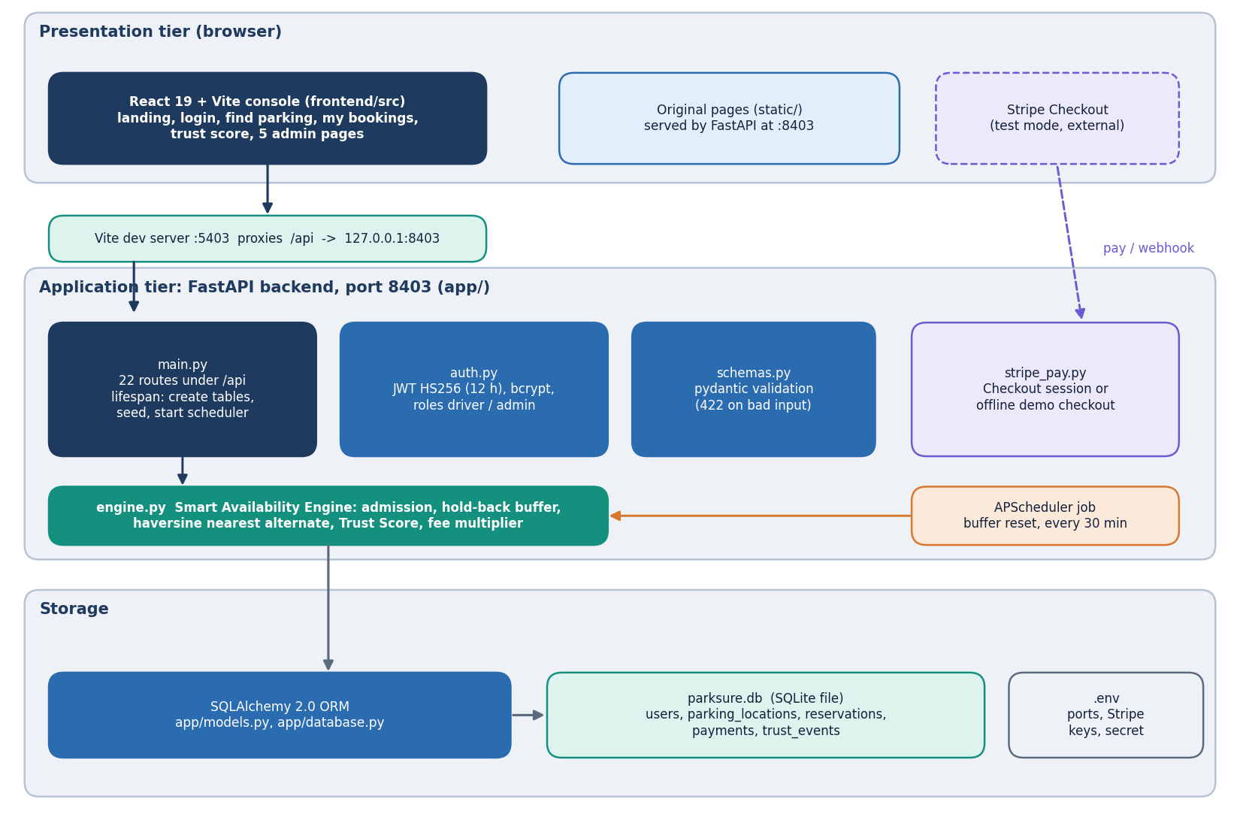
Figure 1: Layered architecture of ParkSure: React console, Vite proxy, FastAPI application with 22 routes, the engine and auth modules, SQLite database, and the Stripe and scheduler side services.
The React console on port 5403 reaches the FastAPI application on 127.0.0.1:8403 through the Vite development proxy, so the browser sees one origin. The application exposes 22 routes in app/main.py. Each route is a thin function: it validates input with pydantic, resolves the caller with a bearer token, calls a function of the engine module or queries the SQLAlchemy session, and returns JSON. The rules themselves live in app/engine.py so that they can be tested without HTTP; the unit tests, the simulator and the Strategy Insights script all import them. The architectural style is a stateless REST interface [24] over one relational store; the only state kept in the server process is the scheduler.
The deliberate gaps in this architecture are worth stating. There is one backend process and one SQLite file, so there is no horizontal scaling and writes are serialised by the database. The admission check and the insert are two separate steps without a lock, which is why the concurrency probe in Chapter 7 found one trial in ten in which two simultaneous requests both took the last bay. The buffer-reset job runs inside the web process, so a second process would run it twice. And entry and exit are software events (the Check in and Check out buttons); there are no barriers, sensors or cameras, so the physical occupancy the arrival check uses is the count of bookings the system itself has marked active.

5.2 High-level workflow
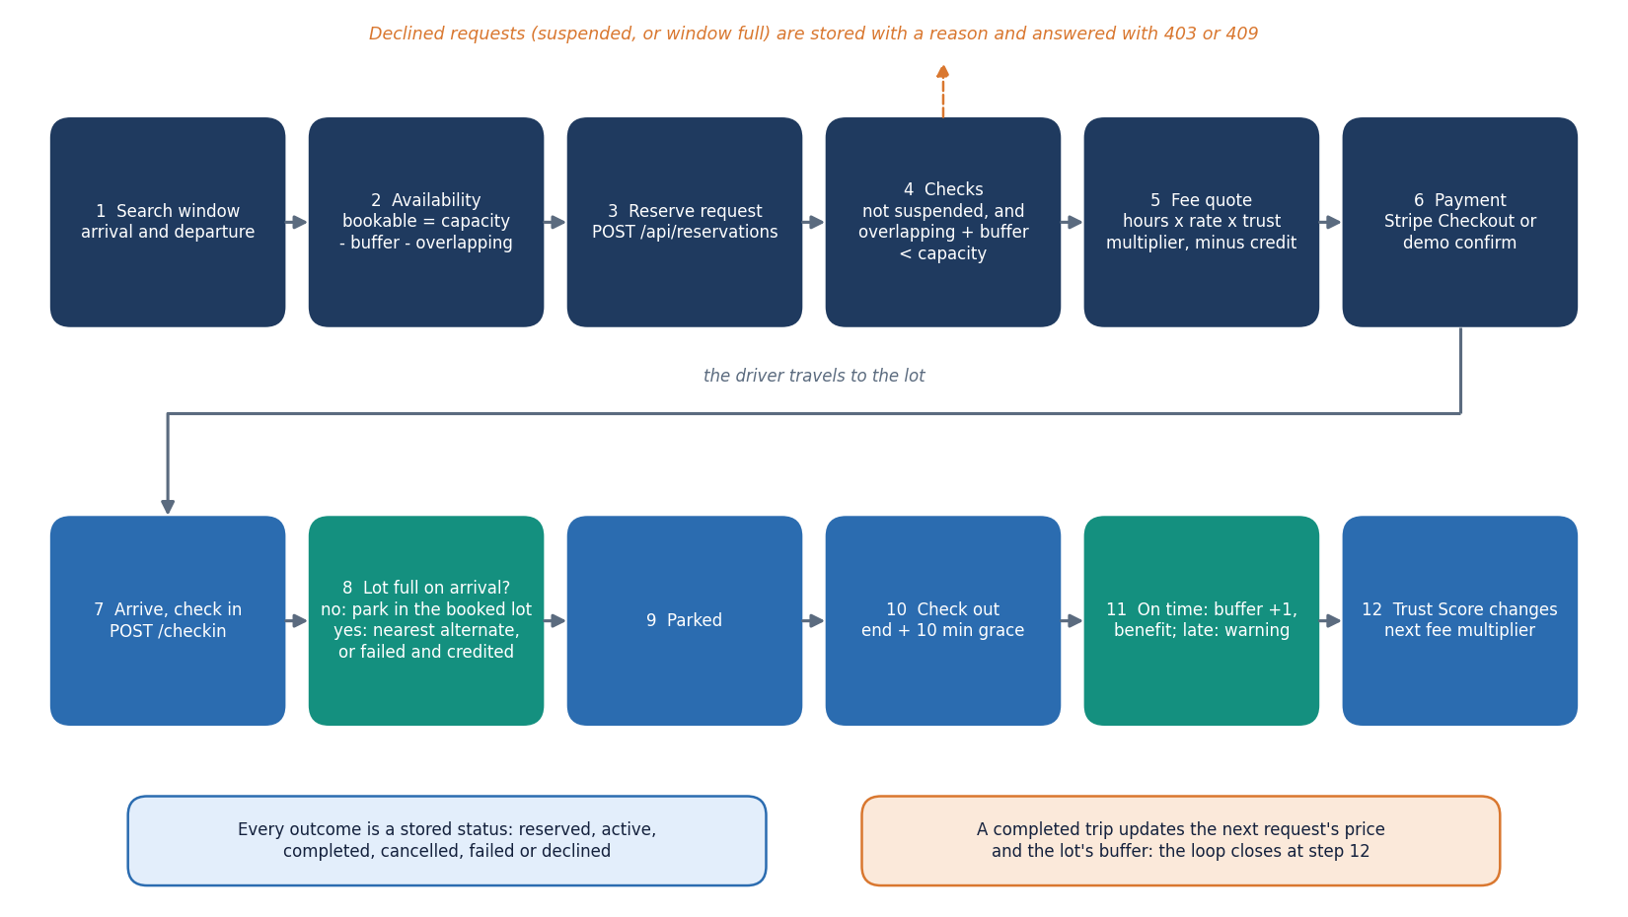
Figure 2: End-to-end workflow: search, reserve, pay, arrive, check in (alternate or fail if full), park, check out, trust update and buffer update.
The workflow has seven stages and every stage maps to a route or a page. Search (GET /api/search, Find parking) shows bookable bays per location for a window. Reserve (POST /api/reservations) applies the suspension check and the admission rule and stores either a reserved or a declined booking. Pay completes through Stripe Checkout in test mode or through the offline demo checkout. Check in (POST /api/reservations/{id}/checkin) activates the booking or triggers the alternate move. Check out judges the departure against the end time plus ten minutes of grace. Trust and buffer update happen in the same call. Analytics (Strategy Insights) replays the stored history for the administrator.
The booking has six states, shown below. Every transition is caused by one API call, and the four final states keep the row for reporting. Two details are easy to miss. A declined request is stored as a row of its own, with the reason in decline_reason, so refused demand is visible to the administrator; and an automatic move to an alternate does not edit the original booking into a new one: the original becomes failed, with the explanation, and a second booking is created as active with parent_id pointing back.
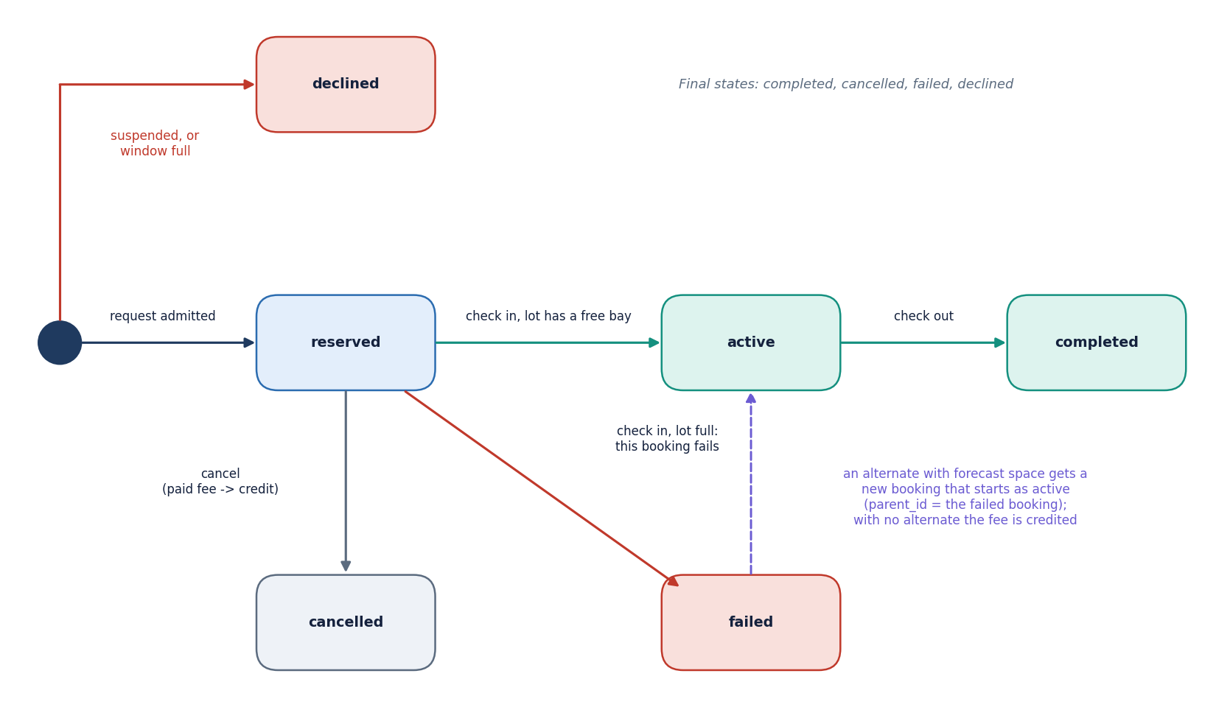
Figure 3: State diagram of a reservation: reserved, active, completed, cancelled, failed and declined, with the events that cause each transition.

5.3 Data flow diagrams

5.3.1 Level 0: context
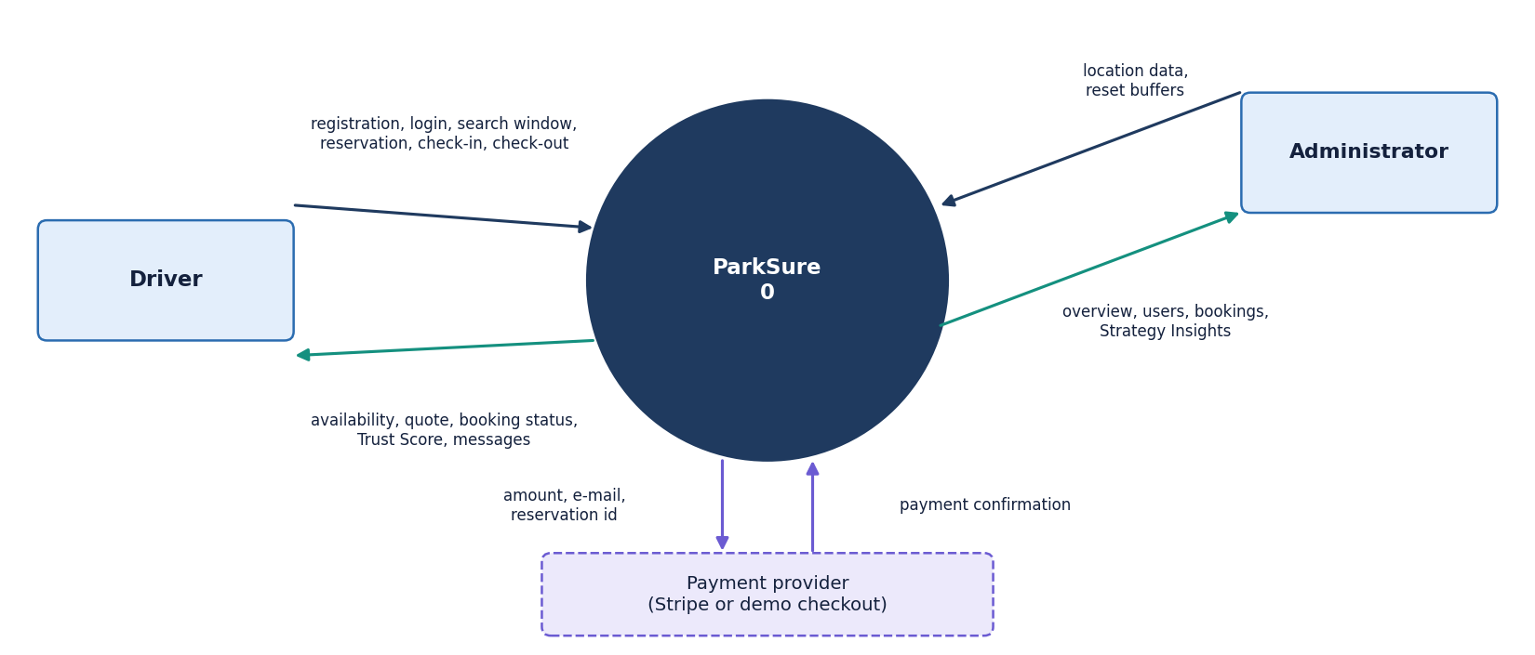
Figure 4: Context diagram (DFD level 0): ParkSure as one process with the driver, the administrator and the payment provider as external entities.
At level 0 ParkSure is one process with three external entities. The driver supplies credentials, search windows and booking actions and receives availability, quotes, booking status, messages and the Trust Score. The administrator supplies location definitions and reset commands and receives overview figures, the user and booking lists and the Strategy Insights replay. The payment provider is Stripe in test mode, or the built-in demo checkout when no key is configured; it receives an amount and a reservation number and returns a confirmation.

5.3.2 Level 1: six processes
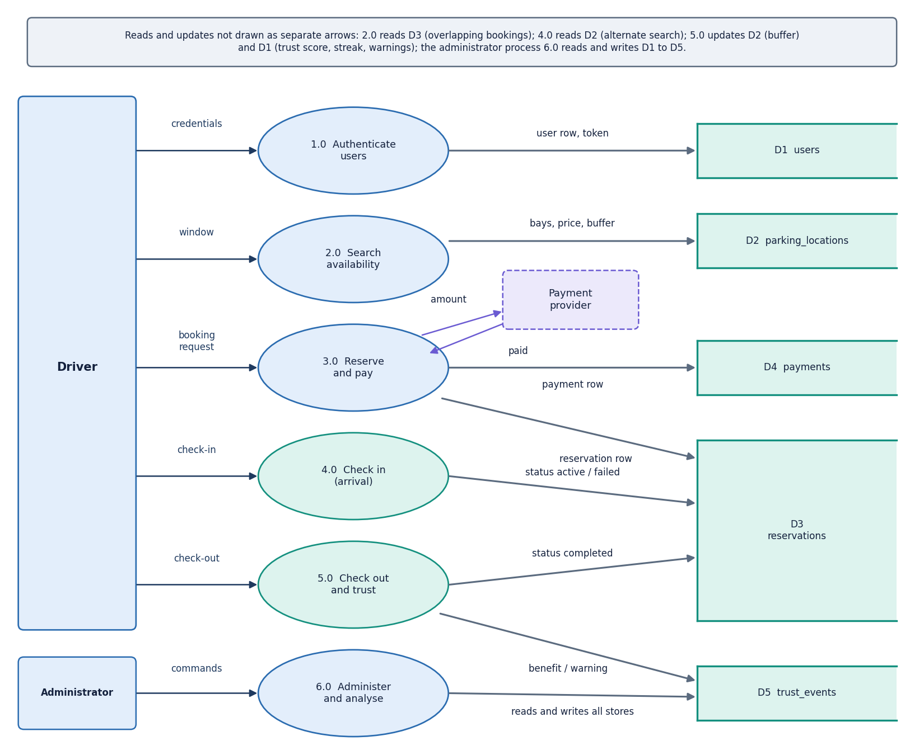
Figure 5: DFD level 1: six processes (authentication, availability search, reservation and payment, check-in and arrival handling, check-out and trust, administration and insights) and the data stores.
Level 1 shows six processes and five data stores. 1.0 Authenticate reads and writes the users store (D1). 2.0 Search availability reads locations (D2) and reservations (D3). 3.0 Reserve and pay writes reservations (D3) and payments (D4). 4.0 Check in reads D2 and D3 and, in the full-lot case, writes a second reservation (D3). 5.0 Check out writes the buffer size back to D2 and appends to the trust events (D5). 6.0 Administer and analyse reads everything and writes only location changes and buffer resets.

5.3.3 Level 2: reservation and payment
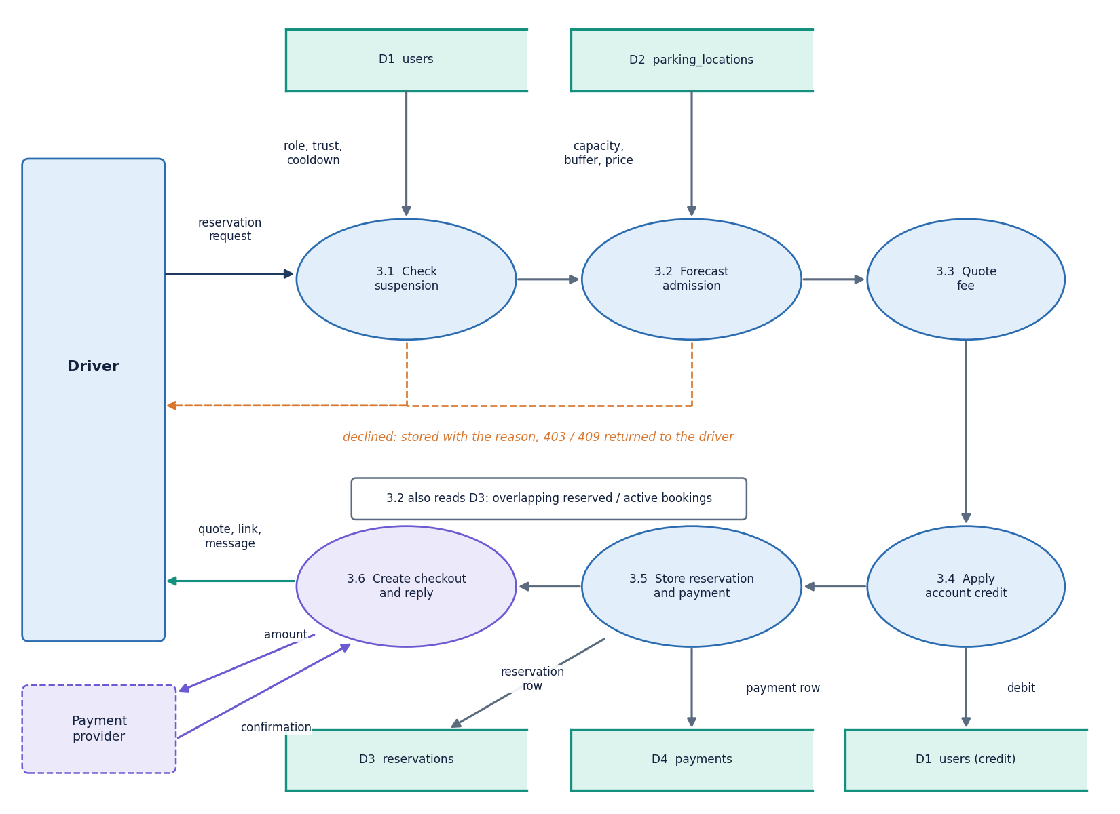
Figure 6: DFD level 2: the reservation and payment process 3.0 expanded into suspension check, forecast admission, fee quote, credit application, payment creation and checkout link.
The reservation process is expanded because it holds the main business rules. Six sub-processes run in a fixed order, and the order matters: the suspension check comes before the admission rule so that a suspended driver never consumes an availability query; the fee is quoted only after admission; and the account credit is applied before the payment row is written, so a booking fully covered by credit is stored as paid and needs no checkout. Both refusals (403 and 409) store a declined booking before raising the error, which is what feeds the declined counter on the admin overview.

5.4 UML design

5.4.1 Class diagram
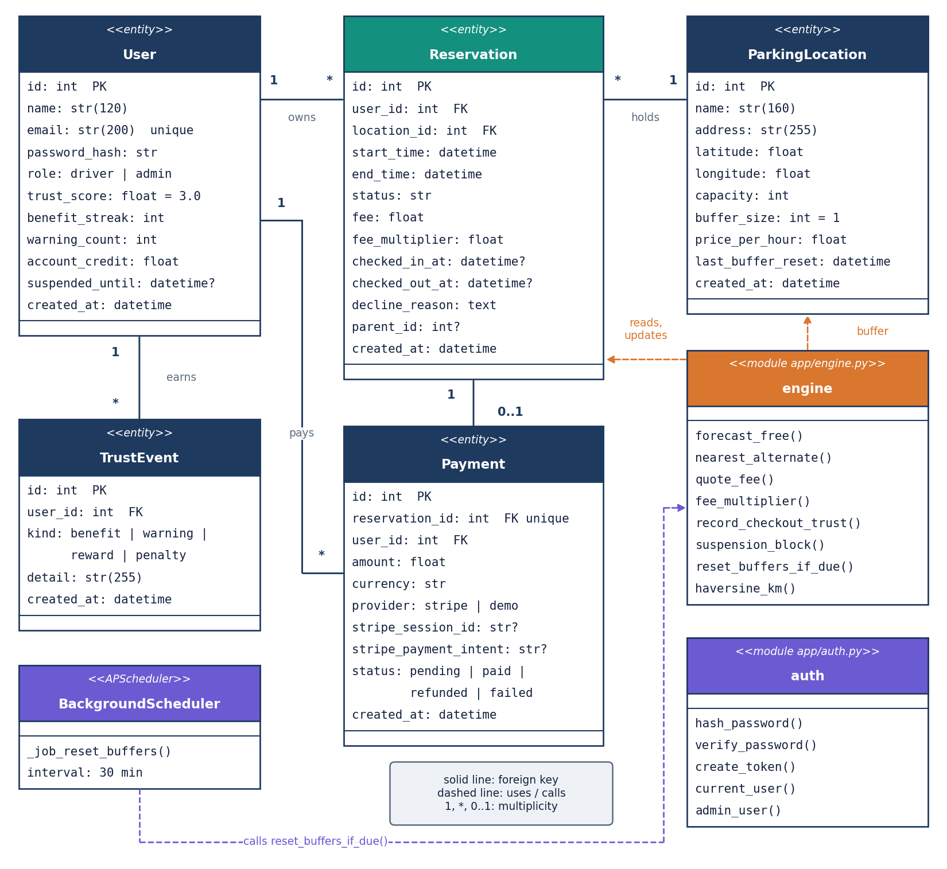
Figure 7: UML class diagram of the five persisted entities (User, ParkingLocation, Reservation, Payment, TrustEvent) and the engine and API modules that operate on them.
The persistence layer is object-relational: five SQLAlchemy classes map to five tables [27]. Behaviour is kept out of the model classes and placed in engine.py as functions that take a session, which makes each rule a plain function that a test can call with an in-memory database. The only other classes are four pydantic input models (RegisterIn, LoginIn, LocationIn, ReservationIn), which carry the length and range limits of the API. The diagram draws the engine, the auth module and the scheduler job as class-like boxes so that the dependencies are visible.

5.4.2 Sequence diagram
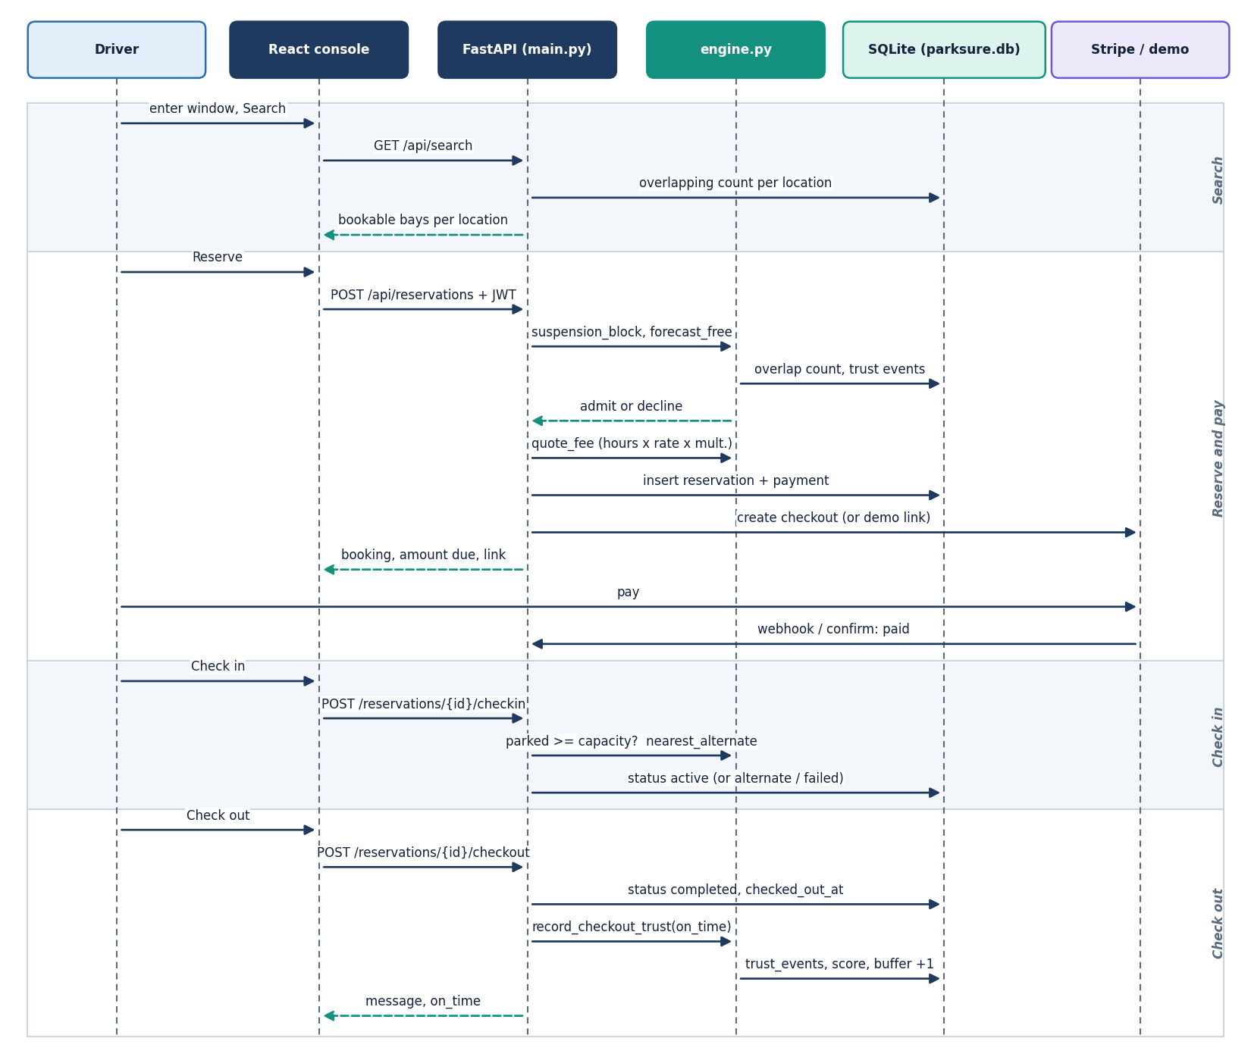
Figure 8: Sequence diagram: reserve, pay, check in, check out and the trust and buffer updates between the driver, the React console, the API, the engine, the database and the payment provider.
The sequence follows one booking from search to check-out. The reservation request passes four gates before any row is written: the token, the existence of the location, the suspension check and the admission rule. The payment is created in the same transaction as the reservation, and the checkout link is requested afterwards, so a failure of the payment provider leaves a booking with a pending payment row instead of a lost booking. At check-out the buffer is updated in the same request as the booking status, then the trust update commits its own events.

5.4.3 Use-case diagram
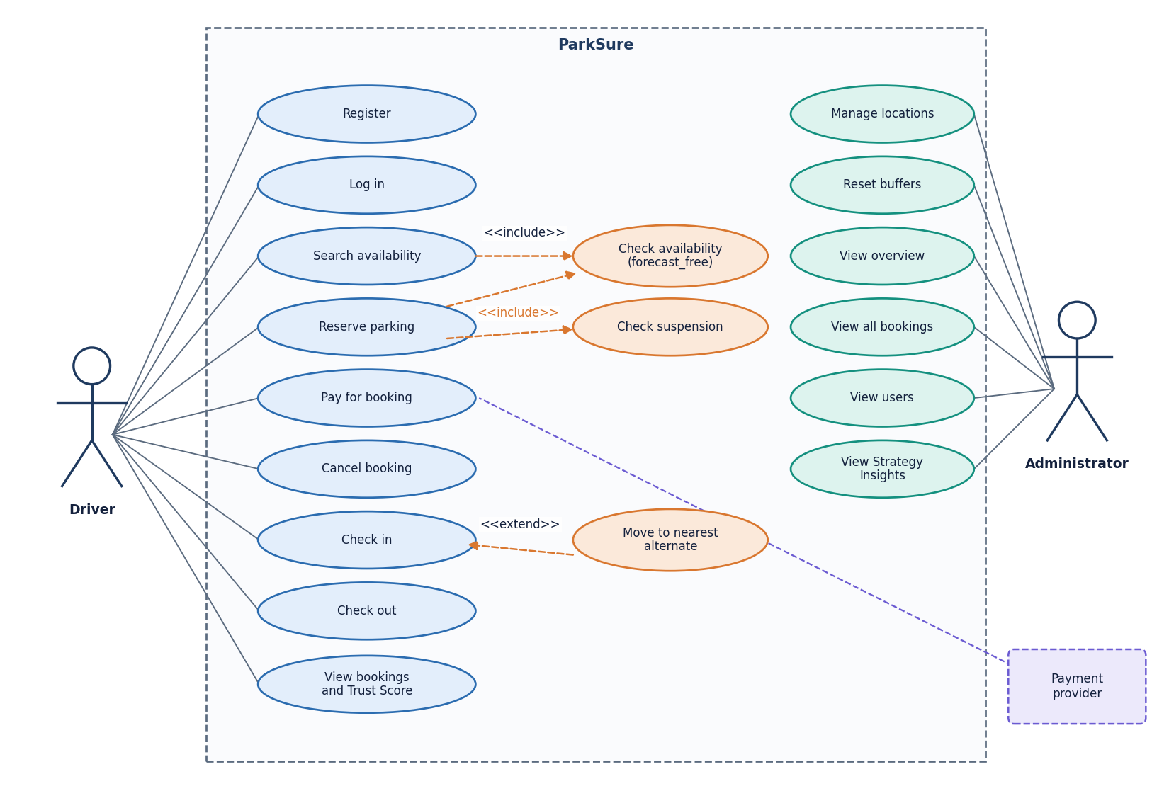
Figure 9: Use-case diagram for the driver, the administrator and the payment provider.
There are two human actors and one system actor. Reserving includes the availability check and the suspension check, and check-in is extended by the alternate move when the lot is full. The administrator account can also use the driver screens (the sidebar shows both groups), but only the admin routes are role-guarded.

5.5 Database design
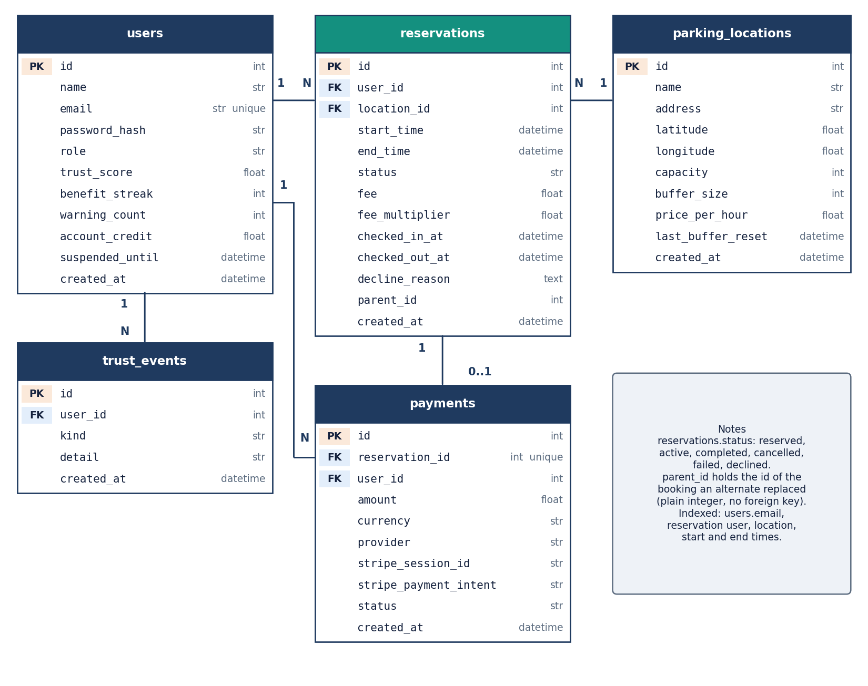
Figure 10: Entity-relationship diagram of the SQLite database: users, parking_locations, reservations, payments and trust_events with keys and cardinalities.
The schema has five tables in one SQLite file, parksure.db; it is created by Base.metadata.create_all at start-up, and the file path can be changed with PARKSURE_DB to point SQLAlchemy at another database. A user has many reservations and many trust events; a location has many reservations; a reservation has at most one payment (a unique foreign key). Deleting a user or a location cascades, through the ORM, to the reservations and events that belong to it.
Table 18: The five tables and their columns.
Table | Columns | Keys, indexes, defaults
users | id, name(120), email(200), password_hash(255), role(20), trust_score, benefit_streak, warning_count, account_credit, suspended_until, created_at | PK id; unique index on email; role driver or admin; trust_score 3.0; streak, warnings and credit 0
parking_locations | id, name(160), address(255), latitude, longitude, capacity, buffer_size, price_per_hour, last_buffer_reset, created_at | PK id; buffer_size 1; price 3.0; capacity limited to 1-5,000 by the schema
reservations | id, user_id, location_id, start_time, end_time, status(30), fee, fee_multiplier, checked_in_at, checked_out_at, decline_reason, parent_id, created_at | PK id; FK user_id and location_id; indexes on user, location, start and end; status reserved; parent_id is a plain integer
payments | id, reservation_id, user_id, amount, currency, provider(20), stripe_session_id, stripe_payment_intent, status(30), created_at | PK id; unique FK reservation_id; provider demo or stripe; status pending, paid, refunded or failed
trust_events | id, user_id, kind(20), detail(255), created_at | PK id; FK user_id (indexed); kind benefit, warning, reward or penalty

Three design points deserve a note. The reservation window is stored as two timezone-aware timestamps and the overlap test is the half-open interval comparison start < other_end AND end > other_start, so a booking that ends at 14:00 does not conflict with one that starts at 14:00. The hold-back buffer is a column of the location, not a computed value, because it is state that grows and is reset by the scheduler. And the fee is stored on the reservation together with the multiplier that produced it, so a later change to the driver's score does not rewrite the price of an old booking.

5.6 Core algorithm design
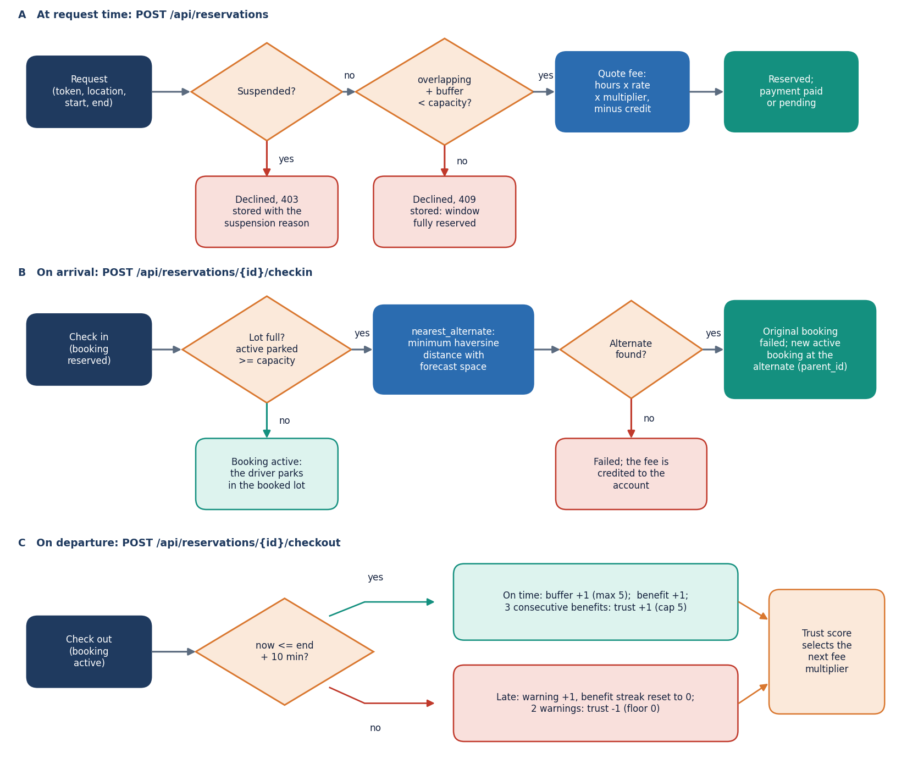
Figure 11: Flowchart of the Smart Availability Engine: suspension check, admission rule, fee quote, arrival check, nearest-alternate search, departure check, buffer growth and trust update.
The engine makes three decisions at three moments. At request time it refuses a suspended driver and applies the admission rule: the number of reserved and active bookings that overlap the window plus the location's buffer must be smaller than its capacity. This is interval-overlap counting, the simplest form of the interval scheduling that [2] attributes to earlier reservation work [7]; the buffer is what turns it into a rule that tolerates overstays. At arrival time it compares the number of bookings marked active at the location with its capacity; if the lot is full it scans every other location, keeps those whose own admission rule would accept the window, and books the one with the smallest great-circle distance [23]. At departure time it compares the checkout instant with the end time plus ten minutes, grows the buffer on an on-time departure and updates the Trust Score.
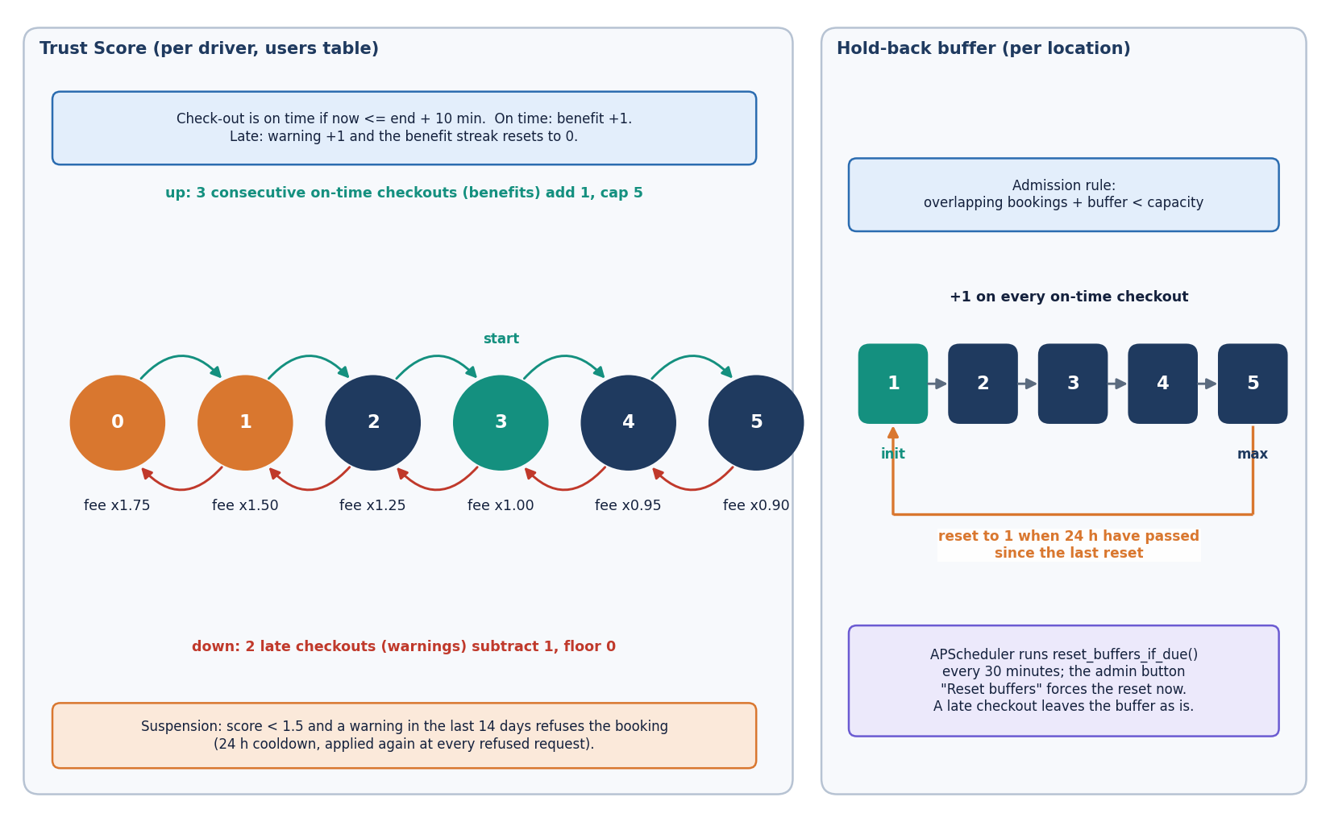
Figure 12: Trust Score state machine (benefit streak, warning count, score 0-5, fee multiplier, suspension rule) and the per-location buffer policy (initial value, growth, cap and daily reset).
The Trust Score and the buffer are the two feedback loops. The score changes the fee multiplier from 1.75 at score 0 to 0.90 at score 5, so a driver who ends sessions late pays more and is eventually suspended; the buffer changes the number of bookable bays at the location. A consequence of the shipped design, measured in Chapter 8, is that the buffer rises when departures are on time, whereas the dynamic rule in [2] raises it when departures are late. The diagram shows the rule as implemented. The design keeps the alternate search simple on purpose, following the same paper: exactly one alternate is offered, because a second alternate would be too far from the driver's destination to be useful.

5.7 Module design
The code is split so that each file has one reason to change. Line counts below were measured from the repository when this report was built.
Table 19: Modules, sizes and responsibilities.
Module | Lines | Responsibility
app/main.py | 440 | FastAPI application: 22 routes, lifespan (create tables, seed, scheduler), static serving
app/engine.py | 141 | Smart Availability Engine: overlap count, admission, haversine, nearest alternate, buffer reset, trust update, suspension, fee quote
app/models.py | 93 | Five SQLAlchemy models: User, ParkingLocation, Reservation, Payment, TrustEvent
app/auth.py | 53 | bcrypt hashing, JWT creation and decoding, current_user and admin_user guards
app/schemas.py | 40 | pydantic input models with length and range limits
app/stripe_pay.py | 35 | Stripe Checkout session in test mode, or the offline demo checkout
app/config.py | 43 | Policy constants (buffer, trust, fee multipliers) and secrets read from the environment
app/database.py | 18 | SQLite engine, session factory and the get_db dependency
app/seed.py | 114 | Seeded demo data: 5 locations, 1 admin, 8 drivers, 60 days of booking history
scripts/compute_buffer_strategy_metrics.py | 119 | Deterministic replay of stored bookings under four buffer policies (Strategy Insights)
scripts/parking_sim.py, scripts/parity.py | 276 | Discrete-event simulator of the reservation rules and its parity check against the engine
scripts/run_experiments.py, scripts/measure_api.py | 205 | Experiments, API latency, concurrency and security probes
scripts/smoke_test.py | 114 | 27-check end-to-end test on a throw-away database
frontend/src/ | 6,494 | React 19 console: 11 page components, UI kit, charts, three.js hero, API client, auth and theme providers
tests/ | 642 | 70 pytest tests (29 engine, 36 API, 5 simulator parity)

5.8 API design
All routes live under /api. Reads are GET and actions are POST; the three location-management routes use PUT and DELETE. Failures return the FastAPI detail string, which the console shows verbatim, so error messages are written for the driver, for example 'Booking paused until ... after a recent late checkout.' or '... is fully reserved for the requested window'. The status codes follow one rule set: 401 means the token is missing or invalid, 403 means the role or the Trust Score does not allow the action, 404 means the object does not exist or does not belong to the caller, 409 means the window is full, 400 means the request is well formed but not acceptable, and 422 means input validation failed.
Table 20: The 22 routes of the ParkSure API.
Method | Path | Who | Purpose | Errors
POST | /api/auth/register | - | Create a driver account (the first account on an empty database becomes admin); returns token and user | 400 duplicate email; 422 validation
POST | /api/auth/login | - | Check the bcrypt hash; returns token and user | 401 wrong email or password
GET | /api/auth/me | user | Profile with trust score, streak, warnings, credit, suspension time | 401
GET | /api/locations | - | All locations, ordered by name | -
POST | /api/locations | admin | Create a location | 403; 422
PUT | /api/locations/{id} | admin | Update a location | 403; 404; 422
DELETE | /api/locations/{id} | admin | Delete a location and, by cascade, its reservations | 403; 404
GET | /api/search | - | Per location: overlapping bookings, bookable bays, available flag for a time window | 400 end before start or window over 30 days; 422
POST | /api/reservations | user | Suspension check, admission rule, fee quote, credit, payment record, checkout link | 403 suspended; 409 full; 404; 400; 422
GET | /api/reservations | user | The caller's reservations, newest window first | 401
POST | /api/reservations/{id}/cancel | owner or admin | Cancel a reserved booking; a paid fee returns as account credit | 404; 400 not cancellable
POST | /api/reservations/{id}/checkin | owner or admin | Activate; if the lot is physically full, move to the nearest alternate or fail and credit | 404; 400 not reserved
POST | /api/reservations/{id}/checkout | owner or admin | Complete; on time or late; buffer and trust update | 404; 400 not active
GET | /api/trust | user | Score, streak, warnings, next reward, fee multiplier and the last 20 trust events | 401
GET | /api/payments/demo-confirm | - | Offline demo checkout link: marks the payment paid | 404
POST | /api/payments/{id}/confirm | owner or admin | Confirm a payment from the console | 404; 403
POST | /api/stripe/webhook | Stripe signature | On checkout.session.completed mark the payment paid | 400 bad signature; inert without keys
GET | /api/admin/overview | admin | Counts of users, locations, reservations, paid revenue, unable-to-park, declined | 403
GET | /api/admin/users | admin | All users with trust and credit | 403
GET | /api/admin/bookings | admin | The 300 most recent reservations | 403
POST | /api/admin/reset-buffers | admin | Reset buffers by policy, or force a reset | 403
GET | /api/admin/insights | admin | Deterministic replay under four buffer policies for a window of days | 403

GET /api/search and GET /api/locations need no login, so that the landing page can show live capacity. GET /api/admin/insights takes a window in days and is the only route that runs a simulation; it replays each location's stored bookings under no buffer, fixed buffers of one and three, and the dynamic rule, and returns the counts per location and in total.

5.9 User interface design
The console has eleven page components: a public landing page, a login page with sign-in and registration tabs, three driver pages (Find parking, My bookings, Trust score), five administrator pages (Overview, Locations, Strategy insights, All bookings, Users) and a not-found page. A role guard hides the administrator group from drivers, and a 401 from the API clears the session and returns to the login page. The visual language is a dark-first interface with a light theme, one accent colour, a three.js hero on the landing page and a static fallback image for users who prefer reduced motion.
Table 21: Pages, routes and the endpoints they use.
Page | Route | Endpoints used
Landing | / | GET /api/locations (live capacity and location names)
Login and registration | /login | POST /api/auth/login, POST /api/auth/register
Find parking | /app/find | GET /api/search, POST /api/reservations, GET /api/trust
My bookings | /app/bookings | GET /api/reservations, POST /api/reservations/{id}/cancel, checkin, checkout, POST /api/payments/{id}/confirm
Trust score | /app/trust | GET /api/trust
Admin overview | /app/admin | GET /api/admin/overview, GET /api/admin/insights
Admin locations | /app/admin/locations | GET, POST, PUT, DELETE /api/locations, POST /api/admin/reset-buffers
Strategy insights | /app/admin/insights | GET /api/admin/insights
All bookings | /app/admin/bookings | GET /api/admin/bookings
Users | /app/admin/users | GET /api/admin/users

Four design rules were applied to every working page. Each page opens with its purpose in one sentence. Long actions show a busy state and finish with a toast, and the toast names the consequence (for example 'Moved to Central Station Garage'). Money and times are formatted the same way everywhere, and a booking's status is a coloured badge with the reason beneath it when it is declined or failed. Errors from the API appear in an inline panel with a retry button. Chapter 8 shows the working pages with real data; the screens below illustrate the design itself.

5.10 Design decisions and trade-offs
Every design has costs. The table records the main decisions, what each bought and what it cost, so that the limitations in Chapter 9 can be traced back to a choice and not to an accident.
Table 22: Principal design decisions.
Decision | Reason | Cost
Keep the rules in engine.py, separate from the routes | Each rule is testable with an in-memory database; the simulator and the replay reuse the same functions | Two rules (buffer growth and the late test) are still written inside the check-out route
SQLite with create_all and seeded data | Zero configuration; a clean database is re-seeded on first start | One writer at a time; no migrations; the admission check and the insert are not atomic
Admit on forecast (overlapping bookings plus buffer), check physical space only on arrival | Cheap, deterministic, explainable to the driver; no sensors needed | The arrival check counts bookings marked active, not real cars; the alternate is booked without re-checking its own bays
One nearest alternate by haversine distance | Follows the base paper; no routing service or external API | Straight-line distance, not driving distance; no choice for the driver
Fee multiplier and suspension from the Trust Score | Gives drivers a price signal for punctuality | A suspended driver is locked out for at least 14 days after the last warning because the check repeats at each request
Stripe test mode with an offline demo checkout | Everything works without keys; the demo is labelled in the interface | The demo confirmation route is not authenticated (Chapter 7 reports it)
Deterministic Strategy Insights replay | The same stored history always gives the same counts, so results can be checked | It replays seeded history; its 45-minute overstay linger is a model, not a measurement

Two further choices concern what was left out. There is no vehicle profile (plate, model) and no downloadable receipt: the batch objectives mention both, and the delivered design stores only the payment record. There is also no live occupancy feed, so 'real-time availability' means the forecast of bookable bays for a chosen window, computed from stored bookings at the moment of the request. These are stated plainly as the gap between the objectives and the delivered design.

CHAPTER 6: METHODOLOGY AND SOFTWARE IMPLEMENTATION

6.1 Overall methodology
ParkSure treats parking reservation as an admission-control problem with feedback. A request is a time interval at a location; the system admits it only if enough bays remain after the already admitted intervals and a hold-back buffer, checks physical space when the driver arrives, and judges the departure afterwards. The punctuality of each departure feeds two memories, the location's buffer and the driver's Trust Score, which shape later admissions and prices. The registered base paper [1] solves a different allocation problem (balancing passengers across zones), so the method follows the reservation, buffer and reward mechanism of [2] and builds the surrounding platform. The method has seven steps.
1. Register and authenticate. A driver registers with a name, e-mail and password (stored as a bcrypt hash) and receives a signed token; the first account on an empty database becomes the administrator.
2. Search. For a chosen window, count the reserved and active bookings that overlap it at each location and report the bookable bays, which are capacity minus buffer minus overlapping bookings.
3. Reserve. Refuse suspended drivers; admit the request only if overlapping bookings plus the buffer stay below the capacity; quote the fee; apply account credit; store the booking and the payment.
4. Pay. Create a Stripe Checkout session in test mode, or the offline demo checkout when no key is configured; mark the payment paid on confirmation.
5. Arrive. On check-in compare the bookings marked active at the location with its capacity. If the lot is full, book the single nearest other location whose own admission rule accepts the window, or mark the booking failed and credit the fee.
6. Depart. On check-out decide on time (within ten minutes after the end) or late; grow the buffer after an on-time departure; record a benefit or a warning and update the Trust Score.
7. Analyse. Replay the stored bookings under four buffer policies (Strategy Insights), and measure the rules with a simulator that was checked against the engine.

6.2 Dataset
ParkSure is a rule-based system. It has no machine-learning model and no external dataset, so there is no training set, validation set or test set in the usual sense, and no dataset licence applies. Two kinds of data are used, and both are generated by the project itself.
The demo database is created on first start by app/seed.py with a fixed random seed (42). It contains 9 users (one administrator and eight drivers, two of whom have an overstay history), 5 locations in Bengaluru coordinates (20, 12, 15, 25 and 8 bays at 4.00, 3.00, 2.50, 5.00 and 2.00 dollars per hour), and 347 reservations spread over the last 60 days plus eight Friday-evening peaks at the smallest lot, which is deliberately over-subscribed so that the Strategy Insights page has contention to replay. Of the reservations, 279 are completed, 39 failed (unable to park) and 29 declined; 279 payments are paid. These records are synthetic. They demonstrate the mechanism; they are not observations of real drivers, and no conclusion about real parking behaviour may be drawn from them.
Table 23: The seeded demo database (fresh install, 2026-10-26).
Quantity | Value
Users | 9 (1 admin, 8 drivers); initial trust 2 for drivers 3 and 6, 4 for drivers 1 and 2, 3 for the rest, 5 for the admin
Locations | 5: Central Station Garage (20 bays), Market Street Lot (12), Riverside Parking (15), Airport Express Park (25), Old Town Deck (8)
Reservations | 347: 279 completed, 39 failed, 29 declined, 0 reserved
Payments | 279, all paid, provider demo
History | 60 days of 2 to 5 requests per day, plus 8 weekly Friday-evening bursts at Old Town Deck
Split | None: there is no model to train, so nothing is held out

The simulator scenario is the second data source. It re-creates the experiment of [2]: 8 parking areas of 10 bays, 80 to 110 vehicles, each making 10 parks of 1 to 3 hours, 25 to 50 percent of the vehicles leaving one hour late, and two stops of 8 to 16 hours outside the system. The base paper ran it in the SUMO traffic simulator [21]; ParkSure's simulator is a discrete-event program, not SUMO, and the parameters the paper does not state (arrival process, lead time, gaps, area choice) are assumptions listed in Section 6.6.
Seeded data are used for the product demonstration, the Strategy Insights replay and the screenshots. The simulator output is used for the buffer comparison in Chapter 8. Neither is real-world evidence, and each report section that uses them says so.

6.3 Input handling and preprocessing
There is no feature extraction, but every request is cleaned before it touches the rules. Four steps do that work.
• Schema validation (pydantic). A name must have 2 to 120 characters, an e-mail must be valid, a password 6 to 128 characters; a location needs a latitude in [-90, 90], a longitude in [-180, 180], a capacity from 1 to 5,000, an hourly price from 0.50 to 100 and a buffer from 0 to 20; a reservation needs a location id of at least 1 and an end time later than the start time. A violation returns 422 with the offending field.
• Normalisation. E-mail addresses are stored in lower case and compared case-insensitively; every timestamp is made timezone-aware in UTC with ensure_tz before it is compared, so a naive time from the database and an aware time from the browser can never be mixed. The console sends ISO-8601 strings converted from the browser's local time.
• Window rules. A window is a half-open interval. Search and reservation reject windows longer than 30 days (400). Billing uses at least 0.25 hours, so a one-minute booking costs a quarter of an hour.
• Seeding. On first start the lifespan hook creates the tables and, if the location table is empty, runs the seeder described in Section 6.2. A repeated start does not seed again; deleting parksure.db restores the demo state.
Two things are not checked. A reservation may start in the past (the probe in Chapter 7 shows a window two days ago was accepted), and check-in is not restricted to the booked window (a booking 25 days ahead could be checked in at once). Both are listed as limitations.

6.4 Algorithm choice and justification
The literature offers several ways to allocate parking. The table below sets them against the requirements of this project: a general platform for ordinary urban lots, with a fixed price, no sensors, a response time in milliseconds and rules a driver can understand.
Table 24: Alternatives considered and the reason for the choice.
Approach | Source | What it needs | Decision for ParkSure
Interval-overlap admission with a hold-back buffer | [7], [2] | Booking intervals and a capacity | Chosen: one count and one comparison per request; the buffer absorbs overstays
Auction-based allocation (ASAP, MaPark, bidding) | [5], [6], [8] | Bidding agents or a central auctioneer | Rejected: prices should be fixed and visible before booking
Multi-objective integer programming | [12] | Distances, congestion model, a solver | Rejected: needs inputs and run time that an ordinary lot does not have
Passenger-count grouping heuristics | [1] | Passenger counts, sensing, zone structure | Not adopted: solves zone load balancing inside one facility, a different problem
Deposit to deter false bookings | [11] | Partial payment | Not adopted: the Trust Score prices behaviour instead
Nearest alternate by great-circle distance | [2], [10], [23] | Coordinates of each lot | Chosen: no routing service, one decision, deterministic

Why interval overlap. Counting overlapping reservations is exact for the question 'will a bay be free at the start of this window if everyone leaves on time', it is linear in the number of bookings at one location, and it is the basic form of interval scheduling [22]. Its weakness is the one named by [2]: an overstaying driver breaks the assumption. Why a buffer. A buffer of bays that are never booked in advance but remain physically available turns that weakness into a controllable margin: a larger buffer refuses more requests and protects more arrivals. Why one nearest alternate. The paper argues that a second suggestion would usually be too far from the driver's destination; the code follows that rule. Why a Trust Score. A star rating that moves slowly (three benefits for a point, two warnings to lose one) gives a price signal and a last-resort sanction without any hardware. None of these choices is claimed to be optimal; Chapter 8 measures what each one does and where the shipped version departs from the paper.

6.5 Mathematical formulation
Let a location l have capacity C, buffer b and hourly price p. A booking r has window [s_r, e_r) and status in {reserved, active} while it holds a bay. For a request with window [s, e):
O(l, s, e) = | { r at l : status(r) ∈ {reserved, active}, s_r < e, e_r > s } | (2)
admit(l, s, e) ⇔ O(l, s, e) + b < C bookable(l, s, e) = max(0, C − b − O(l, s, e)) (3)
The search route reports bookable(l, s, e) and the available flag (bookable > 0), which is equivalent to the admission inequality. The fee uses the duration h = (e - s) in hours and the multiplier m of the driver's rounded Trust Score τ:
fee = round( max(0.25, h) × p × m(τ), 2 ) m = {0: 1.75, 1: 1.50, 2: 1.25, 3: 1.00, 4: 0.95, 5: 0.90} (4)
Account credit c is applied before payment: credit used = min(c, fee), amount due = fee minus credit used. On arrival at location l the engine counts the active bookings A(l) and, if A(l) ≥ C, selects the alternate with the smallest haversine distance [23] among the locations whose own admission rule accepts the window:
d = 2R · arcsin( √( sin²((φ₂ − φ₁)/2) + cos φ₁ · cos φ₂ · sin²((λ₂ − λ₁)/2) ) ), R = 6371 km (5)
alternate = argmin d(l, l′) over l′ ≠ l with admit(l′, s, e) (none: booking fails, fee credited) (6)
At check-out at time t_out the departure is on time if t_out ≤ e + 10 minutes. With cap B_max = 5 and initial buffer b₀ = 1 the buffer update is b := min(b + 1, B_max) after an on-time departure, and b := b₀ once 24 hours have passed since the last reset (the scheduler checks every 30 minutes). The Trust Score τ, the benefit streak u and the warning count w, with B = 3, W = 2, τ in [0, 5] and the initial τ = 3, change as follows:
on time: u := u + 1; if u ≥ 3 then τ := min(τ + 1, 5) and u := 0 (7)
late: u := 0; w := w + 1; if w ≥ 2 then τ := max(τ − 1, 0) and w := 0 (8)
A driver is refused when the suspension cooldown is running, or when τ < 1.5 and a warning event was recorded within the last 14 days; in the second case a 24-hour cooldown is started. Because the check is repeated at every request and a refused request records no new benefit, a driver whose score has fallen below 1.5 cannot recover it by booking, so the practical lockout lasts until the last warning is 14 days old.

6.6 Engine parameters, simulator and parity check
In place of a trained model, ParkSure has a small set of policy parameters, all set in app/config.py and overridable by environment variables. They are fixed during every measurement in this report.
Table 25: Policy parameters of the Smart Availability Engine.
Parameter | Value | Meaning
BUFFER_INIT / BUFFER_MAX / BUFFER_RESET_HOURS | 1 / 5 / 24 | Initial buffer, cap, and the interval after which the scheduler resets it
Scheduler interval | 30 minutes | How often the reset job checks every location
BENEFIT_STREAK_FOR_REWARD (B) / WARNINGS_FOR_PENALTY (W) | 3 / 2 | Benefits needed for +1 trust; warnings that cost -1
TRUST_START / TRUST_MIN / TRUST_MAX | 3.0 / 0 / 5 | Trust range
TRUST_SUSPEND_THRESHOLD / RECENT_VIOLATION_DAYS / SUSPEND_COOLDOWN_HOURS | 1.5 / 14 / 24 | Suspension rule
FEE_MULTIPLIER | 1.75, 1.50, 1.25, 1.00, 0.95, 0.90 | Multiplier for trust 0 to 5
On-time grace | 10 minutes | Hard-coded in the check-out route
Booking length limit | 30 days | Hard-coded in _require_future_window

Simulator configuration. scripts/parking_sim.py is a discrete-event simulator with three event types: request, arrival and departure. It uses the engine's pure functions directly and re-implements the stateful rules (admission, trust update, suspension) on plain numbers. Each experimental cell runs 30 seeds (the paper used 5). The settings fixed before the runs were:
Table 26: Simulator settings and the assumptions the base paper does not state.
Setting | Value
Areas and bays | 8 areas x 10 bays, on a 4 x 2 grid 0.012 degrees (about 1.3 km) apart
Population and behaviour | 80, 90, 100 or 110 vehicles (or a random 80 to 110); 25 to 50 percent leave one hour after the reserved end
Parks per vehicle | 10, each planned for 1 to 3 hours; two stops of 8 to 16 hours outside the system
Assumed by the project | Reservation placed 15 to 60 minutes before arrival; next request 15 to 60 minutes after leaving; uniform choice of area; first request within 2 hours; every driver checks in on time
Policies compared | Static buffer 0, 1 and 3; dynamic as shipped (grows on an on-time departure); dynamic as in the paper (grows on a late departure); each with the Trust Score on or off
Outcomes counted per run | Refused by admission (no reservation), refused by suspension, moved to an alternate, alternate physically full, no park, success rate, bay utilisation

Parity check. A simulator is only evidence if it behaves like the product. scripts/parity.py feeds the same random inputs to the simulator's rules and to the real engine functions on an in-memory database and compares every decision: 2,000 admission decisions, 8,000 trust updates and 300 suspension decisions, 10,300 in all, with 0 mismatches. The same check runs as 5 tests in tests/test_sim_parity.py. What the parity check does not cover is the arrival and alternate logic, which the simulator mirrors by reading the code, and the scheduler's 30-minute granularity, which the simulator approximates by resetting at the first event after 24 hours.
Cost of the decisions. On an in-memory database with 5,000 reservations, the admission decision takes 0.3337 ms on average (p95 0.4573 ms), one haversine distance takes about a microsecond, and the nearest-alternate search over 49 other locations takes 18.623 ms (p95 23.4802 ms) because it runs one overlap query per location.

6.7 Application architecture
The product is a single backend process and a browser console. The FastAPI application (app/main.py, port 8403) [28] exposes the 22 routes and also serves the original vanilla pages from static/. The React 19 console (port 5403, Vite) is the interface used in this report. SQLAlchemy 2 maps the five tables to SQLite [27]; APScheduler runs the buffer-reset job; python-jose signs the tokens; bcrypt hashes the passwords; the Stripe SDK creates Checkout sessions.
The backend is organised around one idea: a route does only HTTP work and the rules live in the engine. Every route that changes data receives a database session through the get_db dependency, which opens a session per request and closes it afterwards. Protected routes add the current_user or admin_user dependency. The lifespan hook creates the tables, seeds an empty database and starts the scheduler, and stops it again on shutdown.
def forecast_free(db, loc, start, end) -> bool:
"""A slot will be free at arrival if overlapping bookings + buffer < capacity."""
used = overlapping_count(db, loc.id, start, end)
return (used + loc.buffer_size) < loc.capacity

The console reads the session from a React context. The token is kept in the browser's local storage (every access is wrapped in try/catch so a blocked storage only shortens the session); a single api() wrapper adds the bearer header, turns FastAPI error details into readable messages and reports status 0 when the server cannot be reached ('Cannot reach the ParkSure server. Make sure the backend is running on port 8403.'). A 401 on an authenticated call clears the session. Pages are loaded lazily by route.

6.8 API design
Chapter 5 lists the 22 routes. This section shows the exchange that matters most, the reservation. The request is a three-field document. The response is the booking as the console displays it plus the payment information, so the page needs no second call. The exchange below was recorded from the running application on 2026-10-26 (Market Street Lot, two hours at 3.00 dollars an hour, a driver with Trust Score 3).
POST /api/reservations Authorization: Bearer <token>
{ "location_id": 2, "start_time": "2026-11-02T09:00:00+00:00", "end_time": "2026-11-02T11:00:00+00:00" }

200 OK
{ "id": 355, "location_id": 2, "location_name": "Market Street Lot",
"start_time": "2026-11-02T09:00:00+00:00", "end_time": "2026-11-02T11:00:00+00:00",
"status": "reserved", "fee": 6.0, "fee_multiplier": 1.0,
"checked_in_at": null, "checked_out_at": null, "decline_reason": "", "parent_id": null,
"payment_status": "pending", "payment_provider": "demo",
"credit_applied": 0.0, "amount_due": 6.0,
"checkout": { "url": "/api/payments/demo-confirm?session_id=demo_71d377a3e477&reservation_id=355",
"session_id": "demo_71d377a3e477", "provider": "demo" },
"stripe_configured": false }

When the window is full the same route answers with a conflict and stores a declined booking, so the refusal is visible on the administrator's overview:
409 Conflict
{ "detail": "Kiosk Bay is fully reserved for the requested window (capacity 1, hold-back buffer 0). Please
try another time or location." }

The search route returns, for each location, the numbers the cards show: capacity, buffer_size, overlapping, bookable and available. The check-in route returns {moved, reservation, message} and, when the booking was moved, alternate and distance_km; when no alternate exists it returns {moved: false, failed: true, reservation, message}. The trust route returns the score, streak, warnings, next_reward_in, fee_multiplier and the last 20 events.
Measured behaviour (127.0.0.1, single process, SQLite, 200 sequential requests per endpoint; Chapter 7 gives the full table): search 5.7 ms mean, reservation 19.6 ms, check-in 14.9 ms, check-out 14.6 ms, login 220 ms (bcrypt cost 12, intentionally slow), the administrator's insights replay 60 ms. Two routes are slow because they build each row with two further queries: the driver's booking list (180 ms for about 400 stored rows) and the administrator's list of the 300 latest bookings (273 ms). Eight parallel clients reached 131 search requests per second.

6.9 Security and error handling
ParkSure is a multi-user application and its security model is correspondingly larger than a single-user tool's. We list what exists, and then what the project's own probes found missing.
• Passwords. Hashed with bcrypt (cost 12) [26]; the plain password is never stored or logged. A failed login returns the same message for an unknown e-mail and a wrong password.
• Sessions. A JSON Web Token [25] signed with HS256 carries the user id, the role and a 12-hour expiry. Authorisation does not trust the role claim: admin_user reads the role from the database on every request.
• Role guards and ownership. Eight routes need a login and eight need the admin role (the five administrator routes and the three location-management routes). A driver who asks for another driver's booking gets 404, not 403, so the existence of a booking is not revealed.
• Input validation. pydantic limits on every body (Section 6.3); the ORM uses bound parameters, so the injection payloads tried in Chapter 7 returned 422 and no server error.
• Payments. Card data never reaches ParkSure: Stripe Checkout hosts the form, and the webhook verifies the Stripe signature before marking a payment paid. Without keys the webhook route is inert and the offline demo checkout is used.
• Failure behaviour. Business refusals are stored (declined, failed) and answered with a specific status and message; unknown objects answer 404; the console shows the message verbatim and offers a retry.
What the probes found. Run against a throw-away database on 2026-10-26, and read together with the code, they showed eight weaknesses or gaps, which we report as facts. (1) GET /api/payments/demo-confirm is unauthenticated and marked a pending payment as paid. (2) A token signed with the shipped default secret parksure-dev-secret-change-in-production was accepted for the administrator; the secret must be set with PARKSURE_JWT_SECRET in any real deployment. (3) Thirty wrong passwords in a row were all answered 401 and the correct password then worked: there is no lockout or rate limit. (4) A booking window two days in the past was accepted. (5) A booking 25 days ahead could be checked in at once. (6) The cross-origin policy allows every origin. (7) A user name containing markup is stored verbatim; the React console escapes it when it renders. (8) With 20 simultaneous requests for a window that had exactly one bookable bay, 1 of 10 trials accepted two bookings, because the admission check and the insert are not one atomic step. None of these was changed in the product during this documentation; Chapter 9 lists them as known limitations and Chapter 10 the fixes (a database lock or unique slot rows, an authenticated payment callback, a required secret, a rate limiter, and window checks).
The automated tests cover the role guards, the ownership rule, the validation errors, the 403 and 409 refusals, the cancellation refund and the suspension path (36 API tests and 29 engine tests, all passing).

6.10 Installation and execution
The project needs Python 3.11 or newer and Node.js 20 or newer. requirements.txt lists fastapi, uvicorn, sqlalchemy, pydantic with e-mail validation, pydantic-settings, python-jose, passlib with bcrypt, bcrypt, apscheduler, stripe, python-multipart, reportlab, playwright and httpx2. The measurements in this report were taken with Python 3.14.7 in the project's virtual environment, FastAPI 0.141.1, SQLAlchemy 2.0.52, bcrypt 5.0.0, APScheduler 3.11.3 and Node.js 24.19.0.
1. Open the folder 8.ProjectCode. The ports (backend 8403, frontend 5403) are fixed in run.bat and vite.config.js; the policy and Stripe settings of app/config.py are read from environment variables (the backend does not read the .env file), and every one has a default, so none is required.
2. Run run.bat. It checks Python and Node, creates .venv if absent, installs requirements.txt, runs npm install in frontend/ if needed, starts the backend with uvicorn on 8403 and the Vite dev server on 5403 in two console windows, waits up to 60 seconds for both to answer, and opens the browser.
3. Open http://127.0.0.1:5403 and sign in with driver1@parksure.app / driver123 or admin@parksure.app / admin123, or register a new account.
4. To start from the demo state again, stop the backend, delete parksure.db and start it again; the tables are re-created and re-seeded.
5. To check an installation run python scripts/smoke_test.py (27 checks on a throw-away database) and python -m pytest tests -q (70 tests; pip install pytest first).
Appendix B gives the same instructions as a user guide with the screens. Two practical notes: the first start of run.bat takes several minutes because of the package downloads, and a fresh environment may install newer package versions than those recorded above, which is why the versions are listed. The Docker files run the backend and the original static pages only, not the React console.

CHAPTER 7: SYSTEM TESTING

7.1 Testing strategy
ParkSure was handed over as a working web application with one smoke script and a screenshot script, and no automated test suite. The documentation run added a pytest suite and the measurement scripts used in Chapter 8. The testing follows the structure of the code. The Smart Availability Engine in app/engine.py is a set of small functions with exact, checkable rules (the admission inequality, the haversine distance, the fee multiplier, the Trust Score counters, the suspension rule, the buffer reset), so it is tested at unit level with assertions whose right answer is known in advance. The 22 API routes are tested through FastAPI's test client against a throw-away SQLite database that the application seeds on start. A smoke script walks the complete driver and admin flow, and a separate set of probes measures latency, concurrency and a few security questions against a running server.
Table 27: Test levels, tools and results.
Level | Tool and scope | Count | Result
Unit | pytest, tests/test_engine.py: haversine, fee multiplier and quote, admission rule, nearest alternate, Trust Score, suspension, buffer reset, policy constants | 29 tests | All passed
API / integration | pytest with the FastAPI test client, tests/test_api.py: authentication, role guards, locations, search, reservations, check-in and check-out, payments, admin | 36 tests | All passed
Simulator parity | pytest, tests/test_sim_parity.py: the experiment simulator against the real engine (admission, trust, suspension), determinism, one outcome per request | 5 tests | All passed; 10,300 decisions compared, 0 mismatches
Functional / smoke | scripts/smoke_test.py: register, search, reserve, pay, check in, check out, trust, cancel and the admin screens on a throw-away database | 27 checks | 27 of 27 passed
Screens | Playwright walk of the React console on a fresh seeded database (scripts/capture_docs_screens.py) | 24 screenshots | Rendered with real application data (Section 7.8)
Performance, concurrency, security | scripts/measure_api.py against a live server on 127.0.0.1 | 12 endpoints x 200 calls; 10 race trials; 8 probes | Sections 7.5 and 7.7

The complete suite of 70 tests passed (70 passed, none failed). Everything was run on one machine: a 12th-generation Intel Core i5-12500 (6 cores, 12 threads) with 15.7 GB of memory, Windows 11 and Python 3.14.7, with FastAPI 0.141.1 and SQLAlchemy 2.0.52. Timings were taken while other programs were running on the same machine and are indicative.

7.2 Unit testing
The file tests/test_engine.py holds 29 tests, and all of them passed. They run against an in-memory SQLite database that is separate from the one used by the API tests, and each test builds only the locations, users and bookings it needs, so one rule is checked at a time. Windows are placed days in the future so that no test depends on the clock.
Table 28: Unit tests of the engine, grouped by rule (tests/test_engine.py).
Rule (tests) | What is asserted
Haversine distance (3) | The distance from a point to itself is zero; London to Paris comes out at about 343.5 km (within 1.5 km); the distance is the same in both directions
Fee multiplier (6 + 1 + 2 tests) | Scores 0 to 5 map to 1.75, 1.50, 1.25, 1.00, 0.95 and 0.90; scores outside the range are clamped; a two-hour booking at $4.00 per hour costs $8.00 at score 3 and $7.20 at score 5; a one-minute booking is billed as 0.25 hour ($1.00)
Admission rule (3) | With capacity 3 and buffer 1 the third booking in the same window is refused (2 + 1 is not below 3); bookings in other windows and cancelled bookings are not counted; with buffer 0 a location can be filled completely
Nearest alternate (3) | A location that can never be admitted (capacity 1, buffer 1) is skipped; the closer of two eligible locations is chosen and its distance equals the haversine value; with every other location excluded the answer is none and the distance is 0
Trust Score (5) | Three on-time checkouts raise the score from 3 to 4 and write three benefit events and one reward event; the score never exceeds 5 or falls below 0; two late checkouts lower it by one; a late checkout resets the benefit streak
Suspension (3) | A driver in good standing is not blocked; a low score without a recent warning is not blocked; a score of 1 with a recent warning is blocked, a cooldown time is stored, and the cooldown keeps blocking
Buffer reset (2) | A buffer of 4 whose last reset is 25 hours old returns to 1; one reset 3 hours ago is left at 4
Policy constants (1) | Initial buffer 1, maximum 5, reset every 24 hours, 3 benefits and 2 warnings, start score 3.0 and suspension threshold 1.5 are the documented values

The admission test fails if the inequality in forecast_free is changed from strict to non-strict, which would silently let the buffer be booked, and the trust tests fail if a late checkout does not reset the benefit streak.

7.3 Integration and API testing
The file tests/test_api.py holds 36 tests, and all of them passed. A session-scoped test client starts the real application, which creates the tables and seeds the demo data, so the tests exercise the same start-up path as a user. They cover the routes in the order a driver meets them.
Table 29: API and integration tests by area (tests/test_api.py).
Area (tests) | What is asserted
Authentication (10) | The seeded admin and driver can log in; a wrong password and an unknown user answer 401; a duplicate e-mail (compared without regard to case) answers 400; a short name, an invalid e-mail and a short password answer 422; /api/auth/me needs a valid token; a new driver starts at trust 3.0; passwords are stored as bcrypt hashes
Role guards (2) | A driver receives 403 on every admin route and on admin writes; an anonymous reservation request receives 401
Locations (1) | Create, update, validation (latitude 95 is refused), 404 on an unknown location, delete and a second delete
Search (2) | A location with capacity 5 and buffer 1 shows 4 bookable bays, and 3 after one booking; end before start and a window over 31 days answer 400 and a missing parameter 422
Reservations (8) | The fee uses the trust multiplier (2 h at $5.00 is $10.00 at multiplier 1.0); a full window returns 409 and stores a declined booking; end before start gives 422; an unknown location 404; a window over 30 days 400; cancelling a paid booking refunds the fee to account credit and a second cancel answers 400; credit offsets the next fee; another user's booking cannot be cancelled or checked in (404)
Check-in and check-out (5) | An on-time round trip completes the booking, grows the location's buffer from 1 to 2 and writes a benefit event; checkout without check-in and a second check-in answer 400; a late checkout records one warning; with a one-bay location occupied the second driver is moved to the nearest alternate, 0.5 to 2 km away, with parent_id set; with no alternate the booking is marked failed and the fee is credited
Suspension (1) | A driver with score 1.0 and a recent warning receives 403 with the pause message
Payments (2) | Demo confirmation sets the payment to paid; the Stripe webhook is inert (received: false) when no key is configured
Admin (5) | Overview fields and user count; four strategies in Strategy Insights with the policy init 1, max 5, reset 24; two calls with the same input give identical totals; reset sets every buffer to 1; a new registration on a seeded database is a driver, not an admin

A further 5 tests (tests/test_sim_parity.py) check the simulator used for the experiments of Chapter 8 against the real engine. scripts/parity.py replays 2,000 admission decisions on five capacity and buffer settings, 8,000 trust updates for 200 simulated drivers, and 300 suspension decisions in the engine and in the simulator, and compares them one by one: 0 mismatches in 10,300 decisions. This shows that the rules the simulator applies are the product's rules, not that it is a good model of drivers.

7.4 Functional testing with the smoke script
scripts/smoke_test.py starts the application on a throw-away database, so the real parksure.db is untouched, and runs 27 checks, 27 of which passed. It is written from the driver's point of view: reject a bad password, register, reject a duplicate e-mail, read the profile, list the seeded locations, search, reject an end time before the start, reserve, receive a checkout, confirm the demo payment, check in, check out on time, read the trust events, reserve a second booking and cancel it with a refund, refuse a second cancel, list the bookings, refuse a window over 30 days, and confirm that a driver cannot reach the admin routes. It then signs in as the administrator and checks the overview, the user list, the booking list, the four strategies of Strategy Insights, adding, editing and deleting a location, and resetting the buffers. A twenty-eighth, optional check confirms that the Vite development server proxies /api to the backend; it is skipped when the dev server is not running, as it was in this run.

7.5 Security testing
Authentication uses bcrypt password hashes (cost 12) and signed JWT tokens that expire after 12 hours; roles are enforced by a dependency on every admin route. scripts/measure_api.py sends eight probes to a running server on a throw-away database. They were written by the project team to test its own system; they are not a penetration test and they were chosen from what the code suggested might be weak.
Table 30: Security probes and what they showed.
Probe | Observed | Reading
Unauthenticated GET /api/payments/demo-confirm on a pending booking | HTTP 200; payment status changed from pending to paid | Defect: the demo-checkout endpoint takes no token, so anyone who knows a booking number can mark it paid
Token forged with the shipped default JWT secret, sent to /api/admin/overview | HTTP 200; accepted: Yes | Defect when the secret is not changed: the development secret in config.py is public; production must set PARKSURE_JWT_SECRET
30 wrong passwords in a row, then the right one | All 401: Yes; correct login afterwards: HTTP 200 | Gap: no lockout and no rate limit on login (each attempt costs about 220 ms of bcrypt work, which slows guessing only slightly)
SQL-injection style text in the login e-mail, the login password and the search time | HTTP 422, 422 and 422; server error: No | Passed: input is validated by pydantic and every query is built by the ORM with bound parameters
Another driver cancels a booking that is not theirs | HTTP 404 | Passed: an unknown or foreign booking answers 404 and reveals nothing
Booking window two days in the past | HTTP 200; accepted: Yes | Gap: only the 30-day length limit is checked, not that the start lies in the future
Check-in 25 days before the booked window | HTTP 200; accepted: Yes | Gap: check-in is not tied to the booked window, so a bay can be occupied long before the booking starts
Script tag as a user name | HTTP 200; stored verbatim: Yes | Acceptable for the React console, which escapes text when it renders; a different client would have to escape it itself

Four of the eight probes are findings against the product, not passes: the unauthenticated demo-confirm route, the default signing secret, the missing login throttle and the unchecked booking and check-in times. They are reported here and again in Chapters 8 and 9 because they limit what can honestly be claimed about the objective of secure online payment. None was corrected in the code during the documentation run. The demo route exists so that the product is usable without Stripe keys, and in a deployment with Stripe configured it should be removed or restricted to authenticated owners.

7.6 Validation and edge cases
Table 31: Edge cases and how the product behaves.
Case | Behaviour | Result
End time not after start time | 422 from the schema (and 400 from the search route) | Passed
Booking longer than 30 days | 400, reservations are limited to 30 days | Passed
Unknown or foreign booking | 404 | Passed
Cancel or check in a booking in the wrong state | 400 with the current state in the message | Passed
Window that is full (overlapping bookings + buffer at capacity) | 409, a declined booking with the reason is stored | Passed
Cancelled booking in the same window | Not counted by the admission rule | Passed
Booking shorter than 15 minutes | Billed as 0.25 hour | Passed
Site physically full at check-in, an alternate exists | Moved to the nearest alternate, new booking linked by parent_id | Passed
Site full and no alternate | Booking marked failed, fee credited to the account | Passed
Driver at trust 1.0 with a recent warning | 403, booking paused for 24 hours | Passed
Trust score at 5 or 0 | Not raised above 5, not lowered below 0 | Passed
Booking start in the past | Accepted | Gap (Section 7.5)
Check-in long before the window | Accepted | Gap (Section 7.5)
Many simultaneous requests for the last bay | Occasionally more than one accepted | Defect (Section 7.7)

7.7 Performance testing
scripts/measure_api.py calls the live API on 127.0.0.1 and sends 200 sequential requests to each endpoint with a persistent connection. The server was one uvicorn process on a SQLite file, on the machine described in Section 7.1. Calls went to 127.0.0.1 because on this machine the name localhost adds about two seconds per request through an IPv6 fallback, which would make every latency far too high.
Table 32: Response time of the API (milliseconds, 200 sequential requests per endpoint).
Endpoint | Mean | p50 | p95 | p99 | Max
GET /api/locations | 2.6 | 2.5 | 3.3 | 3.5 | 3.9
GET /api/search | 5.7 | 5.7 | 6.6 | 7.0 | 8.5
POST /api/auth/login (bcrypt, cost 12) | 220.4 | 224.9 | 234.5 | 245.6 | 251.0
GET /api/auth/me | 3.4 | 3.2 | 5.4 | 6.6 | 6.8
POST /api/reservations | 19.6 | 18.1 | 28.2 | 34.6 | 172.9
GET /api/reservations (own bookings) | 180.1 | 178.2 | 207.4 | 212.7 | 268.8
GET /api/trust | 4.3 | 4.2 | 6.3 | 8.2 | 9.2
POST /api/reservations/{id}/checkin | 14.9 | 13.8 | 25.0 | 33.5 | 83.8
POST /api/reservations/{id}/checkout | 14.6 | 13.6 | 15.7 | 19.1 | 109.1
GET /api/admin/overview | 4.7 | 4.5 | 5.7 | 6.2 | 8.4
GET /api/admin/insights (60-day replay) | 60.3 | 60.0 | 70.8 | 83.7 | 108.4
GET /api/admin/bookings | 272.5 | 276.5 | 314.9 | 325.1 | 335.0

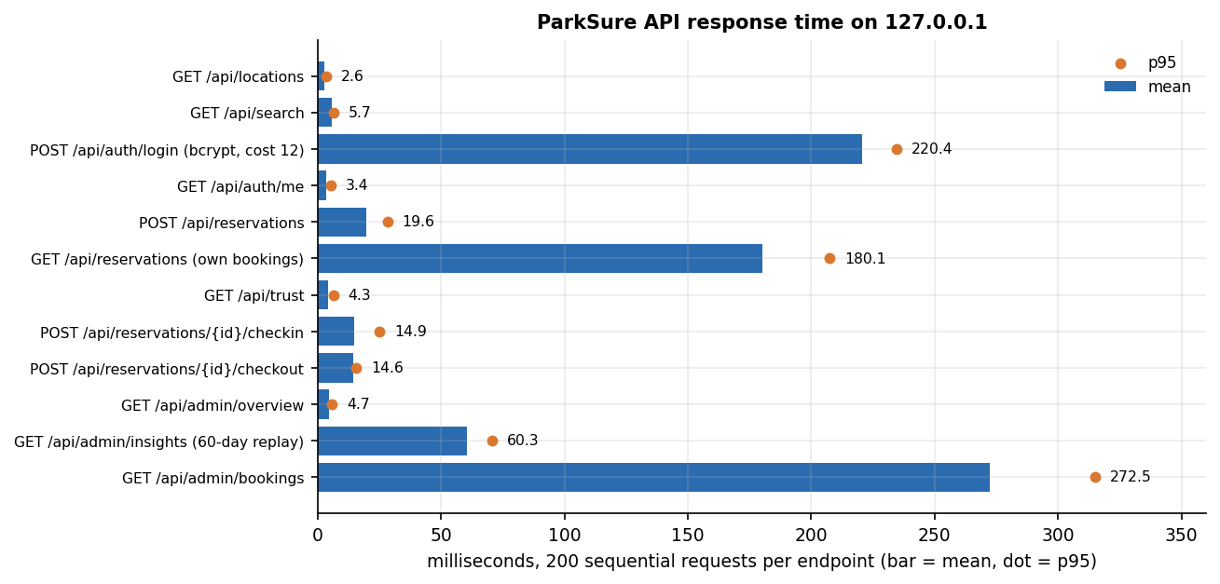
Figure 13: Mean and 95th-percentile response time of each endpoint of the live API.
Everything a driver does in one click answers within about 25 to 28 ms at the 95th percentile (search 5.7 ms mean, reservation 19.6 ms, check-in 14.9 ms, check-out 14.6 ms). Login is slower, 220 ms, by design: the bcrypt work factor is the cost of protecting passwords. Two endpoints are slow for a reason in the code: GET /api/reservations (180 ms mean) and GET /api/admin/bookings (273 ms mean) build each row with two extra queries (the location name and the payment), so the cost grows with the number of rows, about 400 stored bookings in this run (an N+1 query pattern). Strategy Insights replays the stored history in 60 ms.
With 8 client threads sending 480 search requests the server handled 131 requests per second, with a mean of 60 ms, a 95th percentile of 79 ms and a maximum of 102 ms. Measured in-process on an in-memory database holding 5,000 reservations, the admission decision forecast_free takes 0.33 ms on average (95th percentile 0.46 ms), the nearest-alternate search over 49 other locations 18.6 ms (95th percentile 23.5 ms, about 0.4 ms per location because it runs one overlap query per location), and one haversine distance 0.8 microseconds.

7.7.1 Concurrency probe
Admission counts the overlapping bookings and then inserts the new one, in two separate steps without a lock. To see whether that matters, the probe created a location with capacity 2 and buffer 1, so exactly one bay could be booked, and sent 20 reservation requests for it at the same instant from 20 different drivers, ten times. In 9 trials exactly one request was accepted and the rest received 409. In 1 of 10 trials two requests were accepted (the most seen was 2), so the last bay was sold twice. The objective of preventing double bookings is therefore met for requests that arrive one after another, and not under simultaneous requests. The window is small, since the check and the insert are a few milliseconds apart, but it is real. A database-level fix (a transaction that locks the location row, or a unique allocation record per bay) was not implemented.
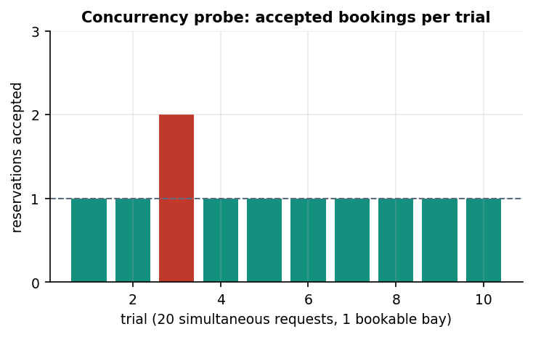
Figure 14: Number of reservations accepted in each of the ten trials; one bookable bay, twenty simultaneous requests.

7.8 User acceptance and the browser walk-through
No user study was run. Nobody other than the project team used the application under observation, so there are no task times, error counts or satisfaction scores, and no claim about usability is made from them. What was done instead is a scripted walk of the console that a real user would follow.
scripts/capture_docs_screens.py starts from a freshly seeded database and drives the React console at 1440 by 900 pixels in Chrome. As a driver it searches a window in which a one-bay location is full, searches a later window, opens the reservation dialog, reserves, opens My bookings, checks in and checks out through the buttons, and opens the Trust Score page. A second driver books the one-bay location for a later window while it is occupied, signs in, checks in, and is moved to the nearest alternate. As the administrator the script opens the overview, locations, Strategy Insights, all bookings and users pages. It also opens the search page at 390 pixels wide and the API documentation page. It saves 24 screenshots that are used in Chapter 8 and Appendix C. Every action in the walk succeeded on the first run of the final script; the earlier run showed that the first Check in button on the page belonged to a booking two days ahead rather than the one meant, so the script was changed to select the button by booking number and the database was reset before the final capture.

7.9 Limits of the testing done
• The data are synthetic. Every test and the Strategy Insights screens use the demo history generated by app/seed.py. No real parking lot, driver or payment contributed to any result.
• The experiments are simulations. The buffer comparison of Chapter 8 ran in a purpose-built simulator. It uses the engine's rules, verified decision for decision, but its driver behaviour (arrival times, gaps, a fixed one-hour overstay) is assumed.
• Concurrency was probed only on admission. Other races, such as two check-ins at the same moment, were not tested.
• Load was small. The heaviest test used 8 client threads on the same machine as the server; no test used many users, a network between client and server, or a database other than SQLite.
• Stripe was tested only through its demo fallback. No Stripe key was configured, so Checkout sessions, the webhook signature check and real refunds were not exercised.
• One browser, one display. The walk used Chrome at two viewport widths; other browsers, assistive technology and an accessibility audit tool were not used.
• No hardware. Barriers, sensors and cameras do not exist in the product, so the physical entry and exit are represented by the Check in and Check out buttons.
• Timings come from a shared machine and should be read as orders of magnitude.
In short: the engine rules and the API contract are well covered (70 automated tests and 27 smoke checks, all passing), the screens render real application data, and the probes found a small number of genuine weaknesses, which are listed rather than hidden. What the testing cannot say is how ParkSure behaves with real drivers, real money or real concurrency at scale.

CHAPTER 8: RESULTS AND OUTPUT SCREENS

8.1 Experimental set-up
ParkSure has no learned model and no external dataset, so the results of this chapter are of four kinds: what the application shows when it runs (Section 8.2), how its availability rules behave in a controlled simulation (Sections 8.3 to 8.5), what its Strategy Insights page computes on the seeded demo history (Section 8.6), and how fast it answers and where it fails (Chapter 7, summarised in Section 8.7). All measurements were made on one machine, a 12th-generation Intel Core i5-12500 with 15.7 GB of memory and Windows 11, and every table and figure is drawn from the stored files experiments/**/metrics.json.

8.1.1 The data
The only data are the demo records that app/seed.py creates with a fixed random seed (42) on first start: 9 users (one administrator and eight drivers, two of whom have overstay history), 5 locations (20, 12, 15, 25 and 8 bays), and 347 reservations spread over the previous 60 days, with eight Friday-evening peaks at Old Town Deck that oversubscribe it. Of these, 279 are completed, 39 failed (the driver could not park) and 29 were declined. These records are synthetic: they show that the mechanisms work, not how real drivers behave. No real payment was taken.

8.1.2 The simulation
For the buffer experiments the team wrote a discrete-event simulator (scripts/parking_sim.py) that re-creates the scenario of the reservation paper [2]: 8 areas of 10 bays (80 in all), 80 to 110 vehicles, each making 10 parks of 1 to 3 hours, a share of the vehicles overstaying by one hour, and two long stops outside the system. The paper ran it in SUMO [21]; ParkSure's simulator applies the product's own rules (admission, nearest-alternate move, Trust Score, suspension), which were compared with the real engine on 10,300 cases with 0 mismatches (Section 7.3). Each cell is the mean of 30 runs (the paper used 5).
Table 33: What the simulator assumes where the paper is silent (fixed before the runs).
Item | Assumption
Areas and requests | 8 areas x 10 bays about 1.3 km apart, uniform choice of area; first request in the first 2 hours, reservation 15 to 60 minutes before arrival, stay 1 to 3 hours, next request 15 to 60 minutes after leaving, two outside stops of 8 to 16 hours
Behaviour | Good vehicles leave exactly at the end, bad vehicles one hour late; every driver checks in at the planned time
Policies | Static buffer 0, 1 and 3; the rule as shipped (+1 on every on-time checkout, maximum 5, reset every 24 hours); the paper's rule (+1 on every late departure, same maximum and reset)
Trust Score | On, as shipped; an ablation switches it off

Outcomes are counted per request. Refused: no space is a request rejected by the admission rule; Refused: suspended is a request rejected by the Trust Score lockout; No park is an admitted booking whose driver found the area full and no alternate with forecast space; Moved to alternate is a driver who found the area full and was served at the nearest alternate; Alternate full counts moves in which the alternate was physically full as well, which the shipped code does not re-check; Parked % is the share of all requests that ended with a parked car; Util. % is bay-hours used divided by bay-hours available over the run.

8.2 Output screens
The screens below were captured from the running application at 1440 by 900 pixels on a freshly seeded database; none is a mock-up and every figure visible in a caption can be found in the picture. The remaining screens (landing page in both themes, login, the check-in and check-out confirmations, the second driver's bookings, the locations, bookings and users tables, the phone layout and the API documentation page) are in Appendix C.
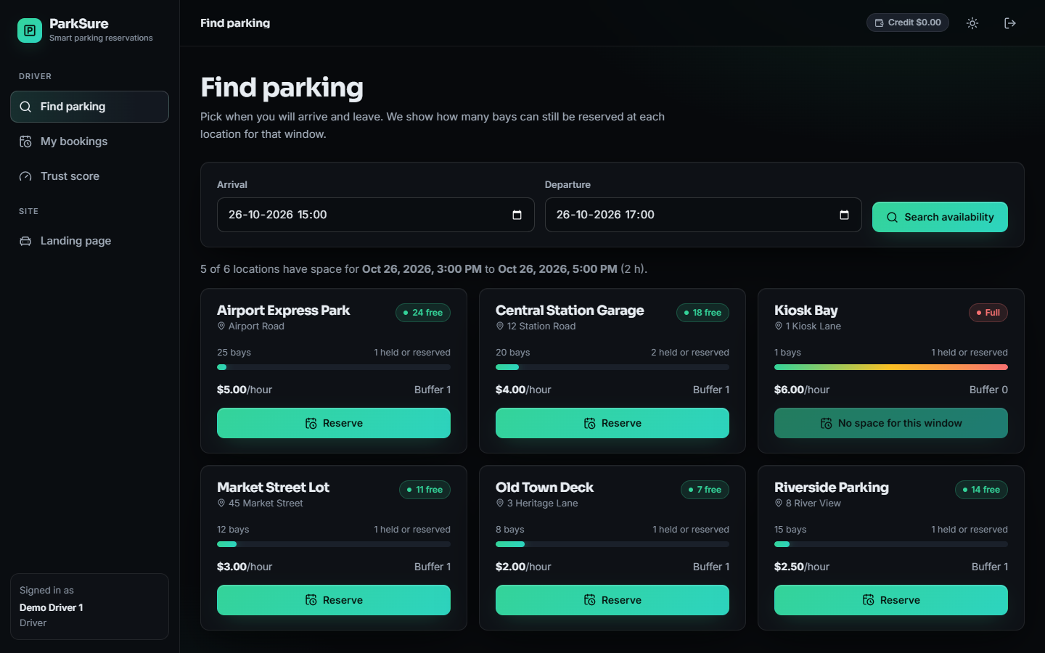  Figure 15: Find parking for the default window (26 October, 3:00 to 5:00 PM): six locations with their bays, how many are held or reserved, the hourly price and the buffer (1 at five locations, 0 at the one-bay Kiosk Bay), and the bays that can still be reserved (Airport Express Park 24 free of 25, Central Station Garage 18 free of 20). Kiosk Bay is already Full for this window. | 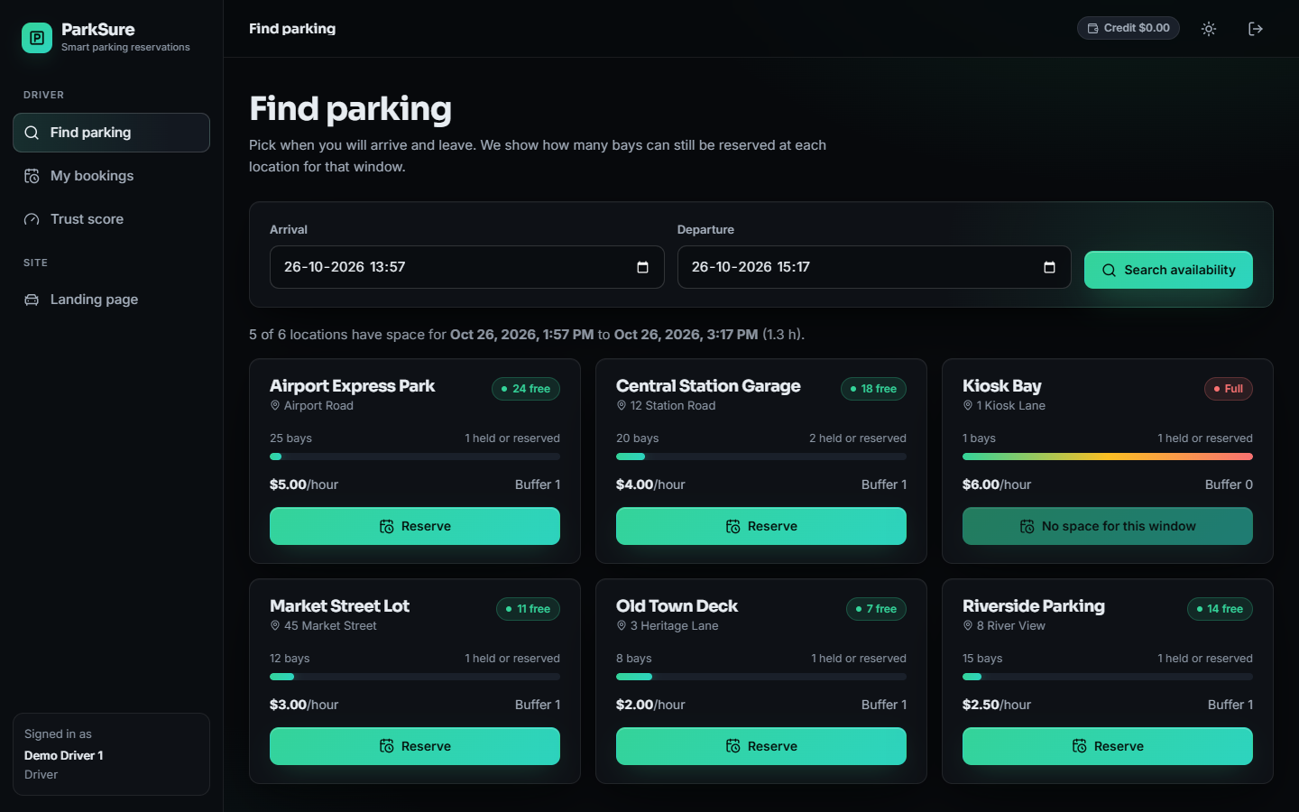  Figure 16: Search for a window that overlaps the booking of the one-bay Kiosk Bay: its card shows Full and a disabled No space for this window button, while the other five locations show free bays.

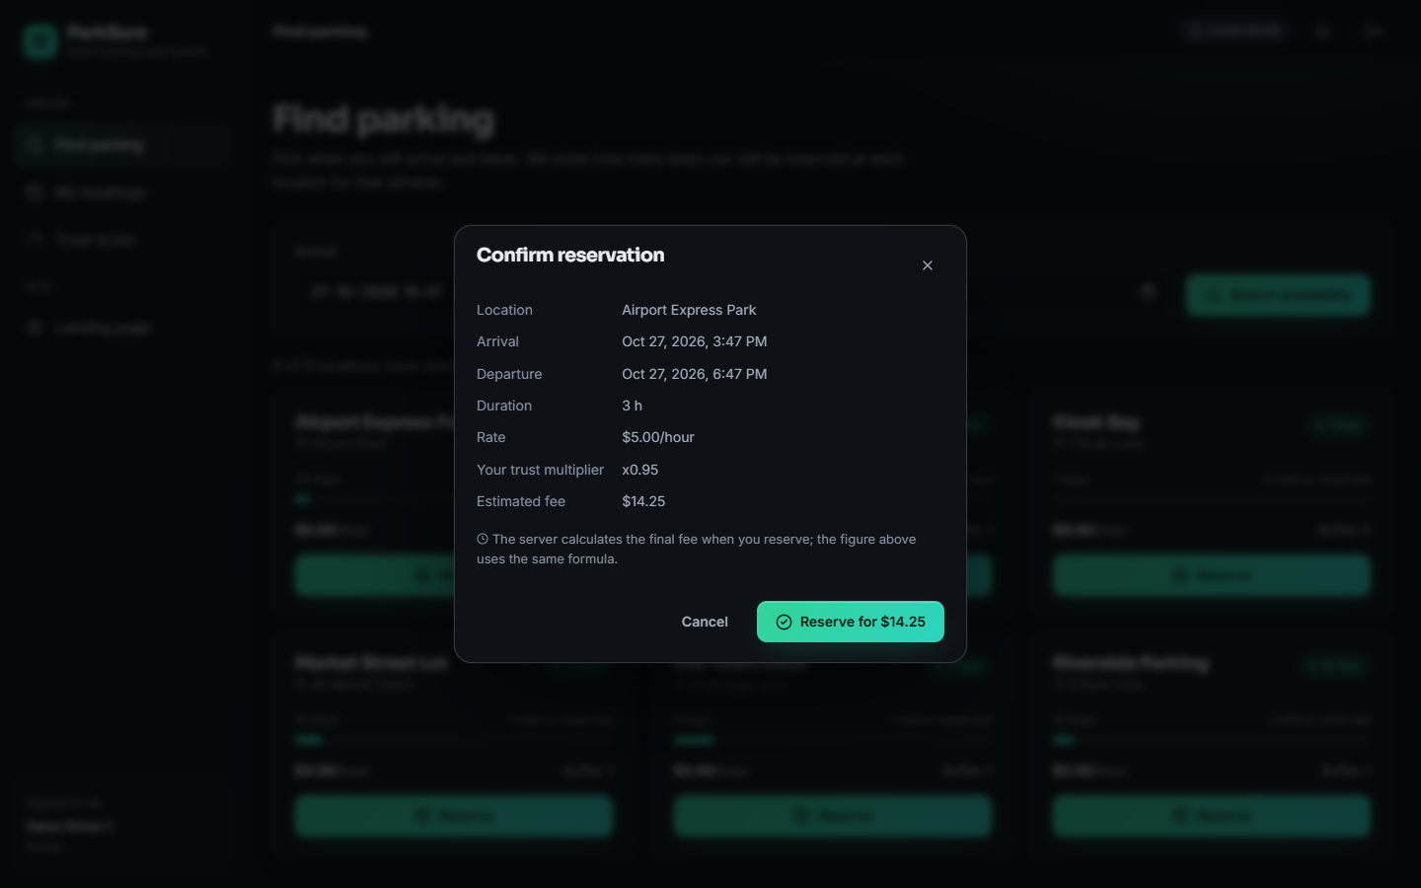  Figure 17: Reserve dialog for Airport Express Park, 27 October 3:47 PM to 6:47 PM: 3 hours at $5.00 per hour with the driver's trust multiplier x0.95 gives an estimated fee of $14.25. The server computes the final fee with the same formula. | 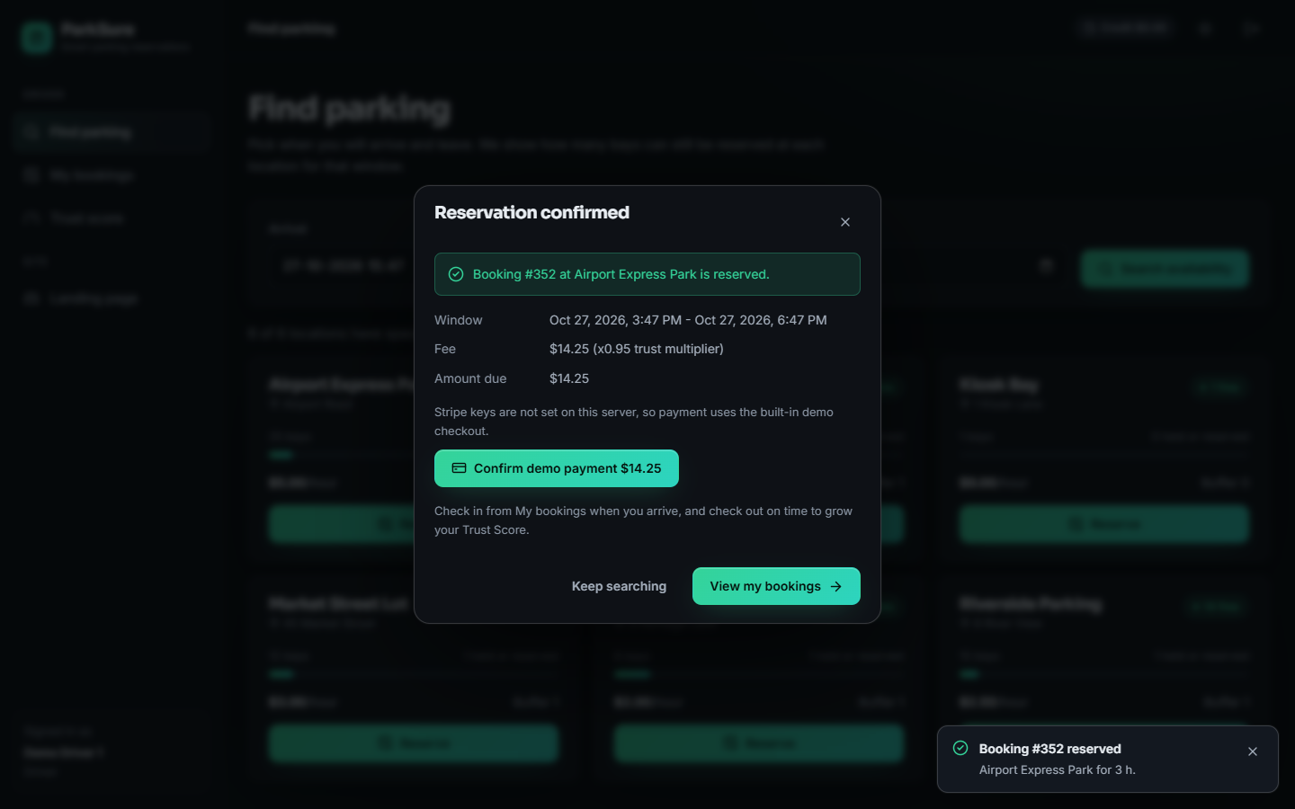  Figure 18: Reservation confirmed: booking #352 with a fee of $14.25 (x0.95 trust multiplier) and the amount due. Because no Stripe key is set, the demo checkout button is offered.

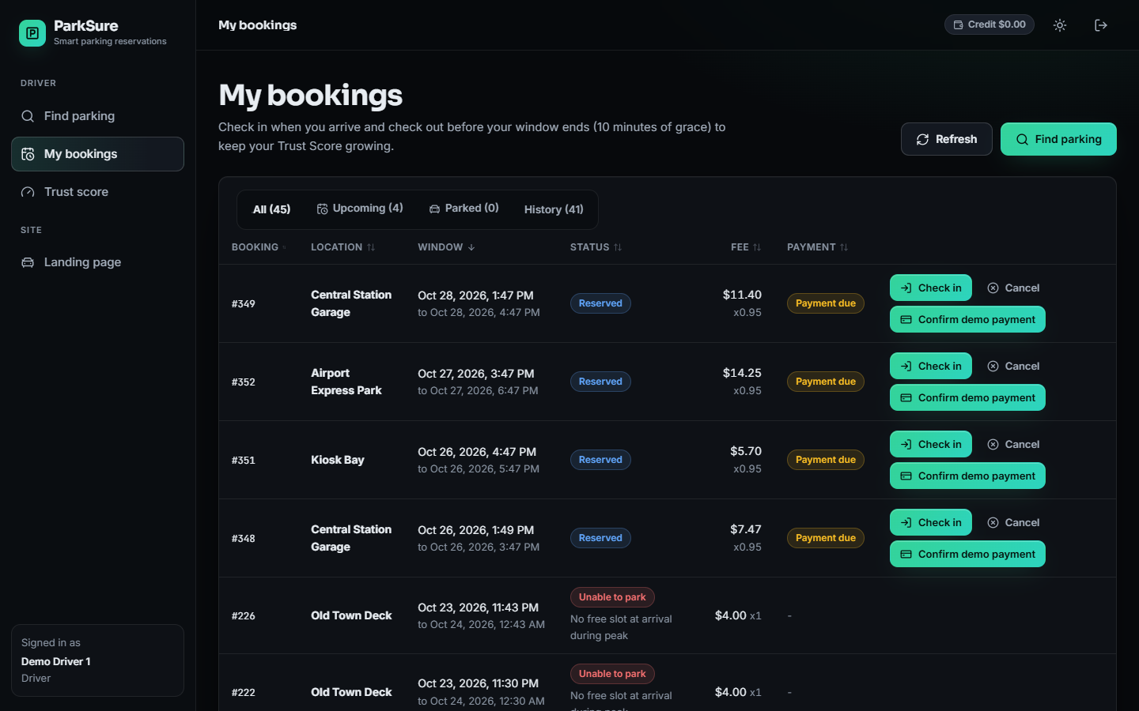  Figure 19: My bookings for the demo driver: booking numbers, locations, windows, status badges, fees with the multiplier, and payment state. Reserved bookings offer Check in and Cancel; unpaid ones offer Confirm demo payment. | 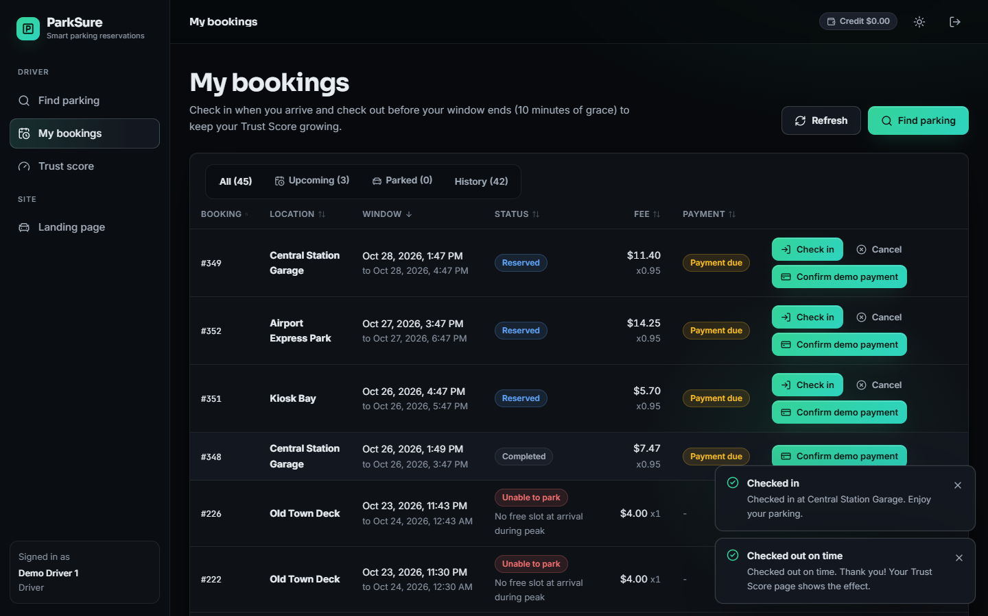  Figure 20: After the driver checked in and out of booking #348 through the buttons: the row is Completed, and the two confirmations read Checked in at Central Station Garage and Checked out on time.

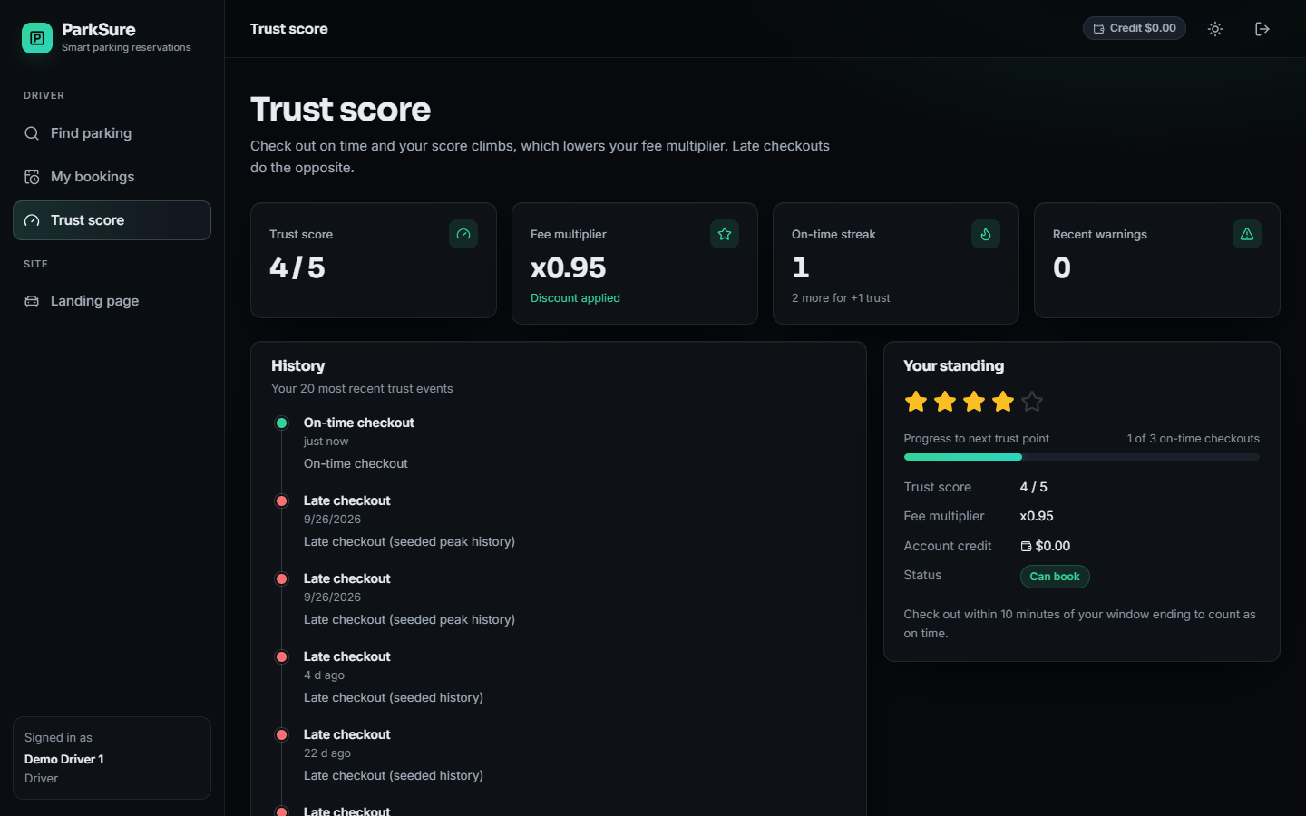  Figure 21: Trust Score page: score 4 of 5, fee multiplier x0.95, on-time streak 1 (two more for the next point), no recent warnings, and the event history that begins with the on-time checkout just recorded above the seeded late checkouts. | 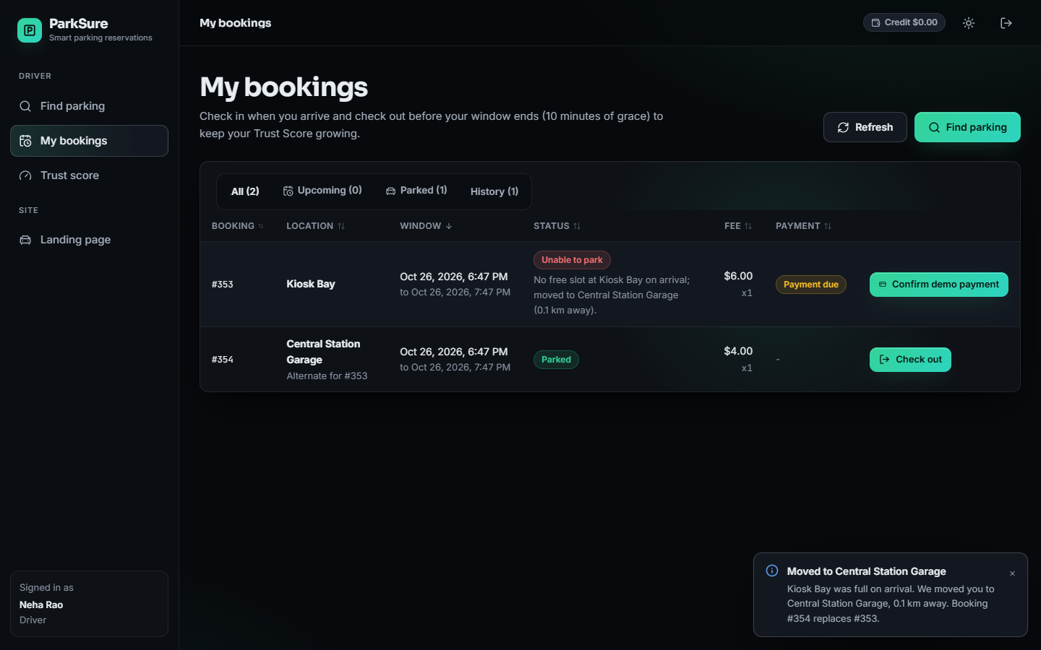  Figure 22: Second driver arriving at Kiosk Bay, whose single bay was occupied: booking #353 shows Unable to park with the reason, the replacement booking #354 at Central Station Garage is Parked and marked Alternate for #353, and the toast reads that the driver was moved 0.1 km away.

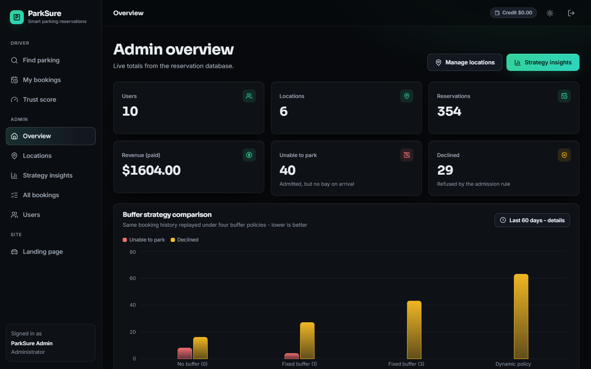  Figure 23: Administrator overview of the fresh database after the capture session: 10 users, 6 locations, 354 reservations, paid revenue $1,604.00, 40 unable to park and 29 declined, with the Strategy Insights chart below. | 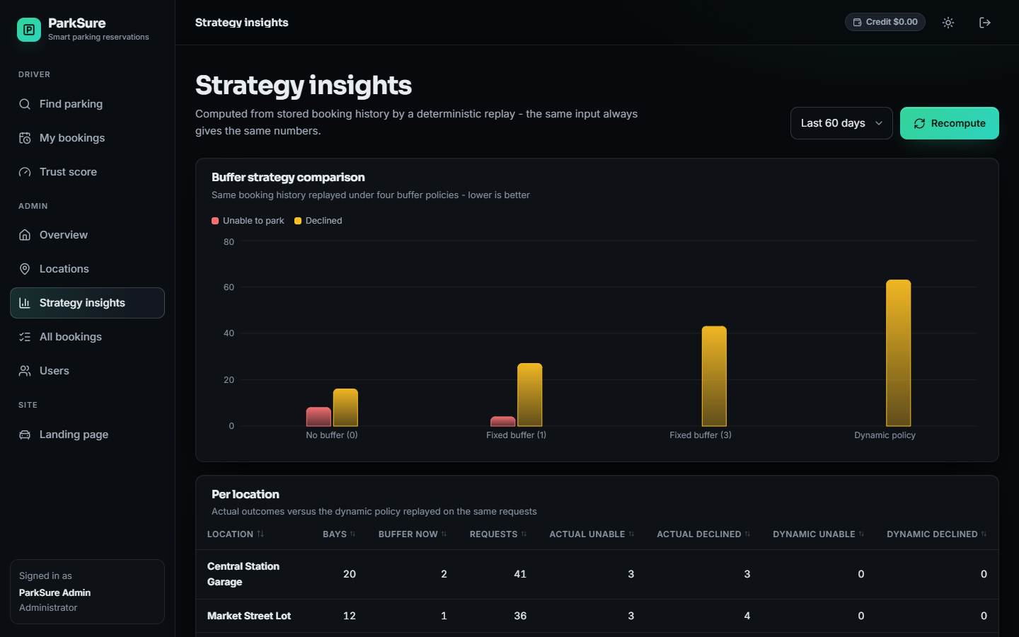  Figure 24: Strategy Insights over the last 60 days: the same stored booking history replayed under no buffer, a fixed buffer of 1, a fixed buffer of 3 and the dynamic policy, shown as unable-to-park and declined counts, with the per-location table below.

8.3 Buffer policies against the number of vehicles
The table and figure below vary the population from 80 vehicles, equal to the number of bays, to 110, with 25 % of the vehicles overstaying. The clearest result is the price of the buffer. At 100 vehicles, which produce 1000 requests per run, a location with no buffer refuses 30 of them for lack of space, a buffer of 1 refuses 53, a buffer of 3 refuses 158, the paper's dynamic rule 165, and the dynamic rule as ParkSure ships it 277. The shipped rule grows the buffer on every on-time checkout, and most checkouts are on time, so the buffer quickly reaches its maximum of 5 and half of each ten-bay area is held back; its share of requests that end with a parked car is 63.0 %, against 82.7 % with no buffer.
Table 34: Outcomes per run, 25 % bad vehicles, mean of 30 runs (requests = vehicles x 10).
 | Policy | Requests | Refused: no space | Refused: suspended | No park | Moved to alternate | Alternate full | Parked % | Util. %
80 | Static 0 | 800 | 7.5 | 118.4 | 0.00 | 1.8 | 0.10 | 84.3 | 27.7
80 | Static 1 | 800 | 15.8 | 116.1 | 0.00 | 0.4 | 0.00 | 83.5 | 27.4
80 | Static 3 | 800 | 59.9 | 106.8 | 0.00 | 0.0 | 0.00 | 79.2 | 25.9
80 | Dynamic (ParkSure) | 800 | 108.2 | 96.7 | 0.00 | 0.2 | 0.00 | 74.4 | 24.8
80 | Dynamic (paper rule) | 800 | 48.6 | 110.0 | 0.00 | 0.3 | 0.00 | 80.2 | 26.2
100 | Static 0 | 1000 | 30.0 | 143.1 | 0.40 | 6.7 | 0.37 | 82.7 | 33.5
100 | Static 1 | 1000 | 52.7 | 138.9 | 0.17 | 2.4 | 0.07 | 80.8 | 32.8
100 | Static 3 | 1000 | 158.1 | 116.5 | 0.03 | 0.0 | 0.00 | 72.5 | 30.2
100 | Dynamic (ParkSure) | 1000 | 276.8 | 92.3 | 0.70 | 0.1 | 0.03 | 63.0 | 26.8
100 | Dynamic (paper rule) | 1000 | 165.3 | 119.1 | 0.23 | 1.7 | 0.03 | 71.5 | 29.9
110 | Static 0 | 1100 | 48.6 | 157.4 | 1.43 | 12.8 | 1.87 | 81.1 | 36.4
110 | Static 1 | 1100 | 82.2 | 149.5 | 0.77 | 4.3 | 0.10 | 78.9 | 35.5
110 | Static 3 | 1100 | 231.7 | 118.6 | 0.03 | 0.1 | 0.00 | 68.2 | 31.7
110 | Dynamic (ParkSure) | 1100 | 383.1 | 89.3 | 1.13 | 0.0 | 0.03 | 57.0 | 26.9
110 | Dynamic (paper rule) | 1100 | 250.0 | 113.4 | 1.00 | 2.4 | 0.03 | 66.9 | 31.2

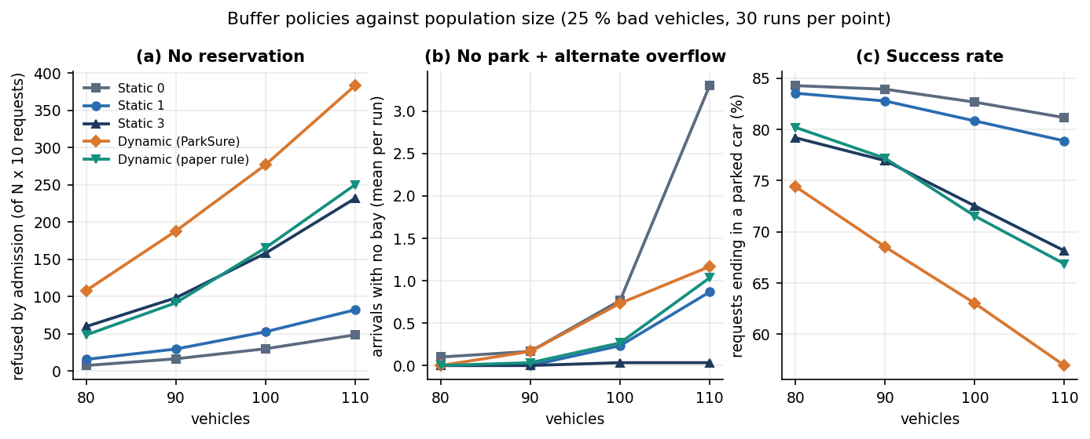
Figure 25: Refused requests, arrivals with no bay and success rate against the number of vehicles for the five buffer policies (25 % bad vehicles, 30 runs per point).
The benefit of a buffer is hard to see. 'No park' stays at or below 1.4 events per run in every policy and population, because an arriving driver who finds the area full is moved to the nearest alternate: with no buffer and 110 vehicles 12.8 drivers per run are moved, and in 1.9 of those moves the alternate was itself full. A buffer of 3 removes the moves almost completely (0.07 per run) at the cost of 232 refused requests, against 49 with none. Utilisation falls as the buffer grows, from 36.4 % with no buffer to 26.9 % with the shipped dynamic rule at 110 vehicles.

8.4 Buffer policies against the share of overstaying vehicles
The table and figure below keep the population random between 80 and 110 and raise the share of vehicles that overstay from 25 % to 50 %. For a location with no buffer the number of arrivals that find no bay rises with the share of bad vehicles: 'no park' plus 'alternate full' goes from 0.40 to 3.33 events per run. A buffer holds it down: static 3 stays at 0.17 at 50 %. The shipped dynamic rule ends at 1.43 and the paper's rule at 1.10, so neither dynamic rule does better than a fixed buffer of 3 on this measure, and both refuse more requests than a buffer of 1.
Table 35: Outcomes per run against the share of bad vehicles (population 80 to 110, mean of 30 runs).
 | Policy | Requests | Refused: no space | Refused: suspended | No park | Moved to alternate | Alternate full | Parked % | Util. %
25 % | Static 0 | 936 | 21.8 | 135.6 | 0.10 | 5.9 | 0.30 | 83.2 | 31.7
25 % | Static 1 | 936 | 38.5 | 131.8 | 0.10 | 1.4 | 0.03 | 81.9 | 31.1
25 % | Static 3 | 936 | 119.0 | 113.4 | 0.00 | 0.0 | 0.00 | 75.3 | 29.1
25 % | Dynamic (ParkSure) | 936 | 214.0 | 96.9 | 0.33 | 0.3 | 0.03 | 67.0 | 26.5
25 % | Dynamic (paper rule) | 936 | 117.9 | 115.9 | 0.17 | 0.8 | 0.03 | 75.2 | 28.9
50 % | Static 0 | 936 | 19.3 | 270.8 | 0.43 | 11.5 | 2.90 | 69.0 | 28.7
50 % | Static 1 | 936 | 33.8 | 265.4 | 0.40 | 5.7 | 0.90 | 68.0 | 28.1
50 % | Static 3 | 936 | 102.4 | 232.4 | 0.17 | 0.4 | 0.00 | 64.3 | 27.4
50 % | Dynamic (ParkSure) | 936 | 161.5 | 211.4 | 1.07 | 1.8 | 0.37 | 60.3 | 26.1
50 % | Dynamic (paper rule) | 936 | 136.1 | 218.4 | 0.47 | 3.3 | 0.63 | 62.2 | 26.5

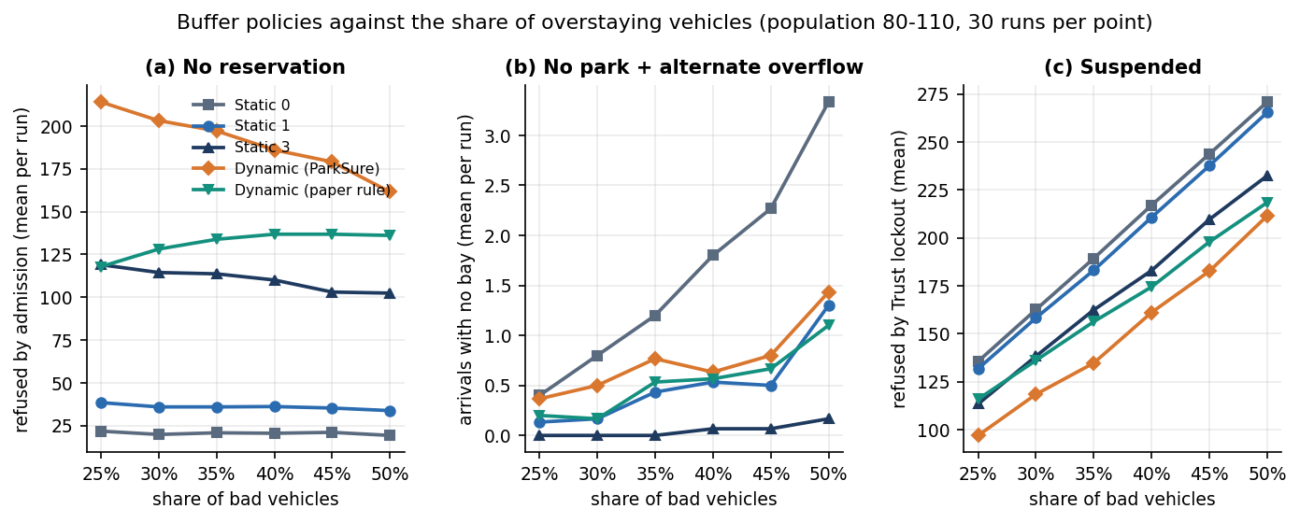
Figure 26: Refused requests, arrivals with no bay and Trust Score lockouts against the share of overstaying vehicles (population 80 to 110, 30 runs per point).
Panel (a) of the figure shows a pattern that the reservation paper also noticed in its own results [2]: the number of refused reservations of the shipped dynamic rule falls as more vehicles misbehave, from 214 to 162. The paper put this down to fewer requests being generated when vehicles stay longer. In this simulator the number of requests is fixed, so the explanation is different and can be read from panel (c): suspended drivers stop requesting, and the number of requests refused by the Trust lockout rises from 97 to 211. A fall in refusals therefore does not mean that the admission policy has improved.
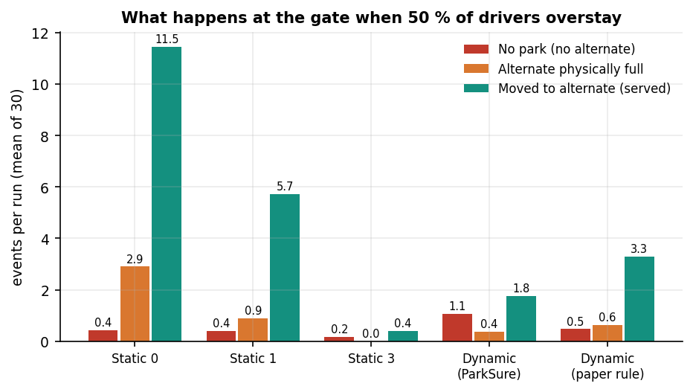
Figure 27: What happens at the gate when half of the drivers overstay: no park, alternate physically full, and moved to the alternate, per run for each policy.

8.5 Effect of the Trust Score system
The Trust Score has two effects in the simulation. It lowers the fee multiplier of punctual drivers and raises it for late ones, and it locks out drivers whose score falls below 1.5 after a recent warning. The ablation below switches the lockout off: with the Trust Score switched off, the share of requests that end with a parked car at 50 % bad vehicles is 97.8 % for a static buffer of 0, against 69.0 % with it on, and for the shipped dynamic rule 78.2 % against 60.3 %. The lockout is the largest source of refused requests at 50 % bad vehicles: for a static buffer of 0 271 of 936 requests per run are refused because the driver is suspended. The cause is in the engine: once the score is below 1.5, every request while the last warning is less than 14 days old re-applies the 24-hour pause, so a suspended driver cannot book for at least 14 days, whereas the reservation paper bars one subsequent session.
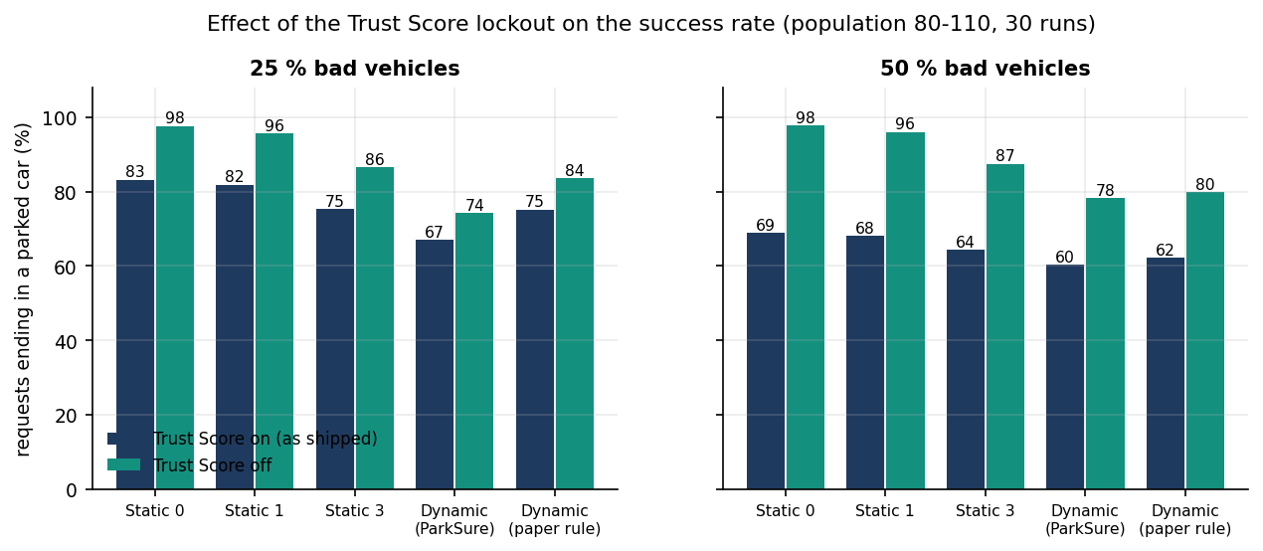
Figure 28: Share of requests that end in a parked car with the Trust Score on (as shipped) and off, at 25 % and 50 % bad vehicles.
The second table follows a single driver for 100 daily sessions, 200 simulated drivers per setting, when each session ends late with a fixed probability. A driver who is late one session in ten ends with a mean score of 4.80 and is almost never suspended (0.5 %). At 30 % the mean score is 1.80, the mean fee multiplier 1.36, and 80 % of drivers are suspended at some point, the median at session 26. At 50 % the mean score is 0.12 and every driver is suspended, the median at session 8. The score separates punctual from unpunctual drivers clearly; whether a 14-day lockout is the right penalty is a policy question that these data cannot answer.
Table 36: Trust Score outcome after 100 daily sessions against the probability of a late checkout (200 drivers per setting).
Late probability | Mean final score | Std | Mean fee multiplier | Ever suspended | Median first suspension (session)
0.0 | 5.00 | 0.00 | 0.90 | 0 % | none
0.1 | 4.80 | 0.49 | 0.91 | 0 % | 90
0.2 | 3.92 | 1.36 | 1.01 | 29 % | 30
0.3 | 1.80 | 1.65 | 1.36 | 80 % | 26
0.5 | 0.12 | 0.33 | 1.72 | 100 % | 8
0.7 | 0.01 | 0.10 | 1.75 | 100 % | 5
1.0 | 0.00 | 0.00 | 1.75 | 100 % | 4

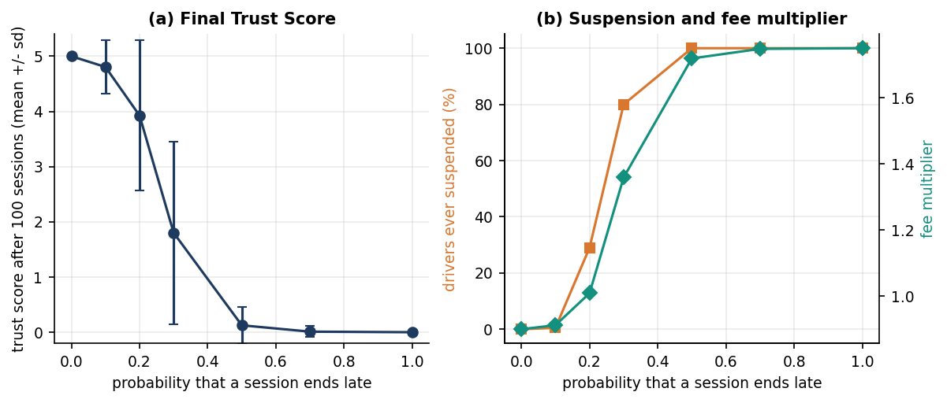
Figure 29: Final Trust Score, share of drivers ever suspended and mean fee multiplier against the probability of a late checkout.

8.6 Strategy Insights on the seeded history
The administrator's Strategy Insights page replays the stored booking history deterministically under four buffer settings and counts the requests that would have been unable to park or declined. On the seeded 60-day history (347 reservations) the totals are: no buffer 8 unable to park and 16 declined; a fixed buffer of 1, 4 and 24; a fixed buffer of 3, 0 and 40; and the dynamic policy, 0 and 60. The same ordering as in Sections 8.3 and 8.4 appears: each step towards a larger buffer removes the failures at arrival and adds refusals at booking, and the dynamic policy, which grows its buffer fastest, refuses the most. Almost all of the difference comes from one location, Old Town Deck (8 bays, 163 requests in the window), where the seeded Friday peaks oversubscribe the bays; the actual history shows 24 unable to park and 15 declined there, against 0 and 60 under the dynamic policy. Because the history is generated, these counts illustrate the mechanism and say nothing about real demand. They are also not a validation of the simulator: both use the same buffer rule.
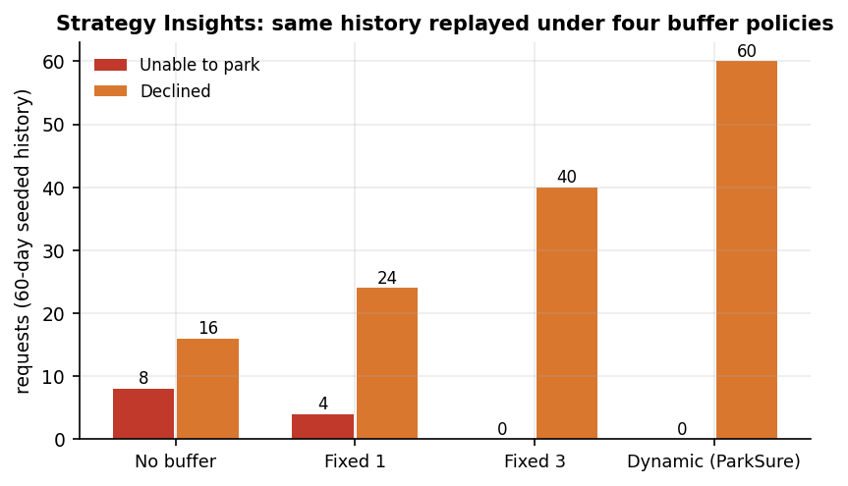
Figure 30: Strategy Insights totals on the seeded 60-day history under four buffer policies (synthetic data).

8.7 Response time and allocation efficiency
Chapter 7 gives the full measurements. The figures that matter for the sixth objective are these. A driver's actions answer quickly on a single uvicorn process with a SQLite file: search 5.7 ms, reservation 19.6 ms, check-in 14.9 ms and check-out 14.6 ms on average. Login takes 220 ms because of bcrypt. The admission decision takes 0.33 ms in process, and the nearest-alternate search over 49 locations 18.6 ms. Allocation efficiency, measured as bay utilisation in the simulation, is 33.5 % with no buffer and 26.8 % with the shipped dynamic rule at 100 vehicles; the booking success rate, the share of requests that end in a parked car, is 82.7 % and 63.0 % for the same two policies. Two defects belong with these results: one of ten concurrency trials sold the last bay twice, and the two list endpoints slow down as the number of stored rows grows.

8.8 Comparison with the base papers
Two papers are used as the base of this project, and neither can be compared with ParkSure on equal terms. The registered base paper [1] (Jemmali et al.) solves a different problem: it balances the number of people across the parking spaces of a medical city using passenger counts, with six grouping-permutation heuristics evaluated on nine instance classes and 2,790 generated test cases. ParkSure implements none of those heuristics and makes no claim to match them. The second paper [2] (Cabri et al.) is the source of ParkSure's buffer and star-reputation ideas. It evaluates them only in a SUMO simulation with 80 spots in 8 areas, 80 to 110 vehicles, 25 to 50 % overstaying vehicles and 5 runs per setting, and presents its results as charts without a table of numbers. ParkSure's simulator re-creates that scenario but is not SUMO, uses assumed arrival times and runs the product's own rules, so a qualitative comparison is all that is meaningful.
Table 37: Comparison of the setting and the findings.
Aspect | Jemmali et al. [1] | Cabri et al. [2] | ParkSure (this work)
Problem | Allocate vehicles to parking spaces so that the number of people per space is balanced | Keep a reserved bay available when earlier drivers overstay | Reserve, pay and manage bays; keep bays available despite overstays
Method | Four-stage grouping and six grouping-permutation heuristics | Buffer of non-reservable slots (dynamic: grows on late departure) and 0-5 star reward system | Same ideas implemented in a web product; buffer grows on on-time checkout; nearest-alternate move; fee multiplier; Strategy Insights
Evaluation setting | 2,790 generated instances in nine classes | SUMO, 80 spots, 8 areas, 5 runs per setting | Own simulator, same sizes, 30 runs per setting; 70 tests; latency probes; seeded demo history
Reported result | Best algorithm has the highest best-solution share (68.2 %); GVb matches or beats baseline MR on 55.4 % of instances; sub-millisecond | Any buffer beats none; the dynamic buffer gives the best trade-off between failed parks and refused reservations (charts only) | See the next two rows
Does a buffer reduce arrival failures? | Not studied | Yes: any buffer beats none | Yes, in the same direction: at 50 % bad vehicles 'no park' plus 'alternate full' is 3.33 per run with no buffer and 0.17 with a buffer of 3
Is the dynamic buffer the best trade-off? | Not studied | Yes | Not reproduced: at 100 vehicles the shipped rule refuses 277 requests and the paper's rule 165, against 158 for a fixed buffer of 3 that gives equal or fewer arrival failures
Execution time | Sub-millisecond allocation | Not reported | Admission decision 0.33 ms; whole reservation call 19.6 ms (different task)

The differences in setting limit the comparison. The reservation paper's vehicles are all equipped and enter through barriers, and its reward system bars a driver for one subsequent session; ParkSure has no barriers and its lockout lasts at least 14 days. The paper raises the buffer when a vehicle leaves late, ParkSure's code when it leaves on time, and the simulation shows that this choice is the main reason the shipped rule refuses so many requests. The paper's rule, run in the same simulator, refuses far fewer, but still does not beat a fixed buffer of 3 on the measures used here. Because the simulator is not SUMO and its arrival process is assumed, this is not a refutation of the paper: its claim that the dynamic buffer is the best trade-off could not be reproduced for either dynamic rule, and the shipped rule is the more conservative of the two.

8.9 Sample inputs and outputs
The following requests and responses were captured from the running application on a seeded database (long fields shortened, and the checked_in_at, checked_out_at, decline_reason and parent_id fields of a new booking, which are empty, omitted). The driver is the demo driver with trust score 4, so the fee carries the multiplier 0.95: two hours at $2.00 per hour is $4.00, and $4.00 x 0.95 = $3.80.

8.9.1 Availability search
GET /api/search?start_time=2026-10-28T08:28:42+00:00&end_time=2026-10-28T10:28:42+00:00

# one element of the answer
{
"id": 5,
"name": "Old Town Deck",
"address": "3 Heritage Lane",
"latitude": 12.96,
"longitude": 77.585,
"capacity": 8,
"buffer_size": 1,
"price_per_hour": 2.0,
"overlapping": 0,
"bookable": 7,
"available": true
}

Old Town Deck has 8 bays and a buffer of 1, and no booking overlaps the window, so 8 - 1 - 0 = 7 bays can be reserved.

8.9.2 Successful reservation
POST /api/reservations
{"location_id": 5, "start_time": "2026-10-28T08:28:42+00:00", "end_time": "2026-10-28T10:28:42+00:00"}

# 200 OK
{
"id": 348,
"location_id": 5,
"location_name": "Old Town Deck",
"start_time": "2026-10-28T08:28:42+00:00",
"end_time": "2026-10-28T10:28:42+00:00",
"status": "reserved",
"fee": 3.8,
"fee_multiplier": 0.95,
"payment_status": "pending",
"payment_provider": "demo",
"credit_applied": 0.0,
"amount_due": 3.8,
"checkout": {
"url": "/api/payments/demo-confirm?session_id=demo_41cedf3d3d25&reservation_id=348",
"session_id": "demo_41cedf3d3d25",
"provider": "demo"
}
}

8.9.3 Refused reservation
POST /api/reservations (the same window, after seven bookings)

# 409 Conflict
{"detail": "Old Town Deck is fully reserved for the requested window (capacity 8, hold-back buffer 1). Please try another time or location."}

The refused request is stored as a declined booking with this reason, so the administrator's overview counts it. A reversed time window answers 422 and a wrong password 401 with the detail Incorrect email or password.

8.9.4 Check-out, check-in and Strategy Insights
Check-out answers with on_time true and the message Checked out on time. Thank you! within 10 minutes after the booked end, and otherwise with on_time false and a message that the checkout was recorded as an overstay. A check-in at a full location answers with moved true, the distance and the alternate, for example Kiosk Bay was full on arrival. We moved you to Central Station Garage, 0.1 km away. (Section 8.2.3), or with failed true and the fee credited when no alternate exists. GET /api/admin/insights answers with the four strategies and the policy {init: 1, max: 5, reset_hours: 24}; its totals on the seeded history are in Section 8.6.

8.10 Success and failure analysis

8.10.1 Where the product succeeds
• Every flow a driver needs works end to end: search, reserve, pay in demo mode, check in, check out, cancel with an automatic credit, and the Trust Score page (Section 8.2).
• The rules are exact and tested: 70 tests and 27 smoke checks pass, and the simulator agrees with the engine on 10,300 decisions.
• A driver who finds a location full is moved to the nearest alternate or has the fee credited automatically (Section 8.2.3), and the administrator's replay of the stored history is deterministic.

8.10.2 Where it falls short
• The shipped dynamic buffer is the most conservative policy tested. At 100 vehicles it refuses 277 of 1000 requests and leaves 26.8 % utilisation, with little extra protection against arrival failures compared with a fixed buffer of 3.
• The Trust lockout is harsh. Because the pause is re-applied at every refused request, a driver below 1.5 with a warning in the last 14 days cannot book for at least 14 days; in the simulation it refuses more requests than the admission rule does for every fixed-buffer policy at 25 % bad vehicles and for every policy at 50 %.
• A bay can be sold twice under simultaneous requests: 1 of 10 trials of the concurrency probe accepted two bookings for one bookable bay.
• The alternate move does not check the alternate's physical bays, so a driver can be sent to a location that is also full; the simulation counts these moves as 'alternate full', up to 2.9 per run at 50 % bad vehicles with no buffer.
• Payment is only as secure as its demo path. An unauthenticated route marks any booking paid, and the default signing secret accepts a forged administrator token. Both are documented in Chapter 7.
• Two list endpoints are slow: the user's bookings (180 ms) and the administrator's bookings (273 ms) issue extra queries for every row.
• Past start times and early check-ins are accepted (Chapter 7).

8.11 Limitations of the evaluation
• All application data are synthetic, generated by the product's own seed; no real parking lot, driver or payment is involved.
• The buffer comparison is a simulation with assumed arrival, lead-time and gap distributions, a fixed one-hour overstay and perfect check-in on time; it is not SUMO and not the paper's exact scenario.
• Each cell is the mean of 30 runs of one scenario family; the spread between runs is stored in the metrics files but a significance test was not carried out.
• The simulator mirrors the product's rules but not its timing details: the buffer reset in the product runs on a 30-minute schedule, in the simulator at the next event.
• Latency was measured on one machine with the client and server together, over the loopback address, with at most 8 client threads and a SQLite file.
• No user study was run, so no claim is made about ease of use or driver acceptance of the Trust Score pricing.
• Stripe was not configured; real Checkout, webhooks and refunds were not exercised.

8.12 Objectives versus outcomes
Table 38: The six project objectives against what was measured.
Objective | Status | Evidence
1. User registration, authentication and vehicle profile management | Partly achieved | Registration, login, JWT roles and account credit work and are tested; there is no vehicle profile (no plate or vehicle details are stored)
2. Real-time slot availability across registered facilities | Achieved as forecast | Search returns bookable bays per location and window (capacity - buffer - overlapping bookings), 5.7 ms; no sensor feed, so occupancy is booked, not measured
3. Slot search, advance reservation and cancellation | Achieved | Tested by API tests and the smoke script; cancellation refunds a paid fee to account credit; one concurrency race was found
4. Secure online payment and digital receipts | Partly achieved | Stripe Checkout in test mode with a demo fallback; payment state is stored; no downloadable receipt; unauthenticated demo-confirm route and default JWT secret weaken the security claim
5. Administrator dashboard for slots, bookings, occupancy and revenue | Achieved | Overview, locations, bookings, users and Strategy Insights pages (Section 8.2.4); occupancy shown is forecast, not live
6. Evaluate booking success rate, allocation efficiency and system response time | Achieved on simulated and synthetic data | Success rate and utilisation from 30-run simulations (Sections 8.3 to 8.5); response times from 200-call probes (Chapter 7); no real-user data

8.13 Summary of findings
• ParkSure runs as a complete reservation platform: 22 routes, 5 tables, 24 captured screens, 70 passing tests and 27 passing smoke checks; the driver's one-click actions answer in 6 to 20 ms on average.
• A hold-back buffer reduces arrival failures and alternate moves but costs refused reservations and utilisation; at 100 vehicles refusals rise from 30 (no buffer) to 158 (buffer 3).
• The dynamic buffer as shipped (+1 on every on-time checkout) is the most conservative policy (277 refusals at 100 vehicles); the paper's rule (+1 on late departure) refuses 165. Neither beats a fixed buffer of 3 on arrival failures, so the claim that the dynamic buffer is the best trade-off was not reproduced.
• 'No park' events are rare in every policy because the nearest-alternate move absorbs overflow; the hidden cost is moves to alternates that are themselves full.
• The Trust Score separates punctual from late drivers, but its lockout of at least 14 days is the largest source of refused requests when half of the drivers overstay.
• The team's own probes found a concurrency race, an unauthenticated payment confirmation, a default signing secret and two slow list endpoints; none was fixed during the documentation run.
• Objectives 1 and 4 are only partly met (no vehicle profile, no receipt); the others are met on synthetic data and simulation. No real drivers, real money or SUMO runs were involved.

CHAPTER 9: CONCLUSION

9.1 Summary
The project set out to build a platform on which drivers reserve parking ahead of arrival, and to keep that promise when earlier drivers overstay. ParkSure delivers the platform: a FastAPI service with 22 routes and five tables, a React console, Stripe test-mode and demo payment, and an administrator console. Its availability engine implements the hold-back buffer, nearest-alternate re-allocation and Trust Score of [2]. The work was verified by 70 pytest tests, a 27-check smoke test and a simulator that matches the engine on 10,300 decisions, and 24 screens were captured from the running application.

9.2 Objectives achieved
Table 39: Objectives against outcomes
Objective | Outcome | Evidence
1 Registration, authentication and vehicle profile | Partly achieved | Registration, login, JWT, roles and Trust Score work and are tested; no vehicle profile exists
2 Real-time slot availability | Achieved as a forecast | Search returns bookable bays per window in 5.7 ms; no sensors, so not a live occupancy reading
3 Search, advance reservation and cancellation | Achieved | Reserve 19.6 ms; cancel refunds to credit; 36 API tests
4 Secure online payment and digital receipts | Partly achieved | Stripe test mode and demo checkout; payment status stored; no downloadable receipt; demo-confirm route is a weakness
5 Administrator dashboard | Achieved | Overview, locations, bookings, users, revenue, unable-to-park, declined and Strategy Insights
6 Evaluate success rate, allocation efficiency and response time | Achieved with a simulator | 30 runs per cell, five policies, utilisation, latency and probes; no real-user data

9.3 Key findings
1. The engine is correct against its own specification. 70 tests pass and the simulator agrees with the engine on 10,300 decisions (0 mismatches).
2. The platform is fast enough for its purpose. On this machine search takes 5.7 ms, reserve 19.6 ms, check-in 14.9 ms and check-out 14.6 ms; login takes 220 ms by design and eight threads sustained 131 search requests per second.
3. The shipped dynamic buffer is the most conservative policy. At 100 vehicles it refused 277 of 1000 requests, against 165 for the paper-literal rule, 158 for a static buffer of 3 and 30 for none. The paper's conclusion that a dynamic buffer is best was not reproduced for it.
4. Failures at the gate are rare in every policy (at most 1.4 per run in about 1,000 requests) because the alternate step absorbs them; the cost shows up as alternate moves and, at high overstay shares, alternate overflows.
5. The Trust lockout dominates refusals. With a quarter of drivers overstaying the lockout refused 136 requests per run against 22 refused by admission with no buffer; at half of drivers it refused 271. A driver who ends 30 percent of sessions late reaches a mean score of 1.8 and 80 percent are suspended at some point.
6. The team's own probes found real defects: an over-booking race, an unauthenticated payment confirmation, a default token secret and two slow list routes.

9.4 Practical applications
• An operator of a small number of urban lots can take bookings and payments online and see, from the Strategy Insights page, how many requests different buffer settings would have refused or failed on their own history.
• A campus, hospital or event car park can use the nearest-alternate step so that a full lot redirects a driver instead of failing.
• The punctuality incentive (fee multiplier and suspension) can be tried on a small scale; the measured trust dynamics show how quickly habitual overstayers are priced up and locked out.
• The simulator and tests can be reused to evaluate a different buffer rule before it is put in front of drivers.

9.5 Closing remark
The value of the project lies in a platform that works end to end and in a measured account of how its availability rules behave. The experiments do not show that the shipped buffer is the best choice; they show what it costs, which is what an operator needs before choosing a setting, and the tests and the simulator make a better choice cheap to evaluate.

9.6 Known limitations
The data are synthetic and the experiments are simulated. The over-booking race, the unauthenticated demo confirmation, the default token secret and the missing vehicle profile and receipt are open defects and gaps. The shipped buffer rule grows in the opposite direction to the paper, and its measured effect is a higher refusal count. Admission and the nearest alternate rely on forecasts from bookings, not on sensors. No real-user study was carried out.

CHAPTER 10: FUTURE SCOPE

10.1 Improvements to the existing system
Each improvement answers a defect or a gap that was measured, so each has a test it must pass.
• Atomic admission. The race probe over-booked one trial in ten; the fix is a lock or serialisable transaction around the count and insert, verified by repeating the probe.
• Close the payment and token weaknesses. Disable the demo confirmation when real keys exist, take payment status only from the signed Stripe webhook, and refuse to start with the default secret.
• Time validation and rate limiting. Reject past windows, limit early check-in and throttle repeated login failures.
• Joined queries for the booking lists, which take 180 ms and 273 ms today because each row issues two extra queries.
• Re-check the alternate's bays before booking it, so that a driver is not sent to a lot that is also physically full.

10.2 Additional features
The features below are ordered by how directly they complete the batch objectives that were only partly met.
• Vehicle profiles and receipts for objectives 1 and 4: stored plate and vehicle type, and a downloadable receipt for each paid booking.
• Occupancy sensing and number-plate recognition so that check-in is automatic and availability is read rather than forecast.
• Dynamic pricing by demand and time of day, extending the fee multiplier.
• A mobile application with push reminders before the booked end.

10.3 Scalability and deployment
ParkSure runs as one process with one SQLite file, which is enough for a demonstration and a small operator. Eight concurrent threads sustained about 131 search requests per second on the test machine; larger loads were not measured.
• Move to a server database, run several workers behind a reverse proxy and run the buffer reset as a separate scheduled job.
• Serve the built React bundle from a static host and keep the API behind HTTPS with the secret and Stripe keys in the environment.
• Add monitoring of refusals, failures and latency per location.

10.4 Order of work
The first stage is the correction of the defects: atomic admission, the payment route, the token secret and time validation. They are small, each has a probe that already exists, and every later feature depends on a booking record that can be trusted. The second stage completes the missing objectives, the vehicle profile and the receipt. The third stage adds hardware integration and pricing, which need an operator to cooperate and real data to judge them.

10.5 Risks and dependencies
• Hardware and access. Sensor and number-plate integration depend on an operator's gates and cameras, and on privacy rules for plate data.
• Payment compliance. Live payments need the provider's signed webhooks, refunds through the provider and a review of how card data are handled; ParkSure stores no card numbers because Stripe Checkout collects them.
• Evaluation. Any change to the buffer or the suspension rule should be judged on real booking histories as well as in the simulator, because the simulator assumes that drivers never react to prices or penalties.

10.6 Further research
The open questions are about policy rather than engineering.
• Which direction of buffer growth gives the better trade-off on real data, and how large should the cap be? The simulator found the shipped direction the most conservative; the paper reports the opposite for its own setting [2].
• How should a suspension lockout be designed so that it deters habitual overstayers without removing a driver for weeks?
• Can the passenger-aware grouping of [1] be combined with reservations when a lot serves a hospital or campus, and does it improve load balance over zones?
• How do real drivers react to fee multipliers and alternates? A field study would replace the simulator's assumption that drivers do not react.

REFERENCES
[1] M. Jemmali, L. K. B. Melhim, A. Ammar, T. R. Gadekallu and W. Boulila, "Smart parking for medical cities via passenger-aware allocation and fast grouping-permutation heuristics," IEEE Open Journal of the Computer Society, vol. 7, pp. 1106-1118, 2026, doi: 10.1109/OJCS.2026.3693801.
[2] G. Cabri, M. Montangero, F. Muzzini and R. Wang, "Reservation based smart parking management," arXiv:2605.17650 [cs.MA], May 2026.
[3] M. Aljohani, S. Olariu, A. Alali and S. Jain, "A survey of parking solutions for smart cities," IEEE Transactions on Intelligent Transportation Systems, vol. 23, no. 8, pp. 10012-10029, 2021.
[4] X. Xiao, Z. Peng, Y. Lin, Z. Jin, W. Shao, R. Chen, N. Cheng and G. Mao, "Parking prediction in smart cities: A survey," IEEE Transactions on Intelligent Transportation Systems, vol. 24, no. 10, pp. 10302-10326, 2023.
[5] S. R. Rizvi, S. Zehra, R. Mukkamala and S. Olariu, "ASAP: An agent-assisted smart auction-based parking system in Internet of Things," in Proc. 9th ACM Symp. on Design and Analysis of Intelligent Vehicular Networks and Applications, 2019, pp. 1-8.
[6] S. R. Rizvi, S. Zehra and S. Olariu, "MaPark: A multi-agent auction-based parking system in Internet of Things," IEEE Intelligent Transportation Systems Magazine, vol. 13, no. 4, pp. 104-115, 2020.
[7] N. Doulamis, E. Protopapadakis and L. Lambrinos, "Improving service quality for parking lot users using intelligent parking reservation policies," in Proc. 27th Int. Conf. on Advanced Information Networking and Applications Workshops, IEEE, 2013, pp. 1392-1397.
[8] E. Kokolaki, M. Karaliopoulos and I. Stavrakakis, "Trading public parking space," in Proc. IEEE Int. Symp. on a World of Wireless, Mobile and Multimedia Networks, 2014, pp. 1-6.
[9] G. Yan, W. Yang, D. B. Rawat and S. Olariu, "SmartParking: A secure and intelligent parking system," IEEE Intelligent Transportation Systems Magazine, vol. 3, no. 1, pp. 18-30, 2011.
[10] R. R. Safitri, A. Pratiarso and A. Zainudin, "Mobile-based smart parking reservation system with rate display occupancy using heuristic algorithm and haversine formula," in Proc. 2020 Int. Electronics Symp. (IES), IEEE, 2020, pp. 332-339.
[11] A. Somani, S. Periwal, K. Patel and P. Gaikwad, "Cross platform smart reservation based parking system," in Proc. 2018 Int. Conf. on Smart City and Emerging Technology (ICSCET), IEEE, 2018, pp. 1-5.
[12] N. Mejri, M. Ayari, R. Langar and L. Saidane, "Reservation-based multi-objective smart parking approach for smart cities," in Proc. 2016 IEEE Int. Smart Cities Conf. (ISC2), 2016, pp. 1-6.
[13] A. O. Kotb, Y.-C. Shen, X. Zhu and Y. Huang, "iParker - a new smart car-parking system based on dynamic resource allocation and pricing," IEEE Transactions on Intelligent Transportation Systems, vol. 17, no. 9, pp. 2637-2647, 2016.
[14] F. Muzzini, N. Capodieci and M. Montangero, "Improving urban viability through smart parking," International Journal of Parallel, Emergent and Distributed Systems, vol. 38, no. 6, pp. 522-540, 2023.
[15] R. Chen, G. Gao, L.-J. Kang and L.-Y. Zhang, "Efficiency and equity analysis on parking reservation," Transportation Research Part E: Logistics and Transportation Review, vol. 187, art. no. 103606, 2024.
[16] M. Jemmali, L. K. B. Melhim, M. T. Alharbi, A. Bajahzar and M. N. Omri, "Smart-parking management algorithms in smart city," Scientific Reports, vol. 12, no. 1, pp. 1-15, 2022.
[17] Y. Geng and C. G. Cassandras, "A new 'smart parking' system infrastructure and implementation," Procedia - Social and Behavioral Sciences, vol. 54, pp. 1278-1287, 2012.
[18] Z. Hu, Y. Cao, J. Huang, L. Wu, L. Xu and R. Zhang, "CRPark: A smart parking system with competition and reservation services," IEEE Transactions on Vehicular Technology, vol. 74, no. 8, pp. 12981-12996, Aug. 2025.
[19] A. Fahim, M. Hasan and M. A. Chowdhury, "Smart parking systems: Comprehensive review based on various aspects," Heliyon, vol. 7, no. 5, art. no. e07050, 2021.
[20] A. O. Elfaki, W. Messoudi, A. Bushnag, S. Abuzneid and T. Alhmiedat, "A smart real-time parking control and monitoring system," Sensors, vol. 23, no. 24, art. no. 9741, 2023.
[21] P. A. Lopez, M. Behrisch, L. Bieker-Walz, J. Erdmann, Y.-P. Flotterod, R. Hilbrich, L. Lucken, J. Rummel, P. Wagner and E. Wiessner, "Microscopic traffic simulation using SUMO," in Proc. 21st IEEE Int. Conf. on Intelligent Transportation Systems (ITSC), 2018, pp. 2575-2582.
[22] J. Kleinberg and E. Tardos, Algorithm Design. Boston, MA, USA: Addison-Wesley, 2006.
[23] R. W. Sinnott, "Virtues of the haversine," Sky and Telescope, vol. 68, no. 2, p. 159, 1984.
[24] R. T. Fielding, "Architectural styles and the design of network-based software architectures," Ph.D. dissertation, Dept. Inf. Comput. Sci., Univ. California, Irvine, CA, USA, 2000.
[25] M. Jones, J. Bradley and N. Sakimura, "JSON Web Token (JWT)," IETF RFC 7519, May 2015.
[26] N. Provos and D. Mazieres, "A future-adaptable password scheme," in Proc. USENIX Annual Technical Conf., FREENIX Track, 1999, pp. 81-91.
[27] M. Bayer, "SQLAlchemy," in The Architecture of Open Source Applications, Volume II, A. Brown and G. Wilson, Eds., 2012.
[28] S. Ramirez, "FastAPI documentation," [Online]. Available: https://fastapi.tiangolo.com (accessed Oct. 2026).
[29] Stripe, Inc., "Stripe Checkout and webhooks documentation," [Online]. Available: https://docs.stripe.com (accessed Oct. 2026).
[30] Meta Platforms, Inc., "React documentation," [Online]. Available: https://react.dev (accessed Oct. 2026).
[31] "Design and implementation of a web-based smart vehicle parking reservation and management system with real-time slot allocation," American Journal of AI Cyber Computing Management, 2026 (title and source as listed in the batch literature survey; not located online and not quoted).
[32] "Digital parking slot reservation system for vehicles," International Journal of Engineering Science and Advanced Technology, 2026 (title and source as listed in the batch literature survey; not located online and not quoted).
[33] "Parking slot prediction and face recognition based parked vehicle theft prevention in smart parking system," International Research Journal of Modernization in Engineering Technology and Science, 2024 (title and source as listed in the batch literature survey; not located online and not quoted).
[34] "Smart vehicle parking reservation system using web and mobile technologies," Research Digest on Engineering Management and Social Innovations, 2026 (title and source as listed in the batch literature survey; not located online and not quoted).

APPENDIX A: IMPORTANT CODE
The key functions are copied from 8.ProjectCode as they stood when the results were measured; docstrings are removed to save space (the full files are in the repository). The rules in Sections A.1 to A.3 are explained with formulas in Chapter 6, and the routes in A.4 to A.6 show how the rules are applied to a request.

A.1 Admission and fee (app/engine.py)
def overlapping_count(db: Session, location_id: int, start: datetime, end: datetime,
exclude_id: int | None = None) -> int:
q = db.query(Reservation).filter(
Reservation.location_id == location_id,
Reservation.status.in_(ACTIVE_BOOKING),
Reservation.start_time < end,
Reservation.end_time > start,
)
if exclude_id:
q = q.filter(Reservation.id != exclude_id)
return q.count()

def forecast_free(db: Session, loc: ParkingLocation, start: datetime, end: datetime) -> bool:
used = overlapping_count(db, loc.id, start, end)
return (used + loc.buffer_size) < loc.capacity

def quote_fee(loc: ParkingLocation, trust: float, start: datetime, end: datetime) -> tuple[float,
float]:
hours = max(0.25, (ensure_tz(end) - ensure_tz(start)).total_seconds() / 3600.0)
mult = fee_multiplier(trust)
return round(hours * loc.price_per_hour * mult, 2), mult

A.2 Nearest alternate (app/engine.py)
def haversine_km(lat1: float, lon1: float, lat2: float, lon2: float) -> float:
r = 6371.0
p1, p2 = math.radians(lat1), math.radians(lat2)
dp = math.radians(lat2 - lat1)
dl = math.radians(lon2 - lon1)
a = math.sin(dp / 2) ** 2 + math.cos(p1) * math.cos(p2) * math.sin(dl / 2) ** 2
return 2 * r * math.asin(math.sqrt(a))

def nearest_alternate(db: Session, origin: ParkingLocation, start: datetime, end: datetime,
exclude_ids: set[int] | None = None) -> tuple[ParkingLocation | None, float]:
best, best_km = None, None
for loc in db.query(ParkingLocation).filter(ParkingLocation.id != origin.id).all():
if exclude_ids and loc.id in exclude_ids:
continue
if not forecast_free(db, loc, start, end):
continue
km = haversine_km(origin.latitude, origin.longitude, loc.latitude, loc.longitude)
if best is None or km < best_km:
best, best_km = loc, km
return best, (best_km or 0.0)

A.3 Trust Score and suspension (app/engine.py)
def record_checkout_trust(db: Session, user: User, on_time: bool, detail: str = "") -> None:
now = utcnow()
if on_time:
user.benefit_streak += 1
db.add(TrustEvent(user_id=user.id, kind="benefit", detail=detail or "On-time checkout"))
if user.benefit_streak >= config.BENEFIT_STREAK_FOR_REWARD:
if user.trust_score < config.TRUST_MAX:
user.trust_score = min(config.TRUST_MAX, user.trust_score + 1.0)
db.add(TrustEvent(user_id=user.id, kind="reward", detail="Trust +1 for consistent
on-time returns"))
user.benefit_streak = 0
else:
user.benefit_streak = 0
user.warning_count += 1
db.add(TrustEvent(user_id=user.id, kind="warning", detail=detail or "Late checkout"))
if user.warning_count >= config.WARNINGS_FOR_PENALTY:
user.trust_score = max(config.TRUST_MIN, user.trust_score - 1.0)
user.warning_count = 0
db.add(TrustEvent(user_id=user.id, kind="penalty", detail="Trust -1 after repeated late
checkouts"))
db.commit()

def suspension_block(db: Session, user: User) -> str | None:
now = utcnow()
if user.suspended_until and ensure_tz(user.suspended_until) > now:
return f"Booking paused until {ensure_tz(user.suspended_until).strftime('%Y-%m-%d %H:%M UTC')}
after a recent late checkout. Please try again after the cooldown."
if user.trust_score < config.TRUST_SUSPEND_THRESHOLD:
cutoff = now - timedelta(days=config.RECENT_VIOLATION_DAYS)
recent = db.query(TrustEvent).filter(
TrustEvent.user_id == user.id, TrustEvent.kind == "warning",
TrustEvent.created_at >= cutoff).count()
if recent > 0:
user.suspended_until = now + timedelta(hours=config.SUSPEND_COOLDOWN_HOURS)
db.commit()
return ("Your Trust Score is below the minimum and a recent late checkout was recorded. "
f"Booking is paused for {config.SUSPEND_COOLDOWN_HOURS}h. On-time history will
restore access.")
return None

A.4 The check-in route (app/main.py)
@app.post("/api/reservations/{rid}/checkin")
def checkin(rid: int, db: Session = Depends(get_db), user: User = Depends(current_user)):
r = db.query(Reservation).filter(Reservation.id == rid).first()
if not r or (r.user_id != user.id and user.role != "admin"):
raise HTTPException(status_code=404, detail="Reservation not found")
if r.status != "reserved":
raise HTTPException(status_code=400, detail=f"Cannot check in a {r.status} reservation")
loc = db.query(ParkingLocation).filter(ParkingLocation.id == r.location_id).first()
parked = active_parked_count(db, loc.id)
if parked >= loc.capacity:
# Rare overstay edge case: suggest exactly one nearest alternate (haversine).
alt, km = nearest_alternate(db, loc, ensure_tz(r.start_time), ensure_tz(r.end_time))
if alt is None:
r.status = "failed"
r.decline_reason = "No free slot at arrival and no alternate with space. Fee credited
automatically."
owner = db.query(User).filter(User.id == r.user_id).first()
owner.account_credit = round(owner.account_credit + r.fee, 2)
pay = db.query(Payment).filter(Payment.reservation_id == r.id).first()
if pay:
pay.status = "refunded"
db.commit()
return {"moved": False, "failed": True, "reservation": _res(r, db),
"message": r.decline_reason}
fee, mult = quote_fee(alt, user.trust_score, ensure_tz(r.start_time), ensure_tz(r.end_time))
new = Reservation(user_id=r.user_id, location_id=alt.id, start_time=ensure_tz(r.start_time),
end_time=ensure_tz(r.end_time), status="active",
checked_in_at=utcnow(), fee=fee, fee_multiplier=mult, parent_id=r.id)
db.add(new)
r.status = "failed"
r.decline_reason = f"No free slot at {loc.name} on arrival; moved to {alt.name} ({km:.1f} km
away)."
db.commit()
db.refresh(new)
return {"moved": True, "distance_km": round(km, 2), "alternate": _loc(alt),
"reservation": _res(new, db),
"message": f"{loc.name} was full on arrival. We moved you to {alt.name}, {km:.1f} km
away."}
r.status = "active"
r.checked_in_at = utcnow()
db.commit()
return {"moved": False, "reservation": _res(r, db), "message": f"Checked in at {loc.name}. Enjoy
your parking."}

A.5 The check-out route (app/main.py)
@app.post("/api/reservations/{rid}/checkout")
def checkout(rid: int, db: Session = Depends(get_db), user: User = Depends(current_user)):
r = db.query(Reservation).filter(Reservation.id == rid).first()
if not r or (r.user_id != user.id and user.role != "admin"):
raise HTTPException(status_code=404, detail="Reservation not found")
if r.status != "active":
raise HTTPException(status_code=400, detail="Only a checked-in reservation can be checked out")
now = utcnow()
r.checked_out_at = now
r.status = "completed"
on_time = now <= ensure_tz(r.end_time) + timedelta(minutes=10)
loc = db.query(ParkingLocation).filter(ParkingLocation.id == r.location_id).first()
if on_time and loc.buffer_size < config.BUFFER_MAX:
loc.buffer_size += 1 # buffer grows as on-time behaviour is observed
owner = db.query(User).filter(User.id == r.user_id).first()
db.commit()
record_checkout_trust(db, owner, on_time,
detail=("On-time checkout" if on_time else "Late checkout (overstay)"))
return {"reservation": _res(r, db), "on_time": on_time,
"message": "Checked out on time. Thank you!" if on_time else "Checked out late — recorded
as an overstay."}

APPENDIX B: INSTALLATION AND USER GUIDE

B.1 Requirements
Python 3.11 or newer, Node.js 20 or newer and the packages in requirements.txt; for tests pip install pytest requests. No account or key is required: Stripe test keys are optional and the demo checkout is used without them.

B.2 Installation and start with run.bat
1. Copy or clone the project so that 8.ProjectCode is on a local disk.
2. Open the folder and double-click run.bat (or run it from a command prompt). It checks Python and Node, creates .venv if absent, installs requirements.txt (several minutes on the first run) and runs npm install in frontend.
3. It starts the FastAPI backend on port 8403 and the Vite frontend on port 5403 in two console windows, waits up to 60 seconds for both to answer, and opens http://127.0.0.1:5403. Keep both windows open.
4. Sign in with a demo account (B.4) or register. To stop, close the two windows.
5. For the documentation run the servers were started with the commands in B.3 and the browser was driven by Playwright; a fresh-machine installation through run.bat was not repeated.

B.3 Manual start
# backend (from 8.ProjectCode)
python -m venv .venv
.venv\Scripts\python.exe -m pip install -r requirements.txt
.venv\Scripts\python.exe -m uvicorn app.main:app --host 127.0.0.1 --port 8403

# frontend (from 8.ProjectCode\frontend)
npm install
npm run dev

# backend only, with the original static pages, in Docker
docker compose build && docker compose up # http://localhost:8000

B.4 Demo accounts and settings
Table 40: Seeded accounts
Account | Role | Initial Trust Score
admin@parksure.app / admin123 | Administrator | 5
driver1@parksure.app / driver123, driver2@parksure.app | Driver | 4
driver3@parksure.app, driver6@parksure.app | Driver (overstay history) | 2
driver4, driver5, driver7, driver8 @parksure.app | Driver | 3

All driver accounts use the password driver123. A newly registered account starts at Trust Score 3; the first account registered on an empty database becomes the administrator. The settings below are read from environment variables (the backend does not read .env); each has a default.
Table 41: Environment variables
Variable | Default | Meaning
PARKSURE_DB | sqlite:///./parksure.db | Database URL; a throw-away file is used by the tests and measurement scripts
PARKSURE_JWT_SECRET | development secret | Signing key of the tokens; must be changed for any real deployment

B.5 Using the console
Table 42: Driver steps
Page | What to do | What you see
Landing / | Read the pitch, pick a window, press Search, or press Log in | Live location and bay counts
Login /login | Press a demo chip, or type e-mail and password, or open Create account | Welcome toast and the Find parking page
Find parking | Choose arrival and departure, press Search availability, press Reserve on a card, read the estimate, confirm | Cards with free bays, buffer and price; a confirmation with the fee, multiplier and payment status
My bookings | Press Confirm demo payment (or pay through Stripe), Check in on arrival, Check out before the end plus ten minutes, or Cancel | Status badges and toasts; a moved booking shows 'Alternate for #...'
Trust score | Read the score, fee multiplier, streak and event timeline | Stars, progress to the next reward, any suspension notice

Table 43: Administrator steps
Page | What to do | What you see
Overview | Read the live totals | Users, locations, reservations, paid revenue, unable to park, declined, and the policy chart
Locations | Add, edit or delete a location; Reset all buffers | Table with bays, buffer, price and coordinates
Strategy insights | Choose the window and press Recompute | Four buffer policies on the stored history, per-location table, policy and totals
All bookings | Search by number or location; filter by status | The 300 latest reservations
Users | Search by name or e-mail | Trust, streak, warnings, credit and whether booking is allowed

A booking can be checked in at any time while it is reserved, and the console does not restrict check-in to the booked window; check out before the end time plus ten minutes to earn a benefit. A payment shown as pending can be confirmed from My bookings when the demo checkout is in use.

B.7 Tests and experiments
python -m pytest tests -q
python scripts/smoke_test.py
python scripts/run_experiments.py
python scripts/capture_docs_screens.py

B.8 Troubleshooting
Table 44: Common problems
Symptom | Cause and fix
Port 8403 or 5403 already in use | Another copy is running; close it. The frontend refuses another port on purpose because the backend address is fixed
The page says 'Cannot reach the ParkSure server' | The backend window is closed or crashed; read its error and start it again
The demo data look wrong or crowded | Stop the backend, delete parksure.db, start again: the tables are re-created and re-seeded
A booking is refused with 'fully reserved' | Overlapping bookings plus the buffer reach the capacity for that window; choose another time or location
A driver is refused with 'Booking paused' | The Trust Score is below 1.5 with a recent late checkout; the lockout lasts until the last warning is 14 days old, or the account can be re-seeded

APPENDIX C: ADDITIONAL SCREENS
The screens below were not shown in Chapter 8; all were captured at 1440 x 900 pixels (the phone view at 390 x 844) on a freshly seeded database on 2026-10-26.
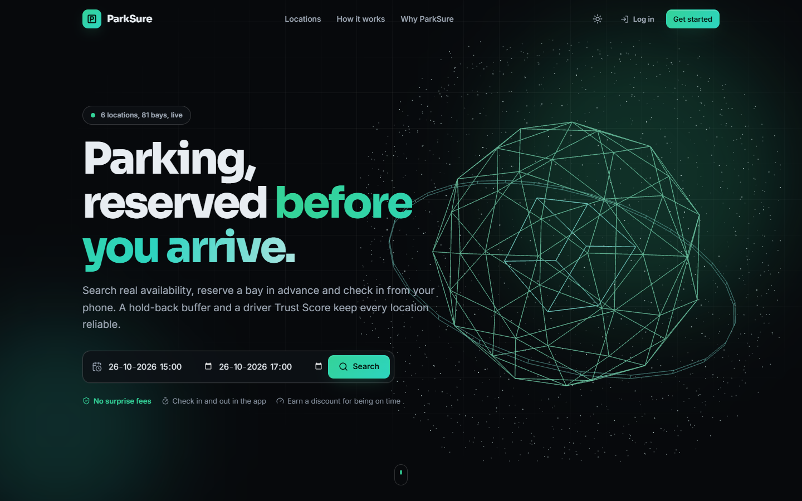  Figure 31: Additional screen: landing page, dark theme, with the live count of locations and bays and the search form. | 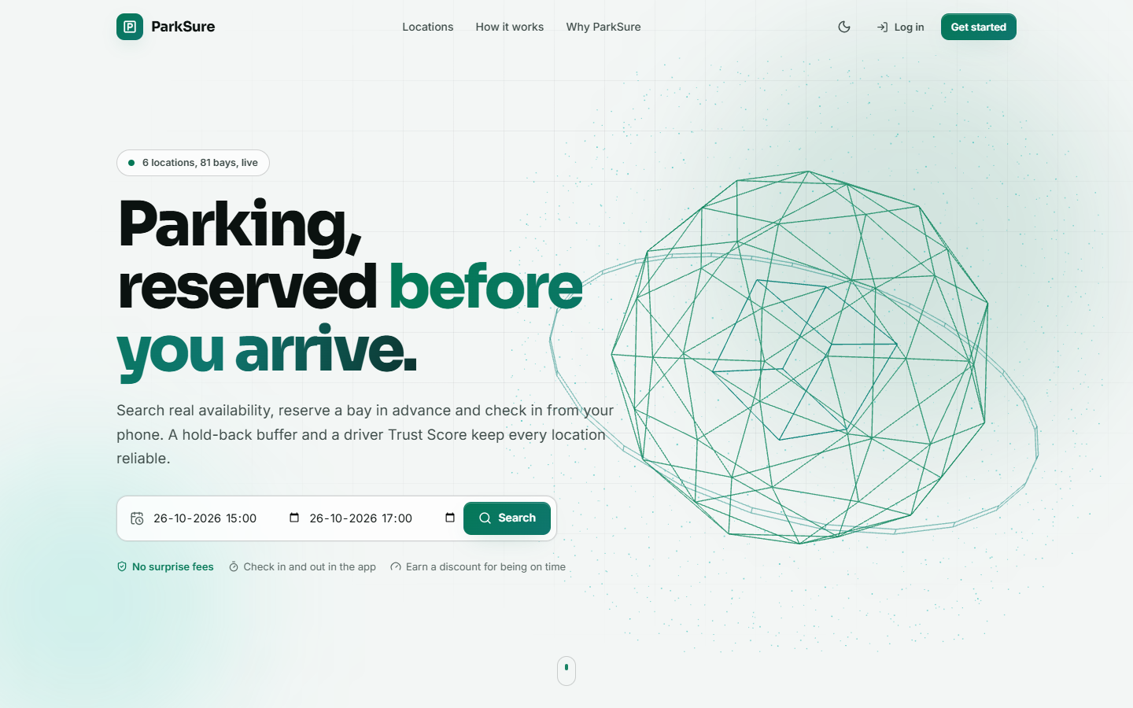  Figure 32: Additional screen: landing page, light theme.

The landing page is public; its badge reads '6 locations, 81 bays, live' (the five seeded locations plus the one-bay Kiosk Bay added for the arrival scenario). Both themes use the same colour tokens.
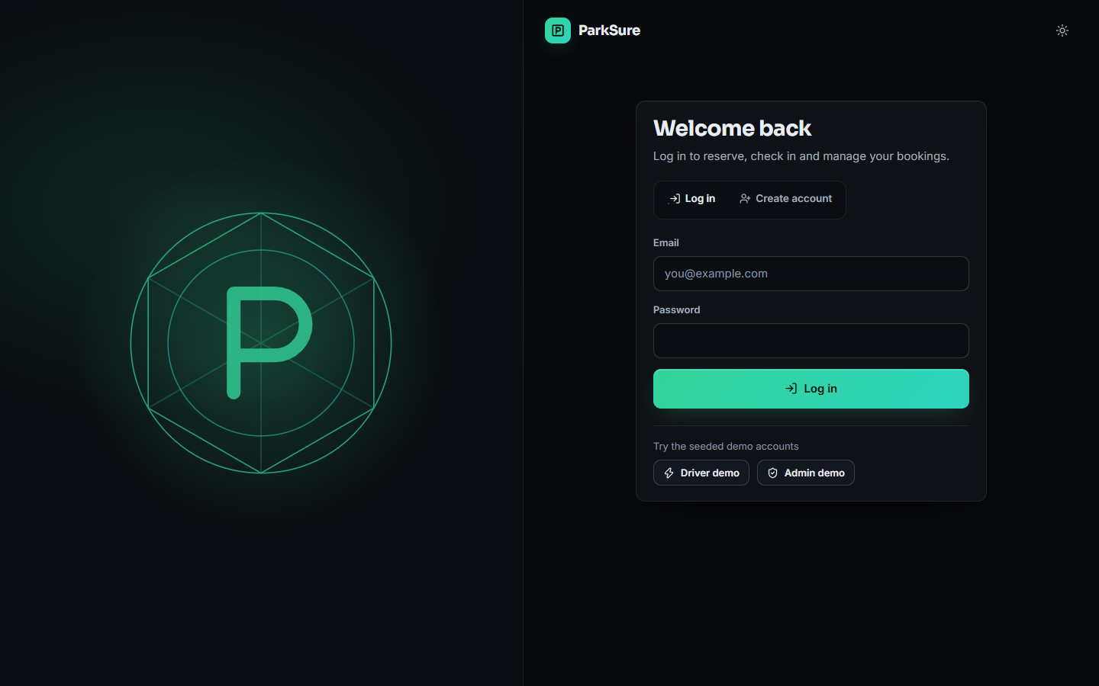
Figure 33: Additional screen: login page with the Log in and Create account tabs and the two demo-account chips.
The login page validates the e-mail format and the password before calling the API; the chips fill in a seeded account.
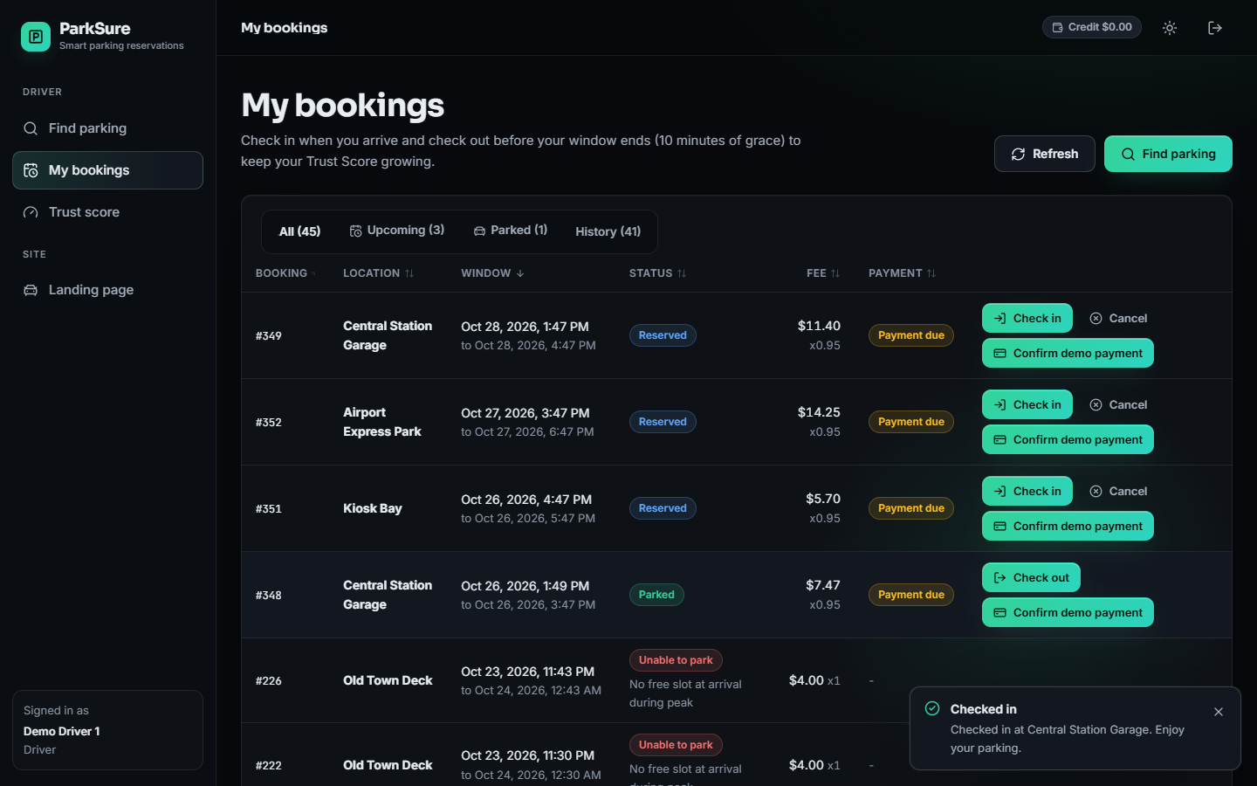  Figure 34: Additional screen: My bookings after a check-in; booking #348 is Parked and shows the Check out action, with the 'Checked in' toast. | 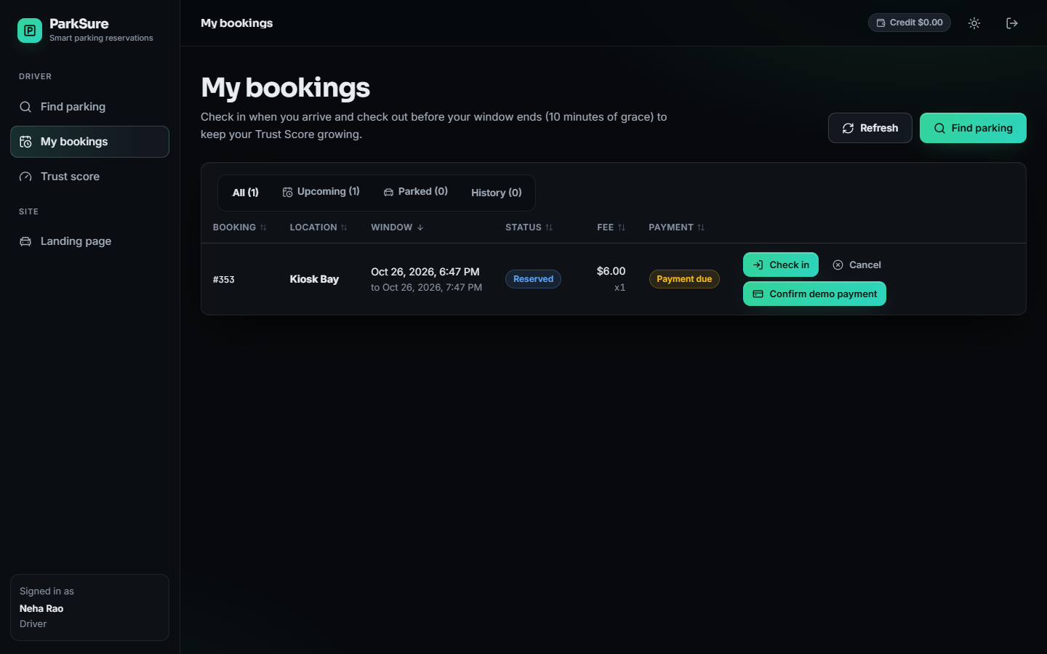  Figure 35: Additional screen: a second driver's bookings before arrival: one reserved booking at the one-bay Kiosk Bay.

In the first capture the table lists the driver's 45 bookings with a Parked tab count of one; the checked-in booking has no payment yet, which the interface shows as 'Payment due' next to a Confirm demo payment action, because check-in does not wait for payment. The second capture is the starting point of the full-lot scenario: the Kiosk Bay's only bay is already occupied by the first driver.
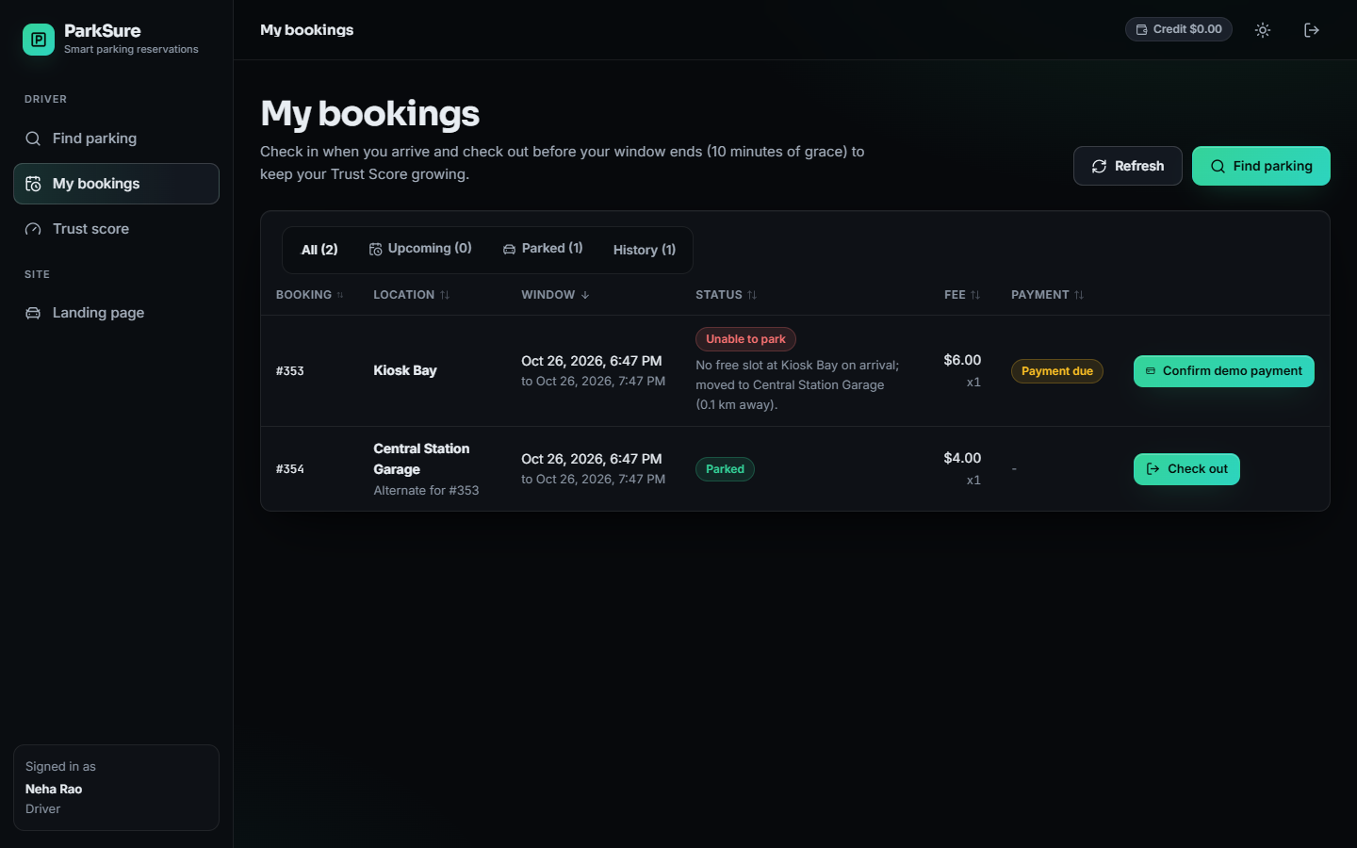
Figure 36: Additional screen: after the arrival at the full lot: booking #353 is marked Unable to park and booking #354 at Central Station Garage is Parked as 'Alternate for #353'.
The original booking carries the reason 'No free slot at Kiosk Bay on arrival; moved to Central Station Garage (0.1 km away)', and the replacement booking has the alternate location's own rate (4.00 dollars for the hour) and no payment row of its own, shown as a dash. This is the behaviour of the code: the original payment stays with the failed booking.
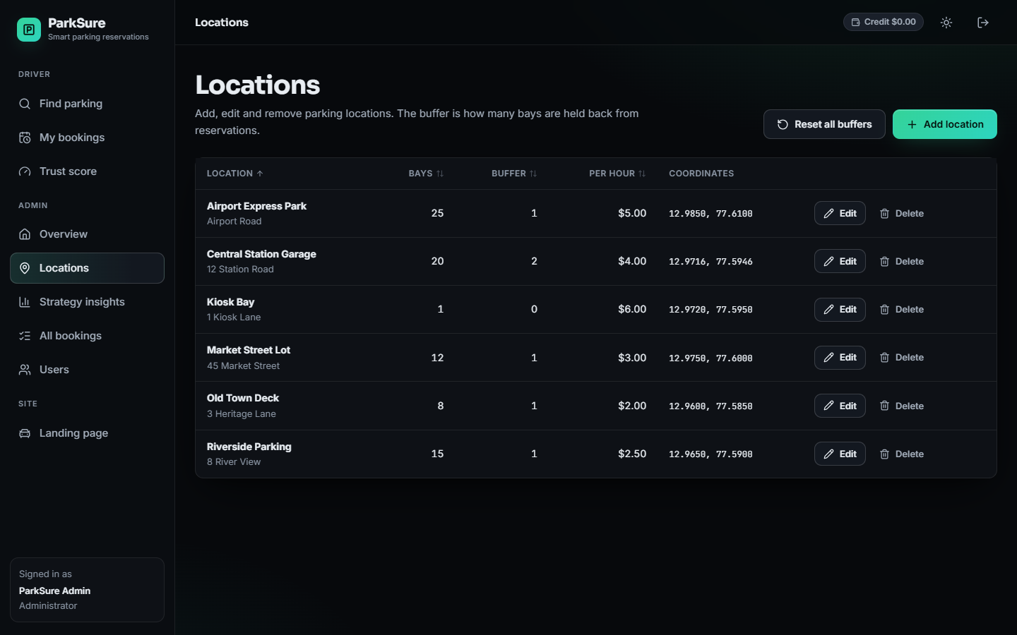  Figure 37: Additional screen: administrator's Locations page with bays, buffer, price, coordinates and the Edit, Delete and Reset all buffers actions. | 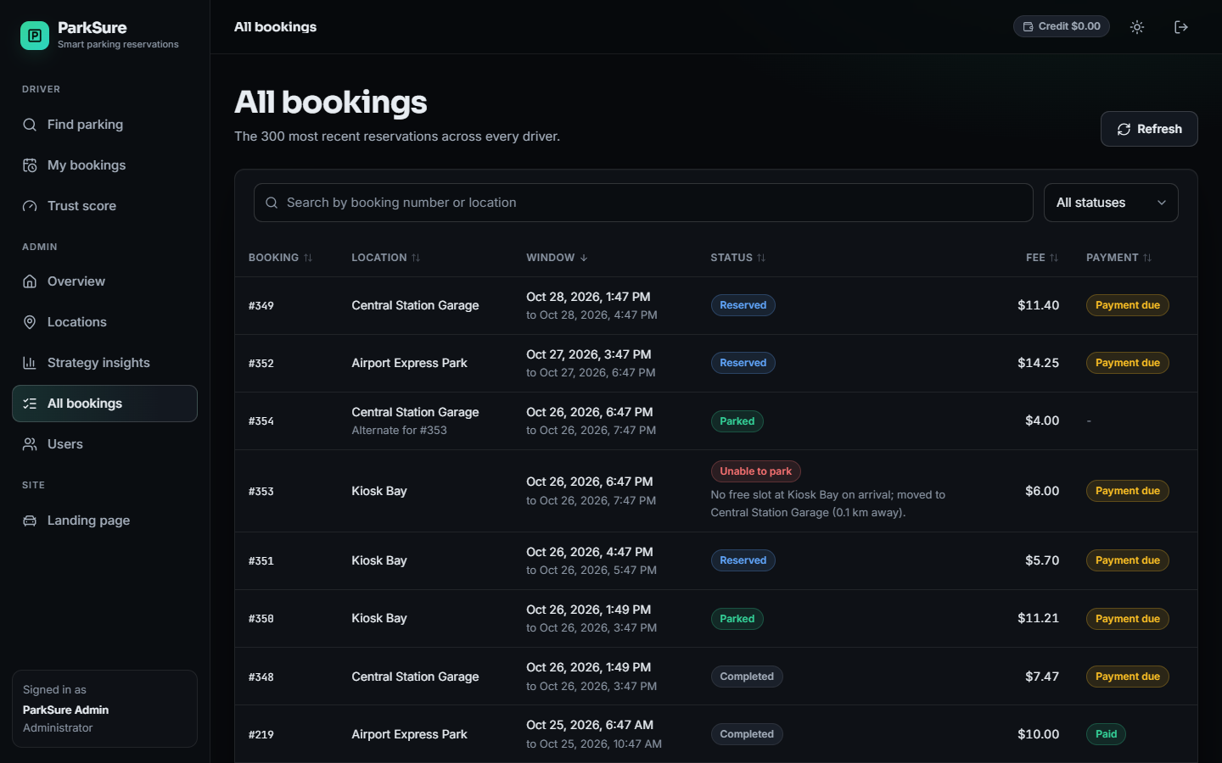  Figure 38: Additional screen: administrator's All bookings page with search and status filter.

On the locations page Central Station Garage has a buffer of 2 because one on-time check-out raised it from 1, while the Kiosk Bay, created with buffer 0, still shows 0.
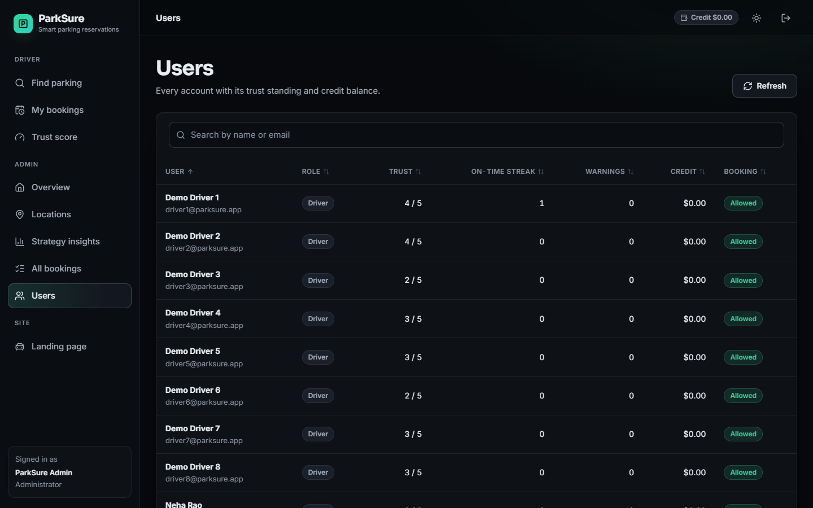  Figure 39: Additional screen: administrator's Users page with trust, on-time streak, warnings, credit and booking permission. | 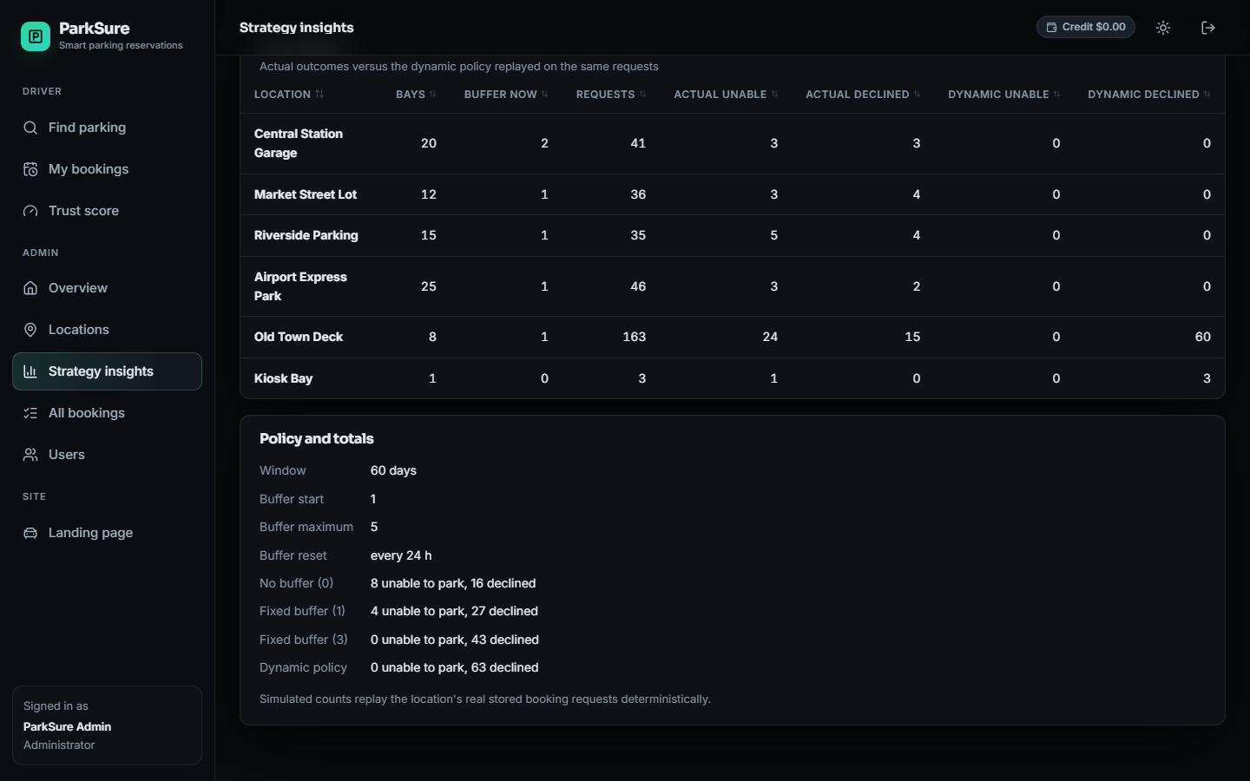  Figure 40: Additional screen: Strategy insights, per-location actual outcomes against the replayed dynamic policy, and the policy and totals panel.

The users table shows the seeded Trust Scores and that every account is allowed to book; the insights panel lists the buffer policy and the replay totals, with Old Town Deck accounting for most dynamic-policy refusals.
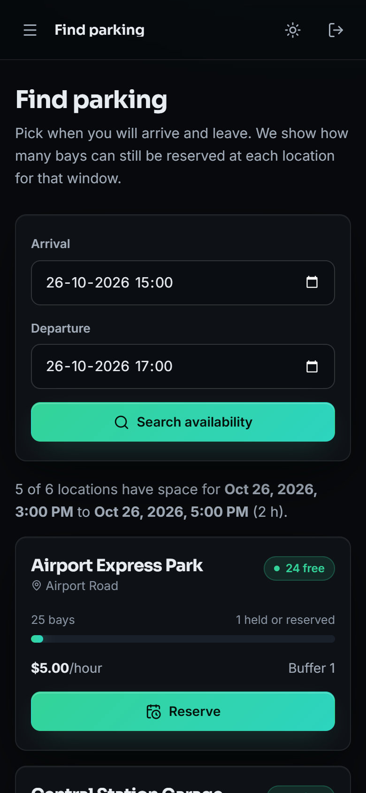  Figure 41: Additional screen: Find parking at phone width (390 px): the sidebar becomes a menu and the form and cards stack. | 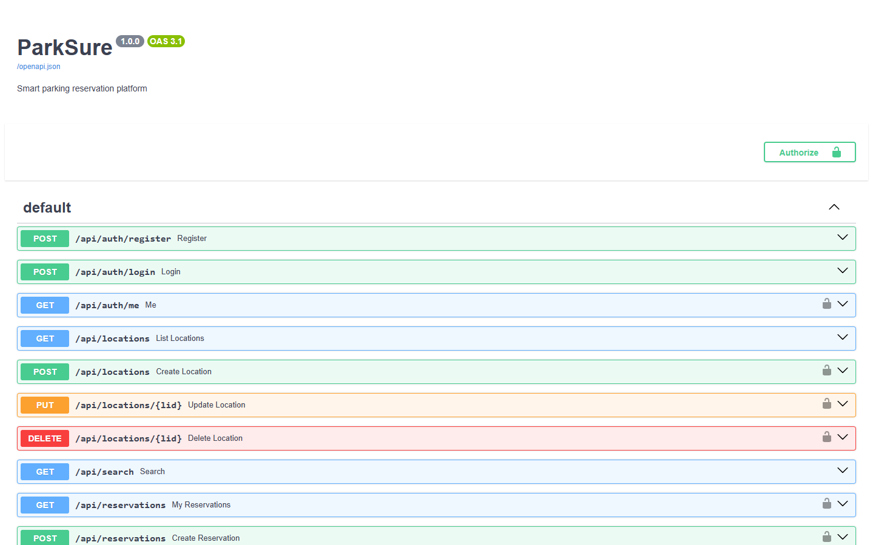  Figure 42: Additional screen: the FastAPI OpenAPI page at /docs on the backend port, listing the 22 routes with the Authorize button for the bearer token.

The phone capture shows the responsive layout; the API page is generated by FastAPI from the route definitions and can be used to try any route with a token.

